MOGOBIZ

Table of contents

Presentation 2

Set up a store and manage users 4

Company Admin 4

General 9

Profiles 10

Users 21

Manage your store 30

Presentation 31

Create a catalogue 35

Create categories 37

General 39

Variations 40

Features 43

Create products 45

Product Creation 45

Product Description 47

Product Properties 53

Product SKU 57

Product Calendar 60

Ticket display 61

Ticket Validity 64

Product Directions 66

Product Suggestions 72

Product Shipping 77

How to Edit or Delete 80

Translation 81

# Presentation

Mogobiz is an open source modular software solution for e-commerce. It is available in SaaS mode or can be hosted in your own environment.

This user document will walk you through the process of setting up your Mogobiz store. It is intended for first time users who want to generate a simple, powerful and full-featured eCommerce platform. No technical expertise is required.  
  
To set up the ecommerce platform, the administrator needs to first create **a store**, by entering:

1. Its **general** information (name, adress, website, etc.),
2. The **profiles** : users’ authorizations to operate on one or several stores
3. The **users:**  authentification informations of the users authorized to operate on one or several stores.

Once the store is created, the ecommerce platform is organized as below:

1. A **store.** Its objective is to display products to sell.   
   Each product is created independently, with its own description and illustration. For an optimized visibility, those products (skirts, rental, concert) are created within categories (clothes, services, tickets, etc.), and each categories belongs to a unique store.
2. A **catalog**. It is set for a limited period of time, for seasonal collections or holidays for example. There can be several catalogs, as many as needed, that can be turned on or off. Products are organized inside a catalog through a hierarchy of categories.
3. **Categories**. They host products and services that share common features. They can host an unlimited number of products.
4. **Products.** They have permanent features (materials, size, color) listed in the category section. Any product can vary - according to customers’ requests and stock availability. These variations can include size or colors for example. Those variations are listed in the product section and create an SKU (Stock Keeping Units).
5. Each of these **SKU**s have then a unique feature value, hence a unique identifier referring to the particular SKU.

# Set up a store and manage users

This section describes how to create a store and manage its users for your Mogobiz online store.

Company Admin

To set up your first store:

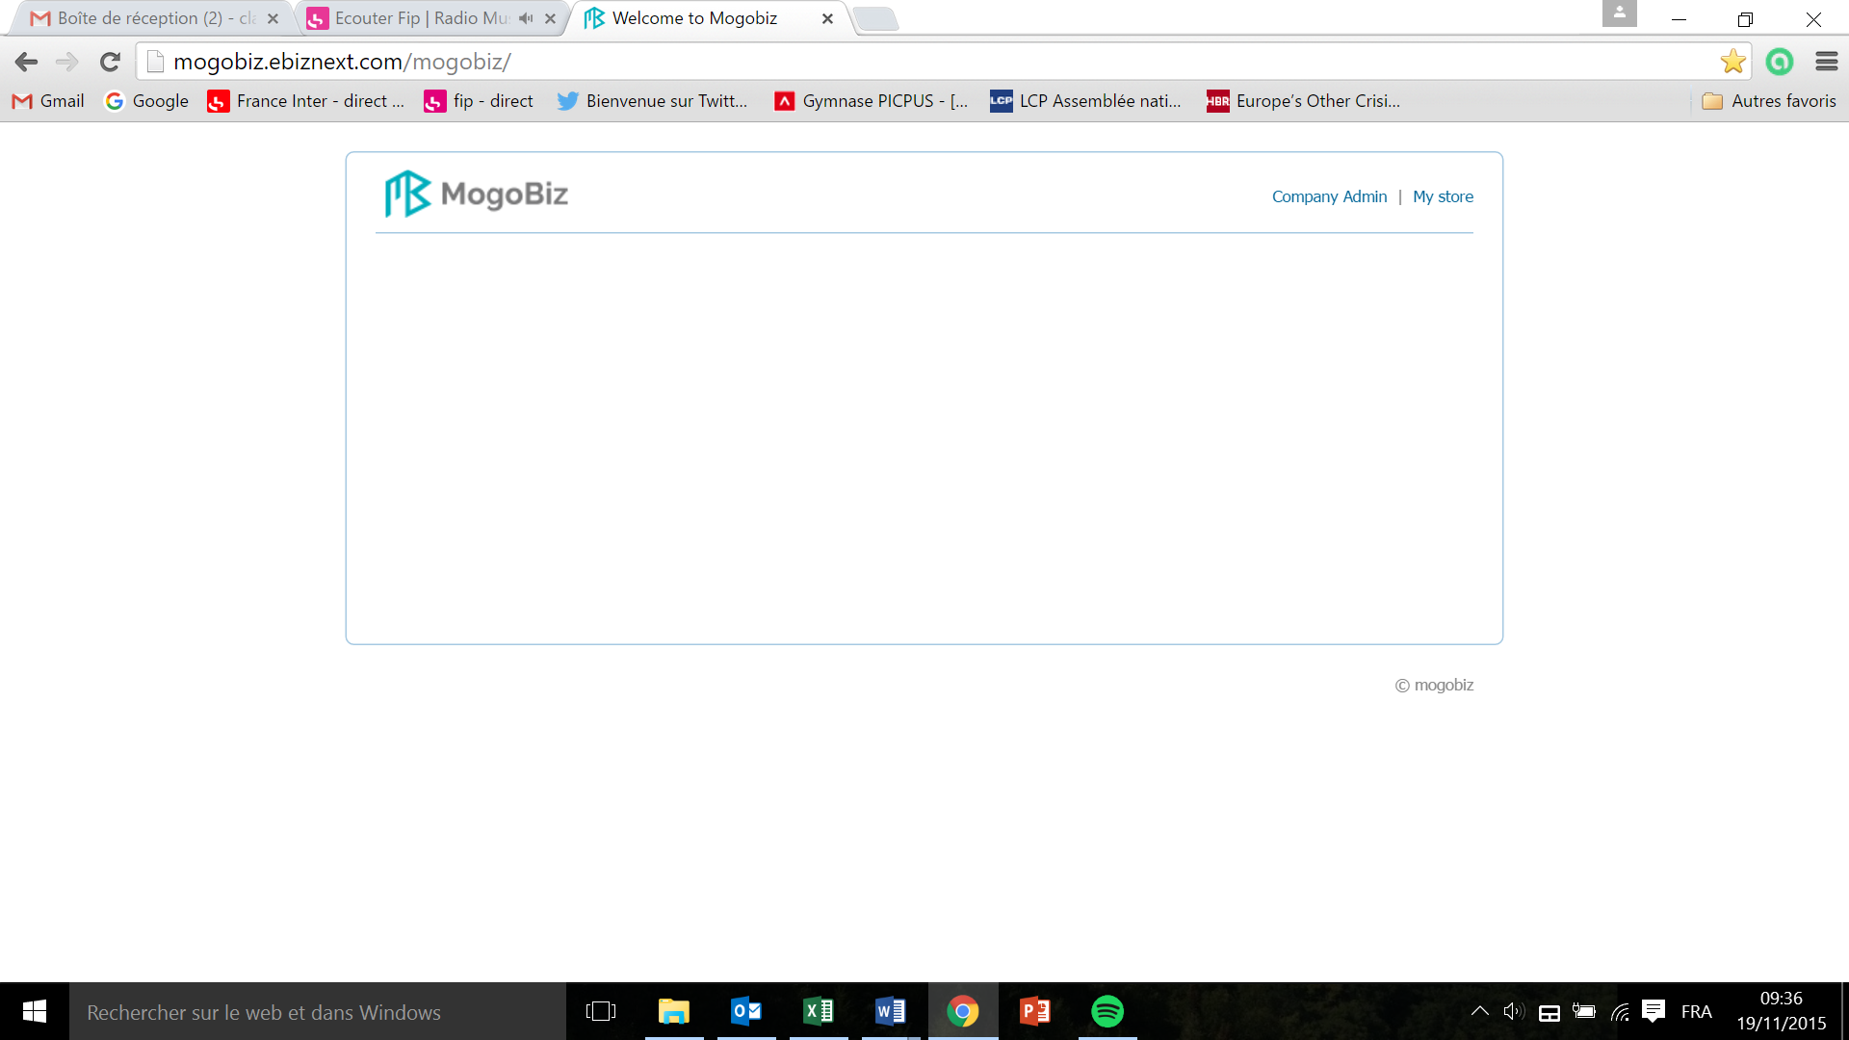

* Click on **Company Admin.**

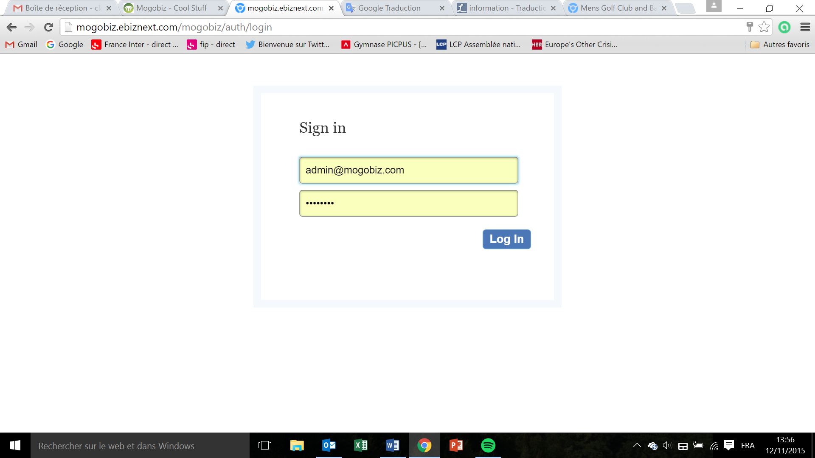

* Enter your email and password attributed by your IT department ? and click **Log In.**

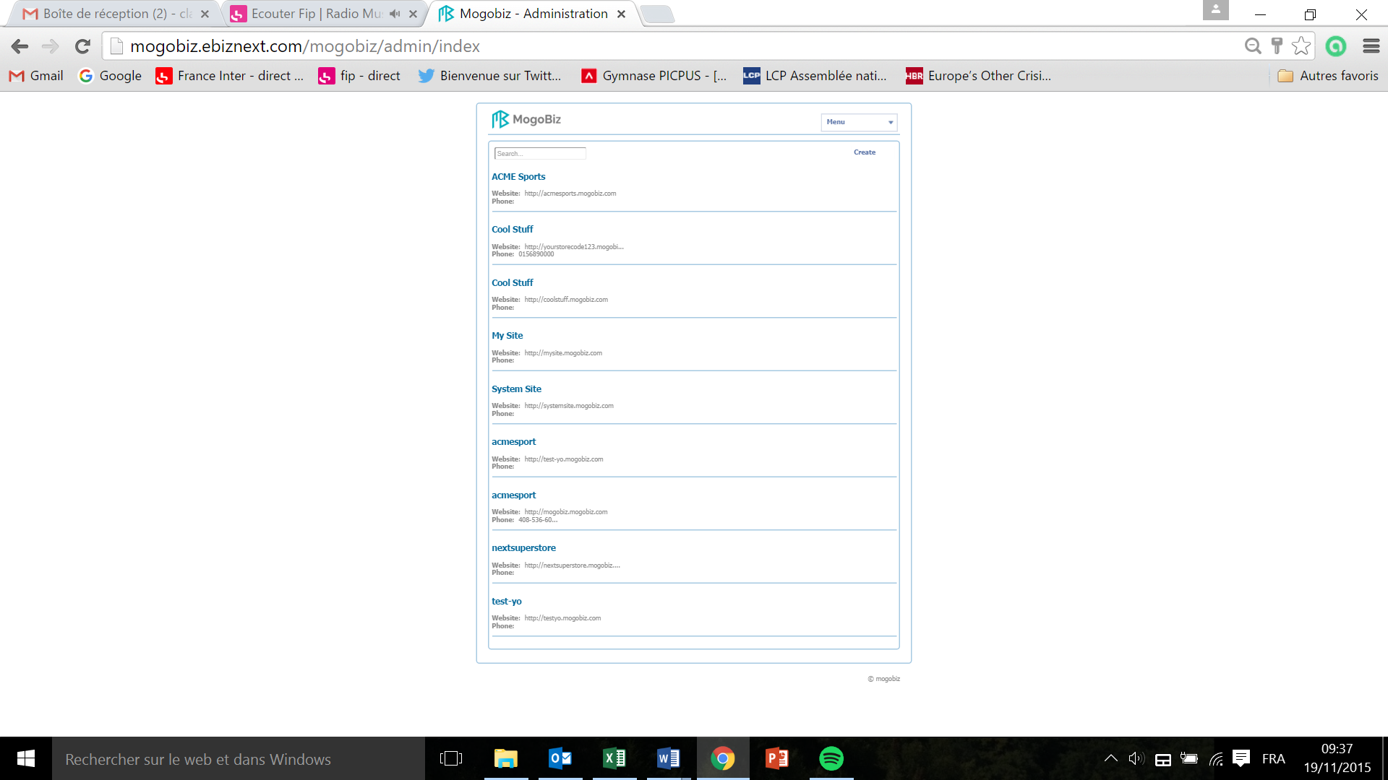

* Click on **Create** on the top right corner.il faudrait un screen sans liste de stores

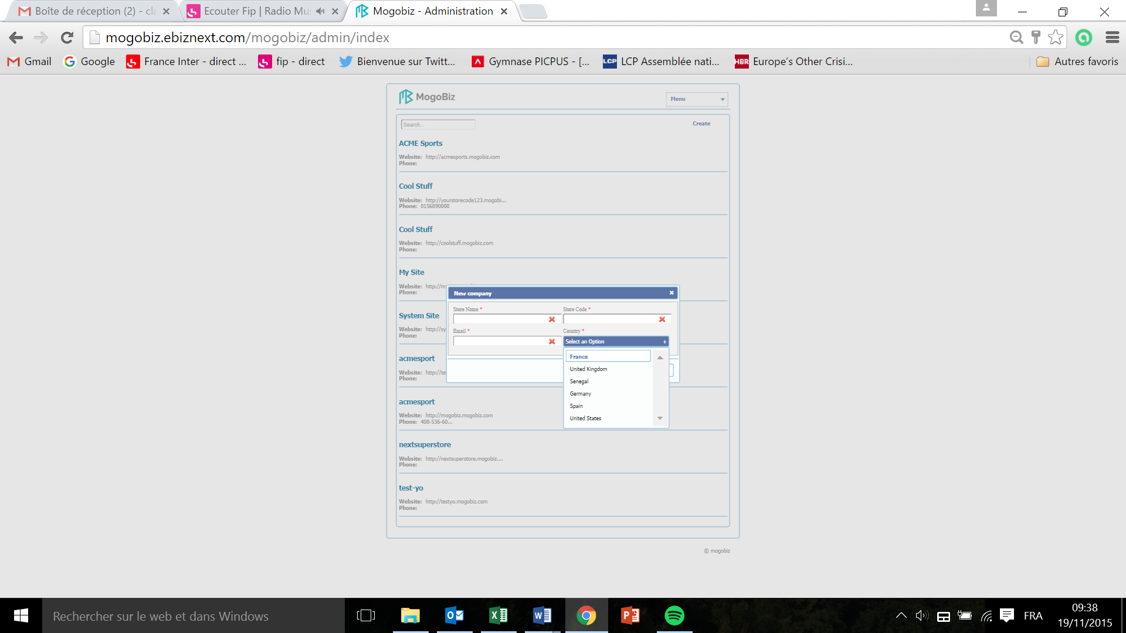

* Enter the **Store Name.**
* Enter the **Store Code** that you chose for this store. No spaces allowed, letters and number only.
* Enter your **Email** address, this will allow you to receive email alerts when ?
* Click on the **Country** drop down menu and select the country where your store is located.

All fields are mandatory.

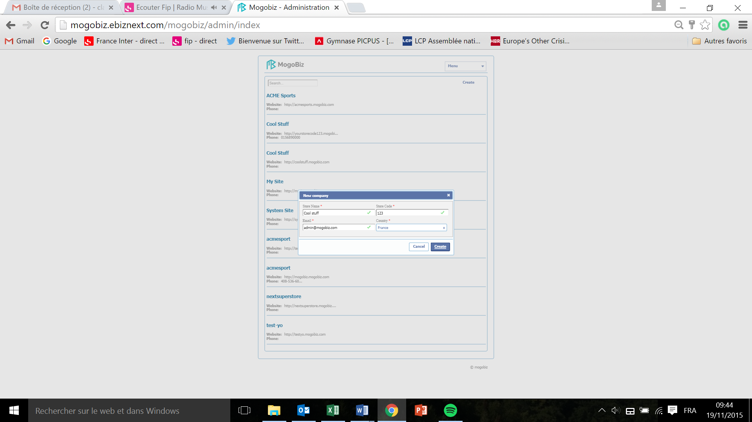

* Click on **Create** to save your store settings **or Cancel** if you don’t want to pursue.

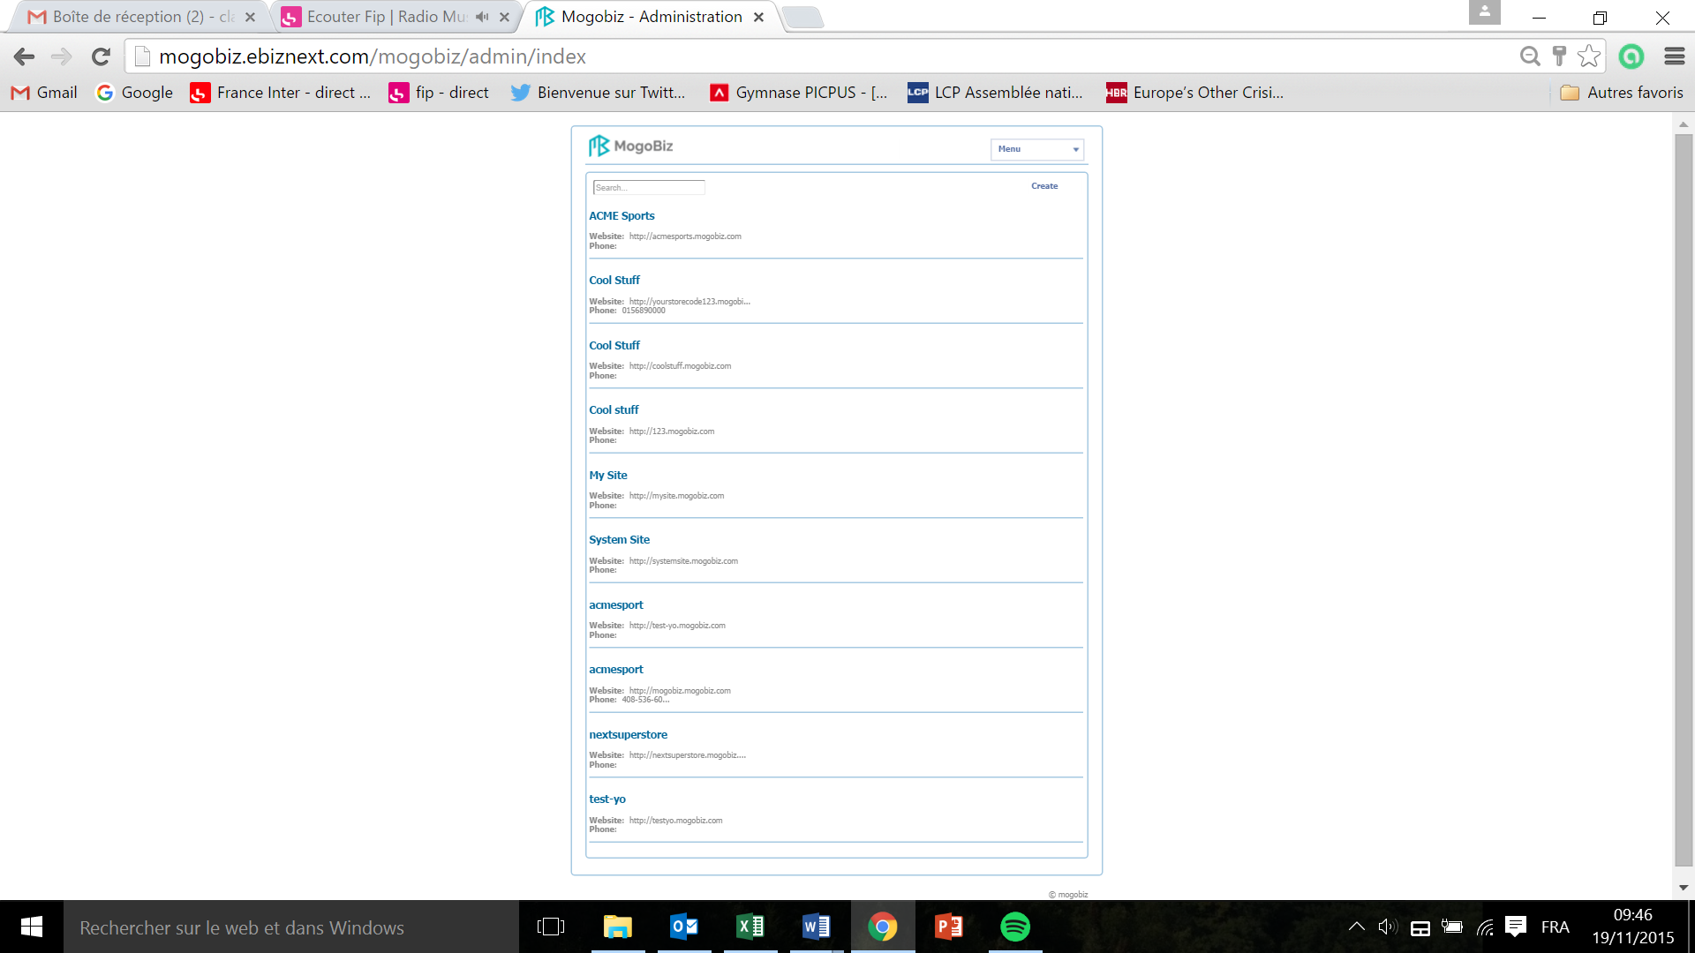

* Click on the store you just created.

General  
  
This section defines the general settings of your Mogobiz online store.

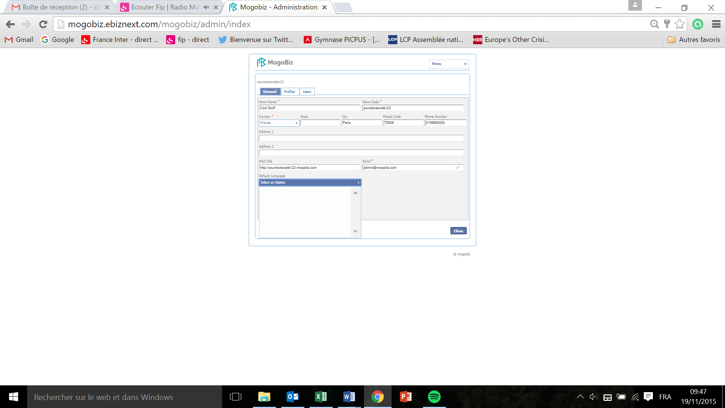

In the window that pops up:

* Your **Store Name**, **Store Code**, and **Email** address entered at the creation of your store are automatically populated.
* The URL of your store is automatically generated by Mogobiz in the **Web Site** field.
* Click on the **Country** drop down menu and select the country where your store is located. This field is mandatory.
* Enter the **State**, **City**, **Postal Code**, **Phone Number, Address 1, and Address 2** of your store.
* Click on the **Defaults Language** drop down menu and select the language that will apply throughout all your store. Pas de langues proposées dans le menu déroulant.
* On the top left corner, click on **Profiles** to set up your users authorisation profiles

Profiles  
  
This section defines the profiles settings of your online store.

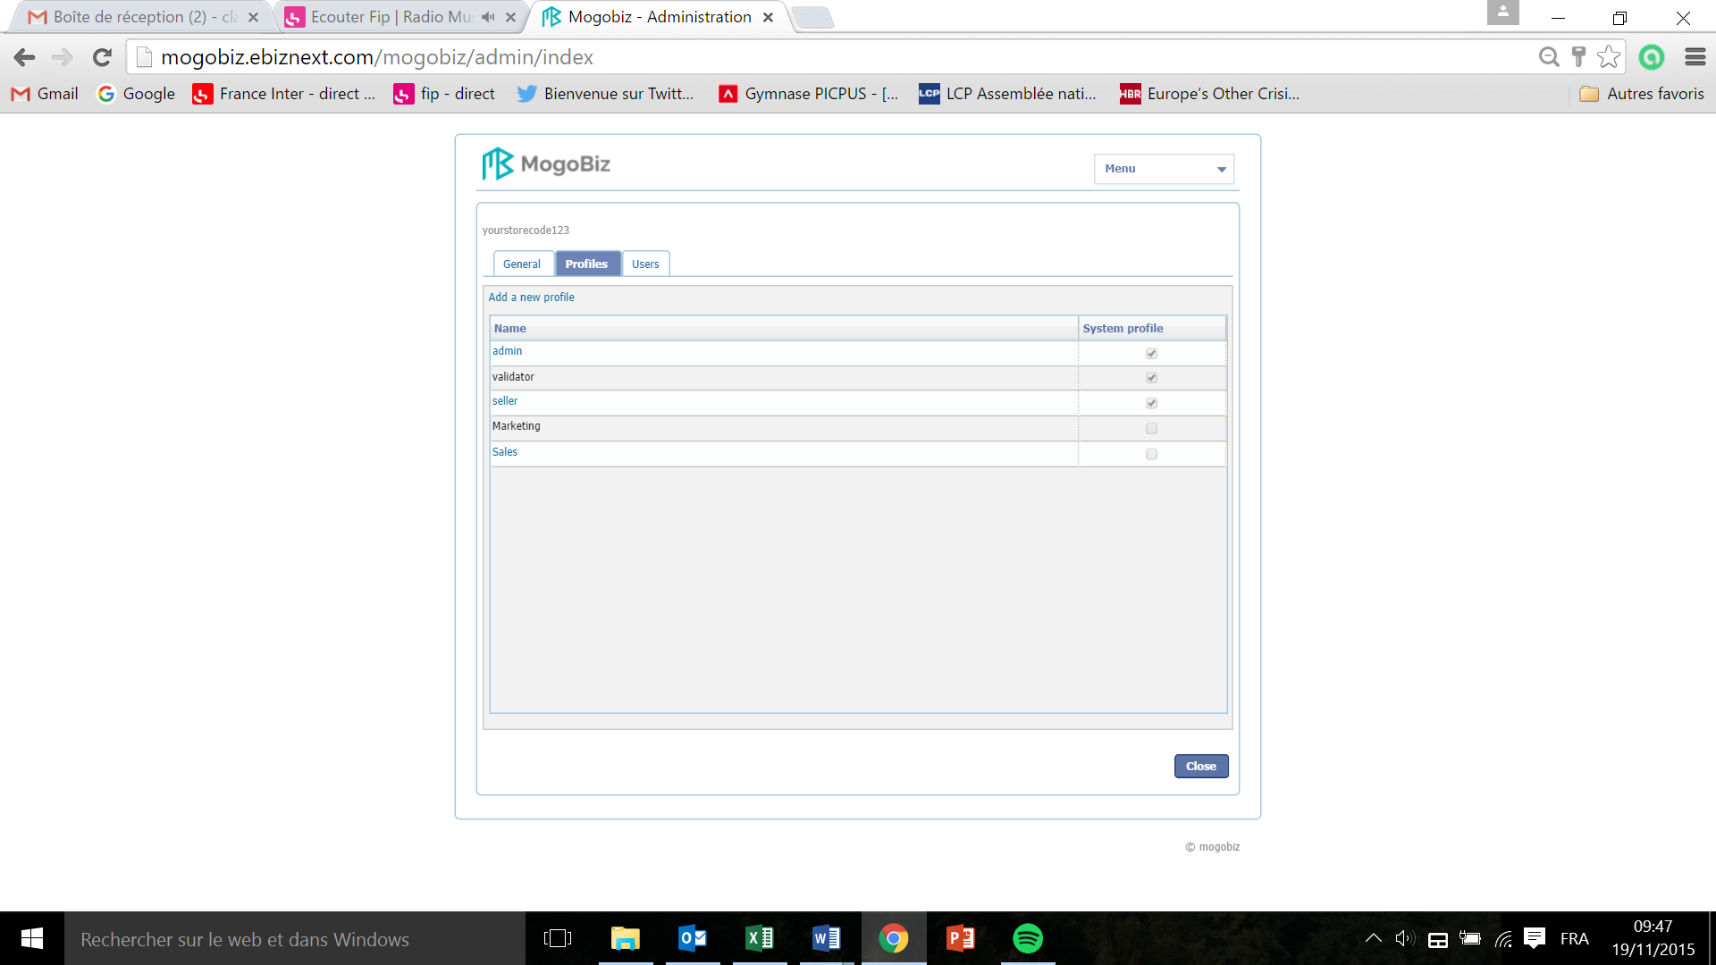

According to each user’s skills and role within the company (finance, sales, marketing, pricing, etc.), the administrator can set up as many specific **profiles** as required.

In order to make this step as easy as possible, Mogobiz has created three **standard profiles** that can be customized and adapted to specific needs:

* An **admin** profile, which defines the employee in charge of the store, profiles and users creation processes.
* A **validator** profile, which defines the employee in charge of managing one or several stores and products that need validation (such as services or downloadable products).
* A **seller** profile, which defines the employee in charge of managing one or several stores and products that don’t need validation.
* Click on **admin**,or **validator**,or **seller**

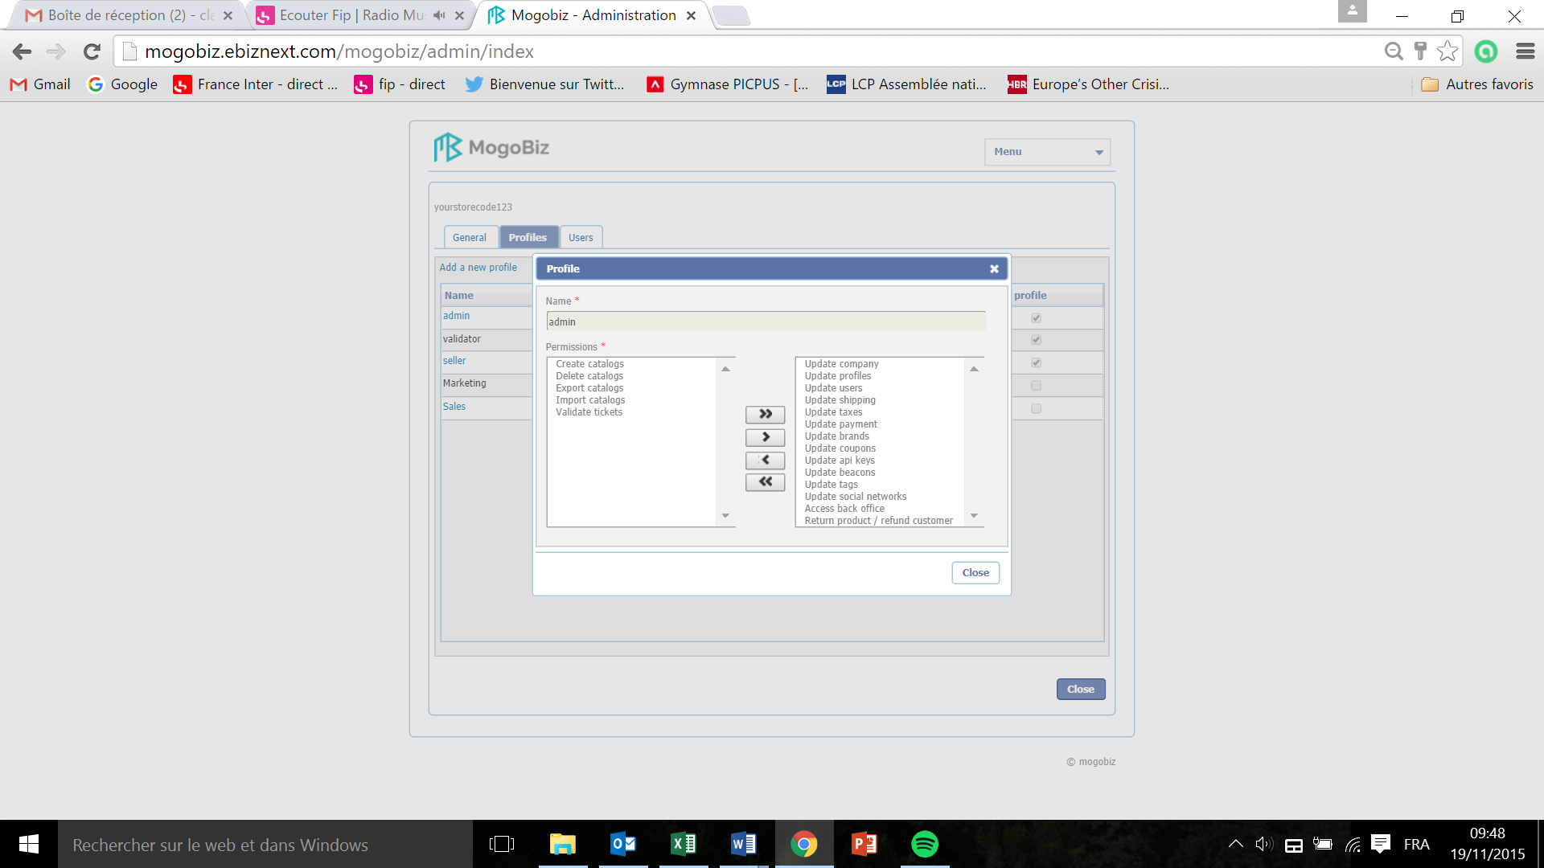

* List of functional authorizations for an **admin** standard profile

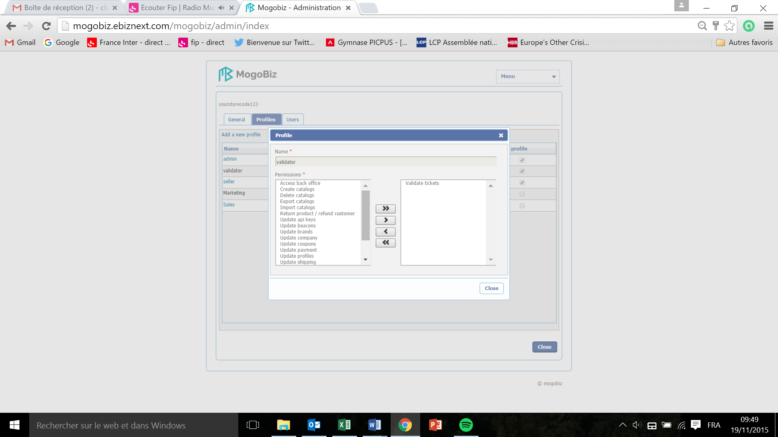

* List of functional authorizations for an **validator** standard profile

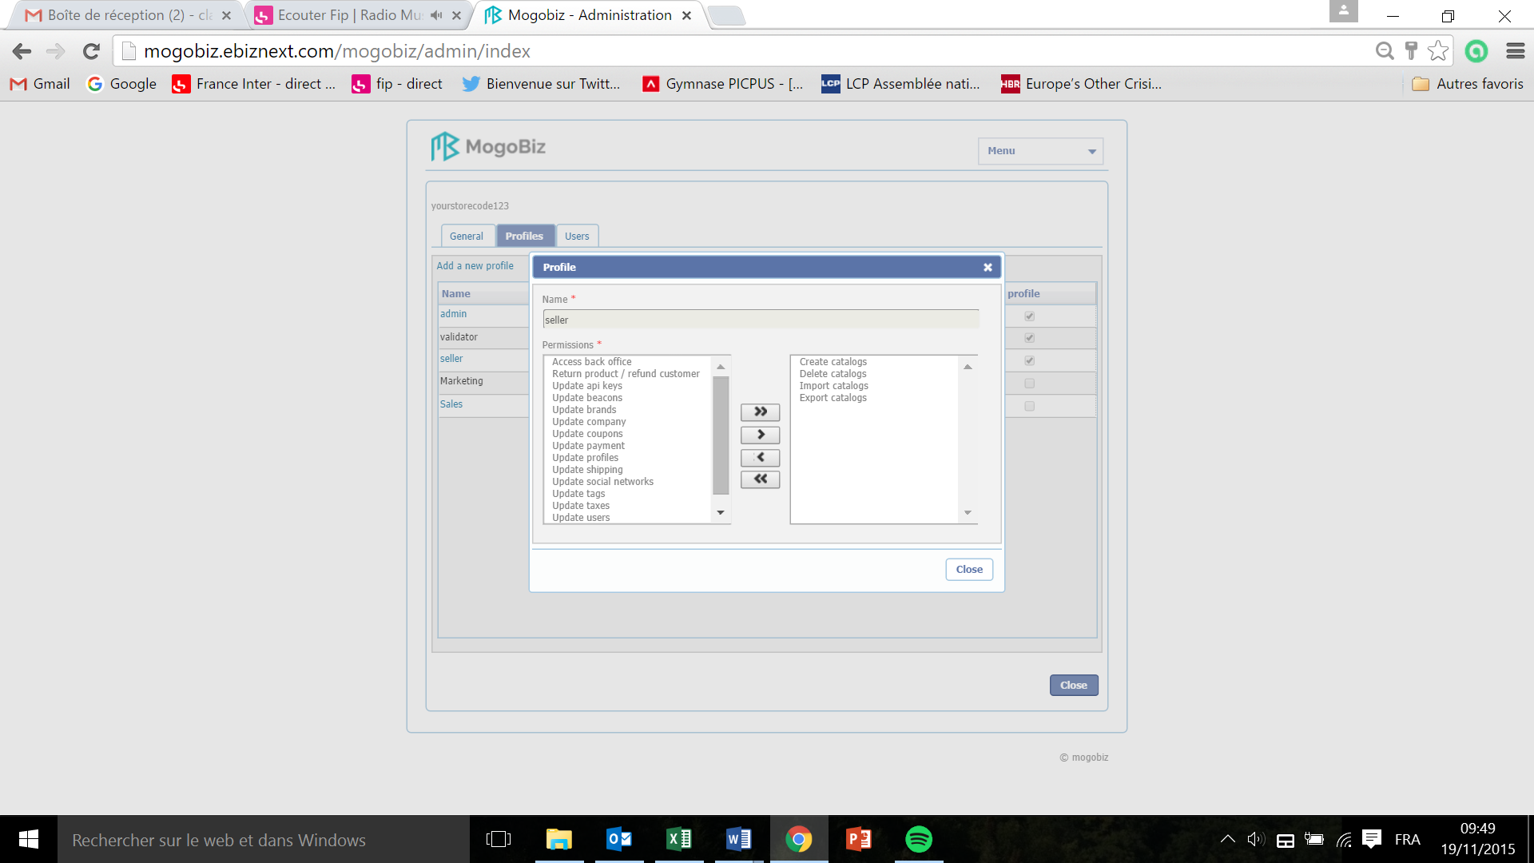

* List of functional authorizations for an **seller** standard profile

The complete list of functional authorizations is as follow:

* Create catalogs
* Delete catalogs
* Export catalogs
* Import catalogs
* Validate tickets
* Update Company
* Update profiles
* Update users
* Update shipping
* Update taxes
* Update payment
* Update brands
* Update coupons
* Update API key *dans la liste validator et seller mais pas admin*
* Update beacons
* Update tags
* Update social networks
* Access back office
* Return product/ Refund customers

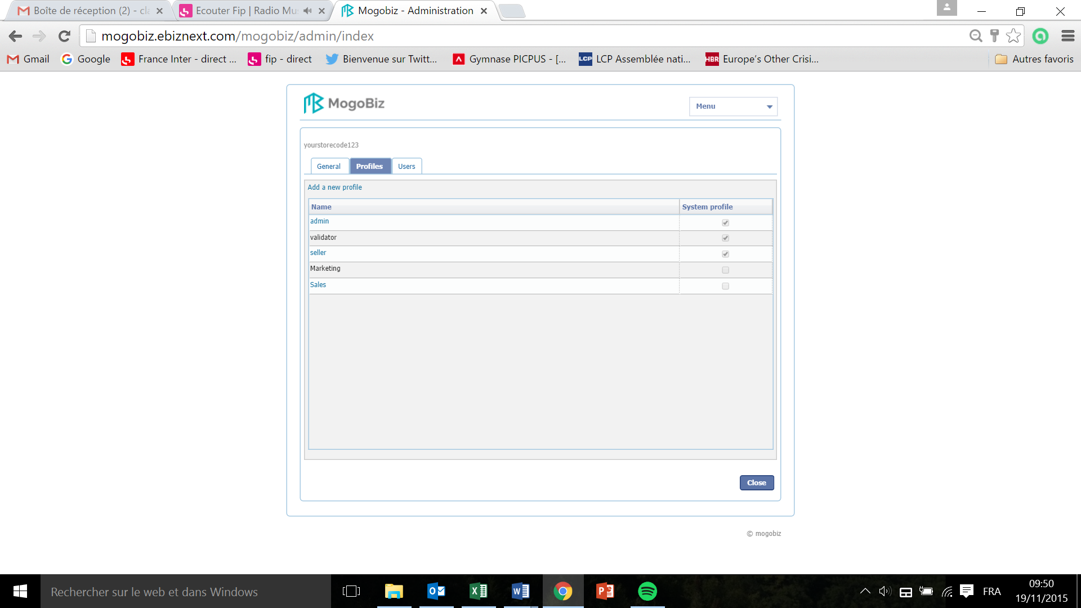

* Click on **Add a new profile** to create a new profile or customize a Mogobiz standard profile.

To create a new profile:

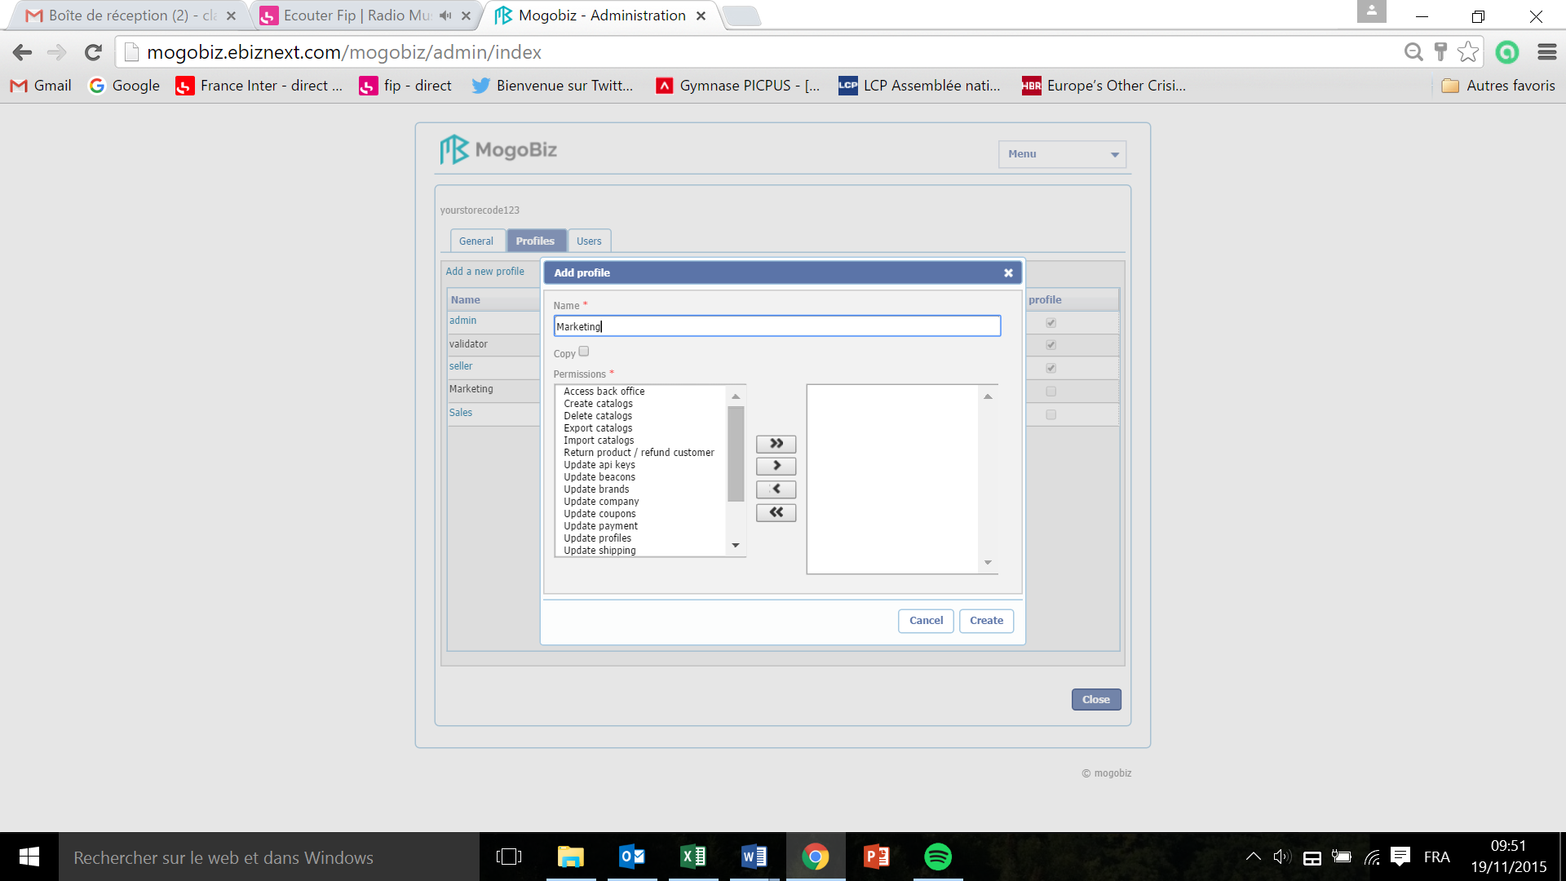

* Enter the name of the new profile in the **Name** field. For example here: Marketing.
* Select one or several functional authorizations from the permission field, and click on the single arrow pointing to the right to add it to the right window.
* Click on the double arrow pointing to the right to add all authorizations to the right window.

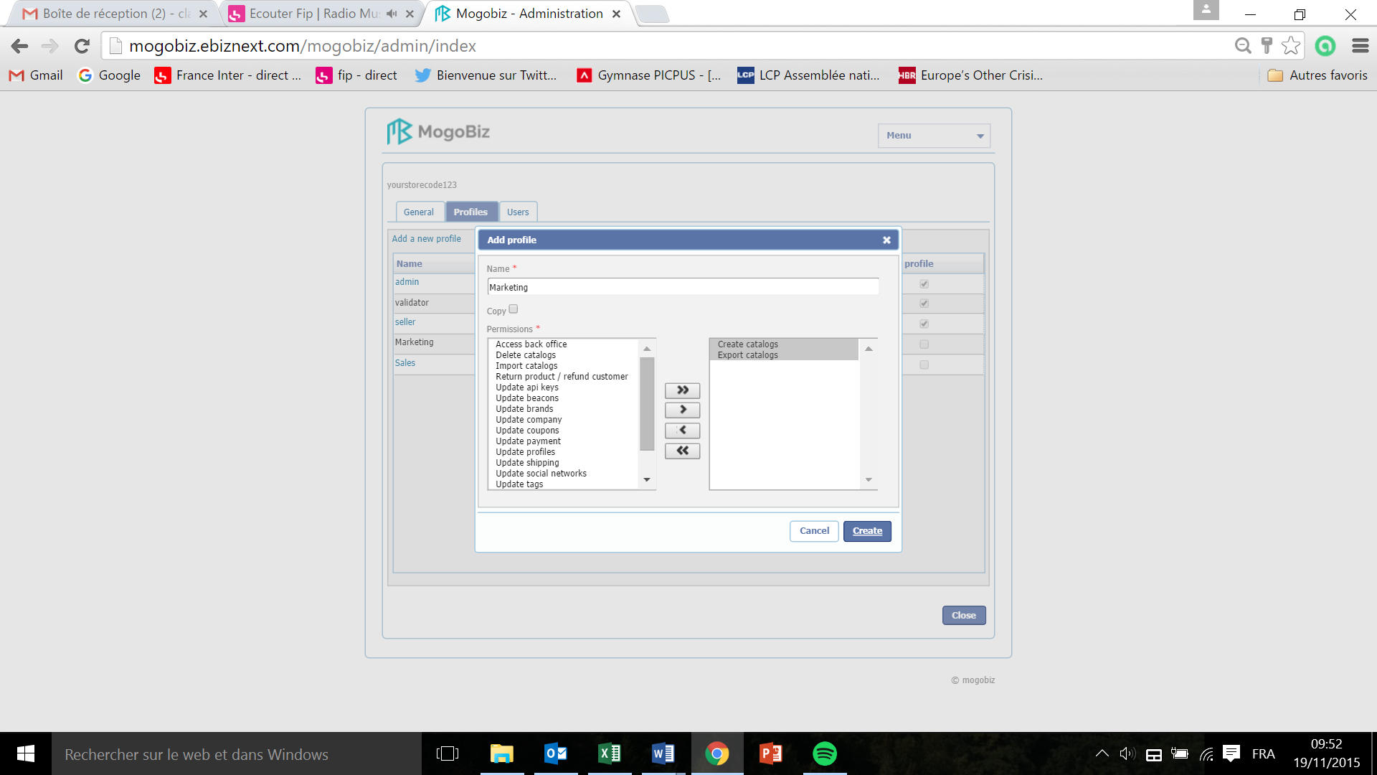

* Click on the single arrow pointing to the left to remove an authorization.
* Click on the double arrow pointing to the left to remove all authorizations.
* Click on **Create** to save your profile settings **or Cancel** if you don’t want to pursue.

To customize a Mogobiz standard profile:



* Click on **Add a new profile.**

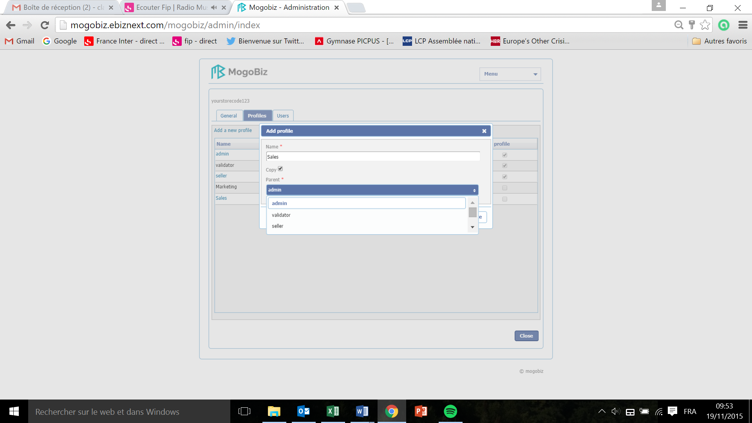

* In the window that pops up, enter the name of the new profile in the **Name** field (here Sales).
* Tick off the **copy** box.
* Click on the **Parent** drop down menu and select the Mogobiz standard profile you want to customize (here admin).

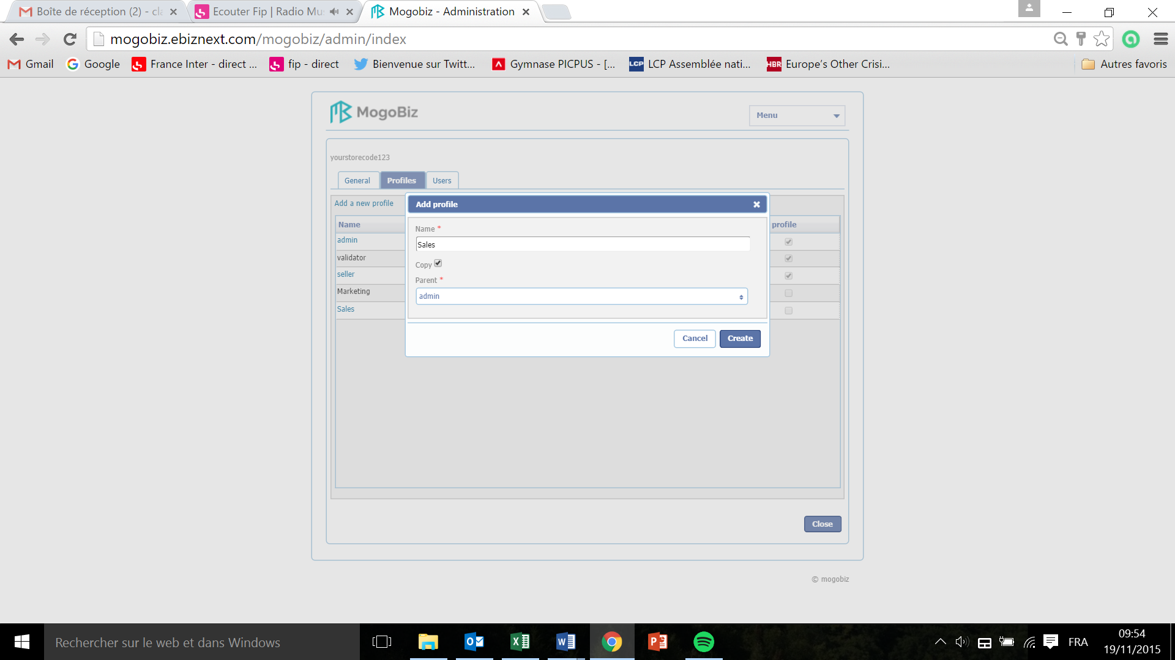

* Click on create to customize your profile or **Cancel** if you don’t want to pursue.



* Click on the new profile created (here Sales)

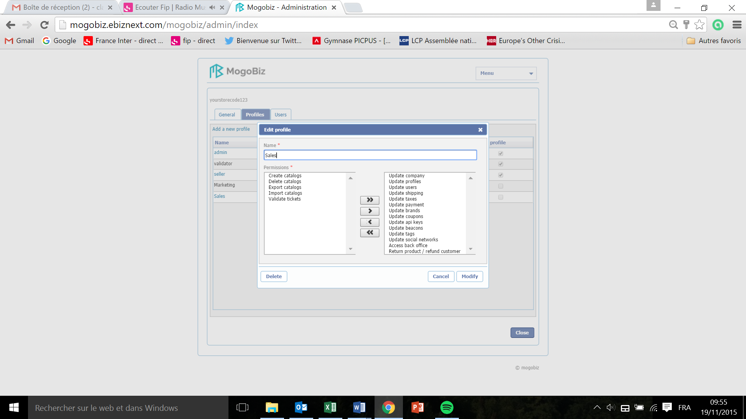

* Customize the authorizations by adding or removing them from the **Permissions** list, using the single or double arrows (see “to create a new profile” section).
* Click **Modify** to save your customization or **Cancel** if you don’t want to pursue.

Users

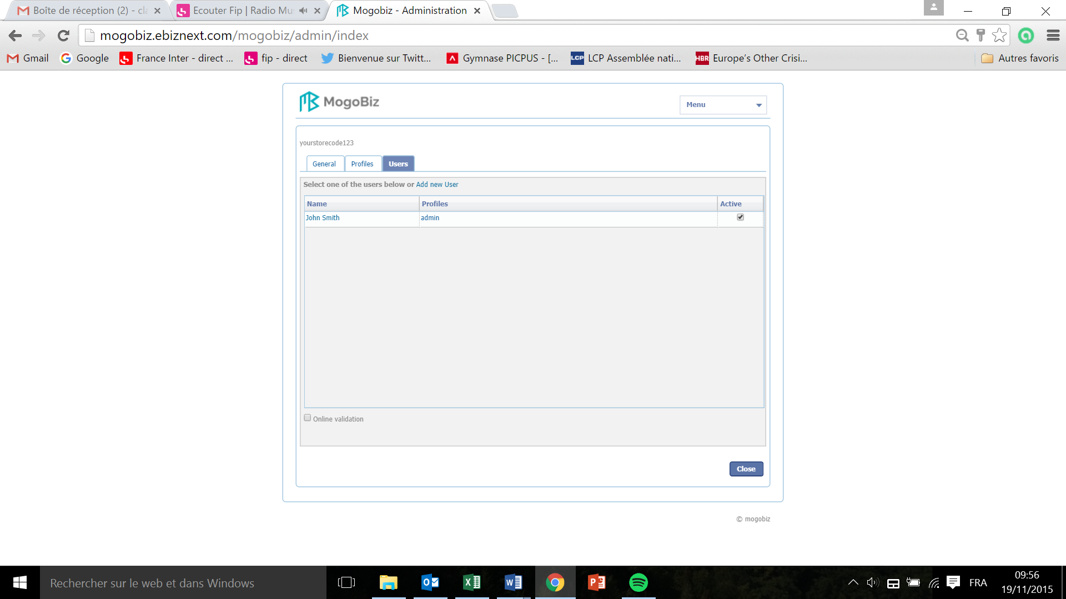

* Click on **Add new User.**

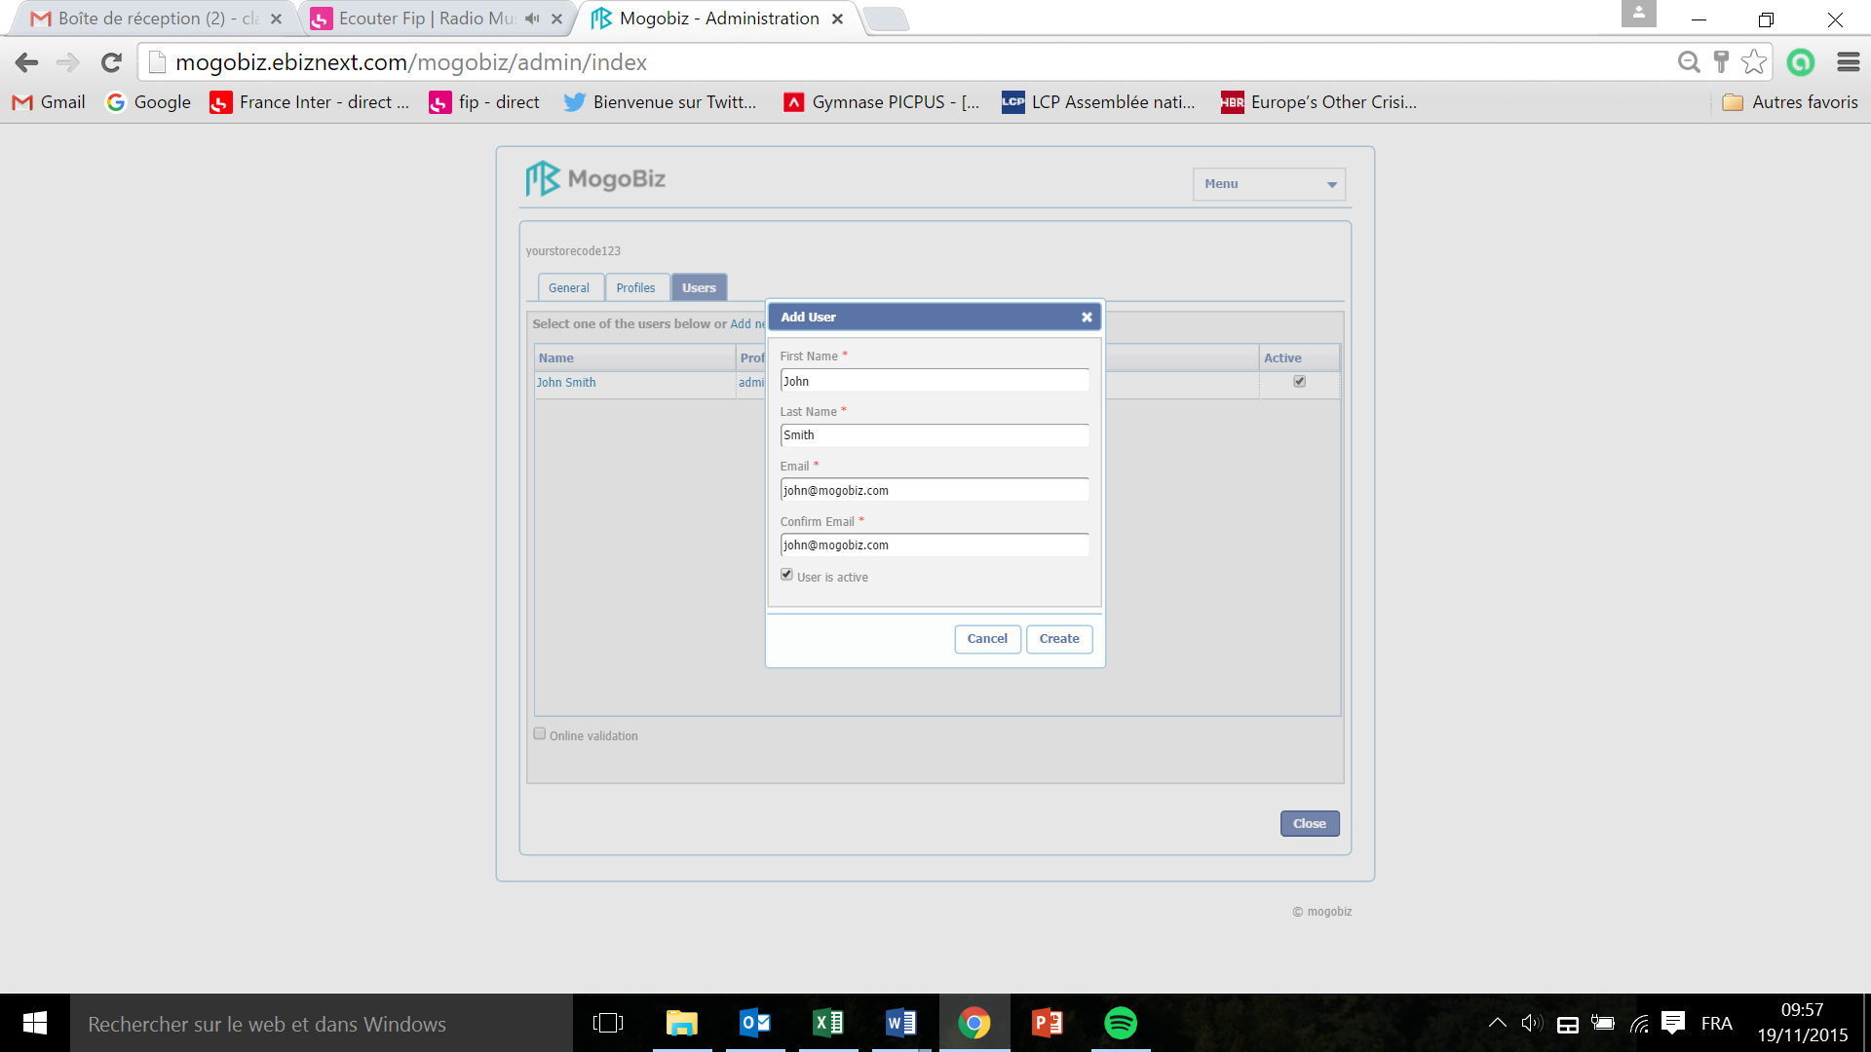

* Enter the details of the user in the **First Name**, **Last Name**, **Email**, **Confirm Email** tabs. All fields are mandatory.
* Tick off the **User is active** box if the user is to be active immediately, or untick it if the user will not be active immediately.
* Click **Create** to save the new user creation, or **Cancel** if you don’t want to pursue.



* Click on the user (here John Smith).

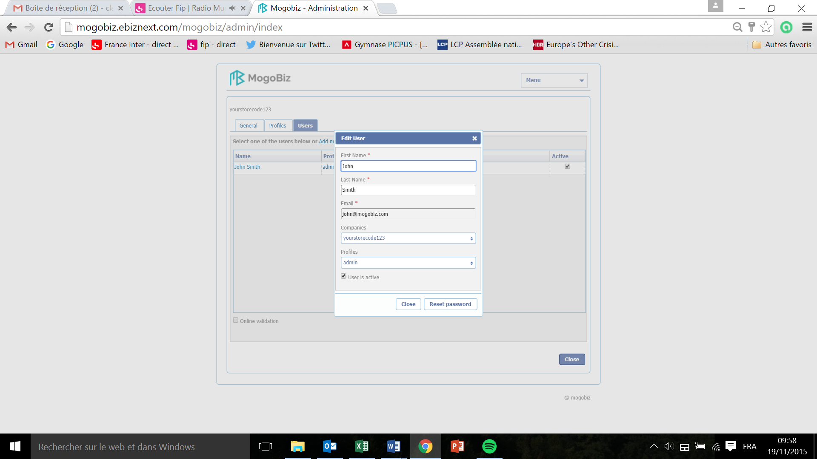

* The **First Name**, **Last Name**, and **Email** entries are populated as per the previous step.

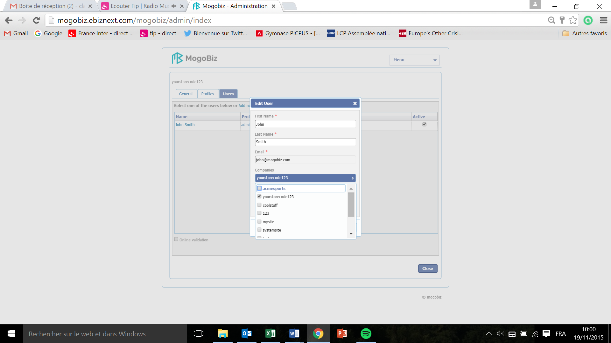

* Click on the **Companies** drop down menu in order to select which store to attribute to the user. Several stores can be selected, with no maximum limit.

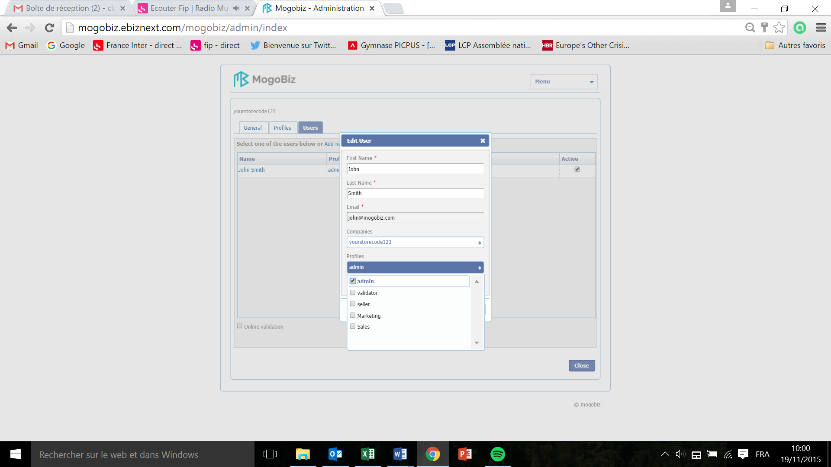

* Select a profile to attribute to the user in the **Profiles** drop down menu, in order to attribute specific functional authorizations to the user.

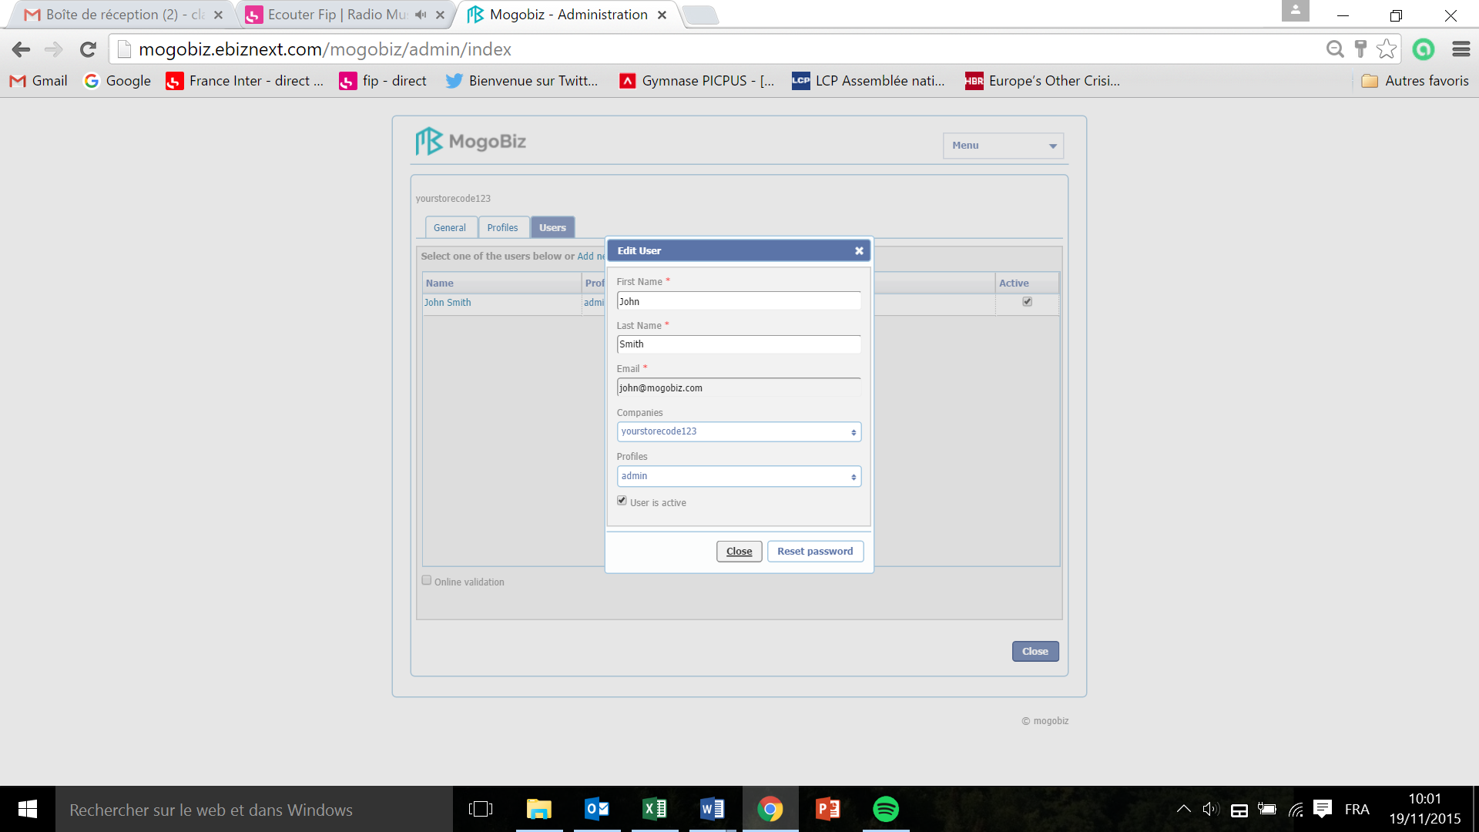

* Click **Close** to save the new user properties.
* Or click **Reset password** if you want a new password to be sent to the user.

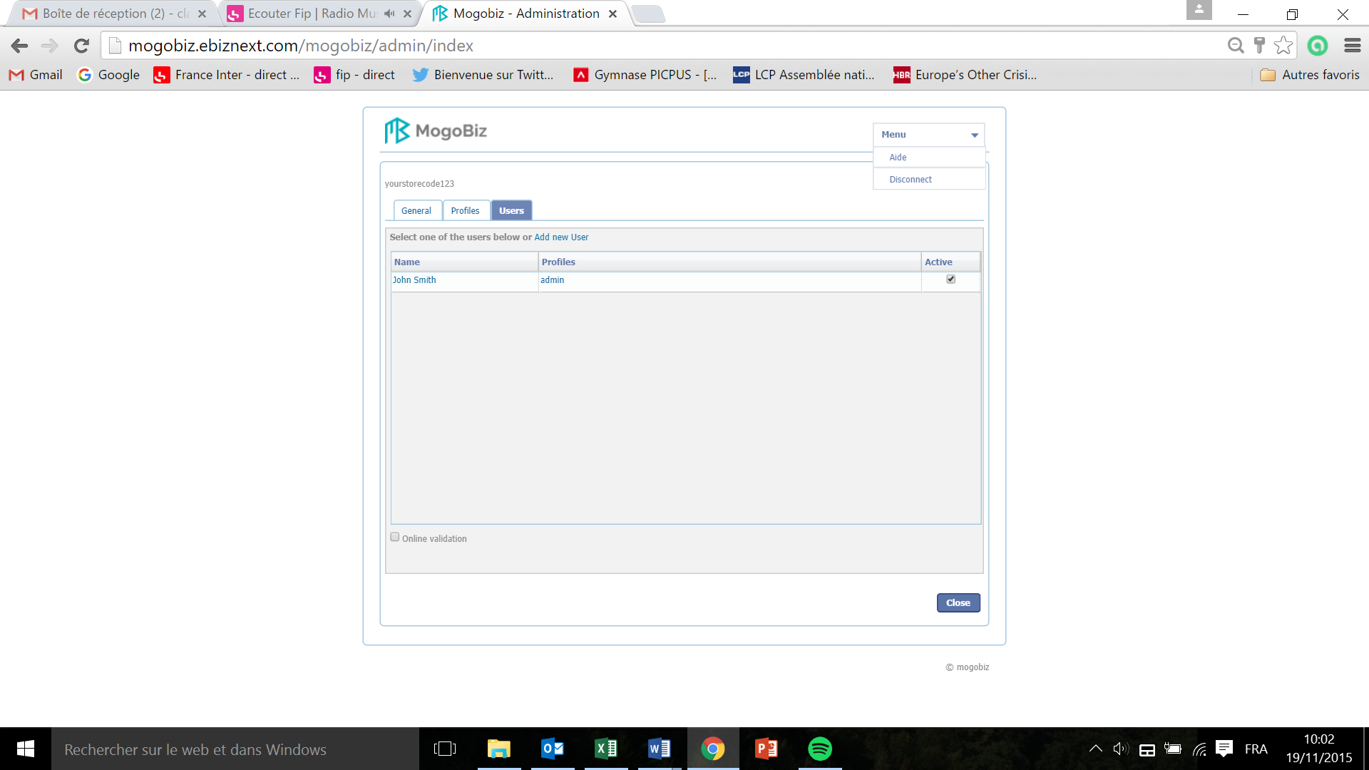

* At any time during your store creation, you can consult the Help section in the top right corner. Click on **Menu** and select **Aide** in the drop down menu.
* You can also choose to disconnect from the platform by selecting **Disconnect** in the drop down menu.

# Manage your store

Now that the administrator has created a store, users can manage them.



* Click on **My Store.**

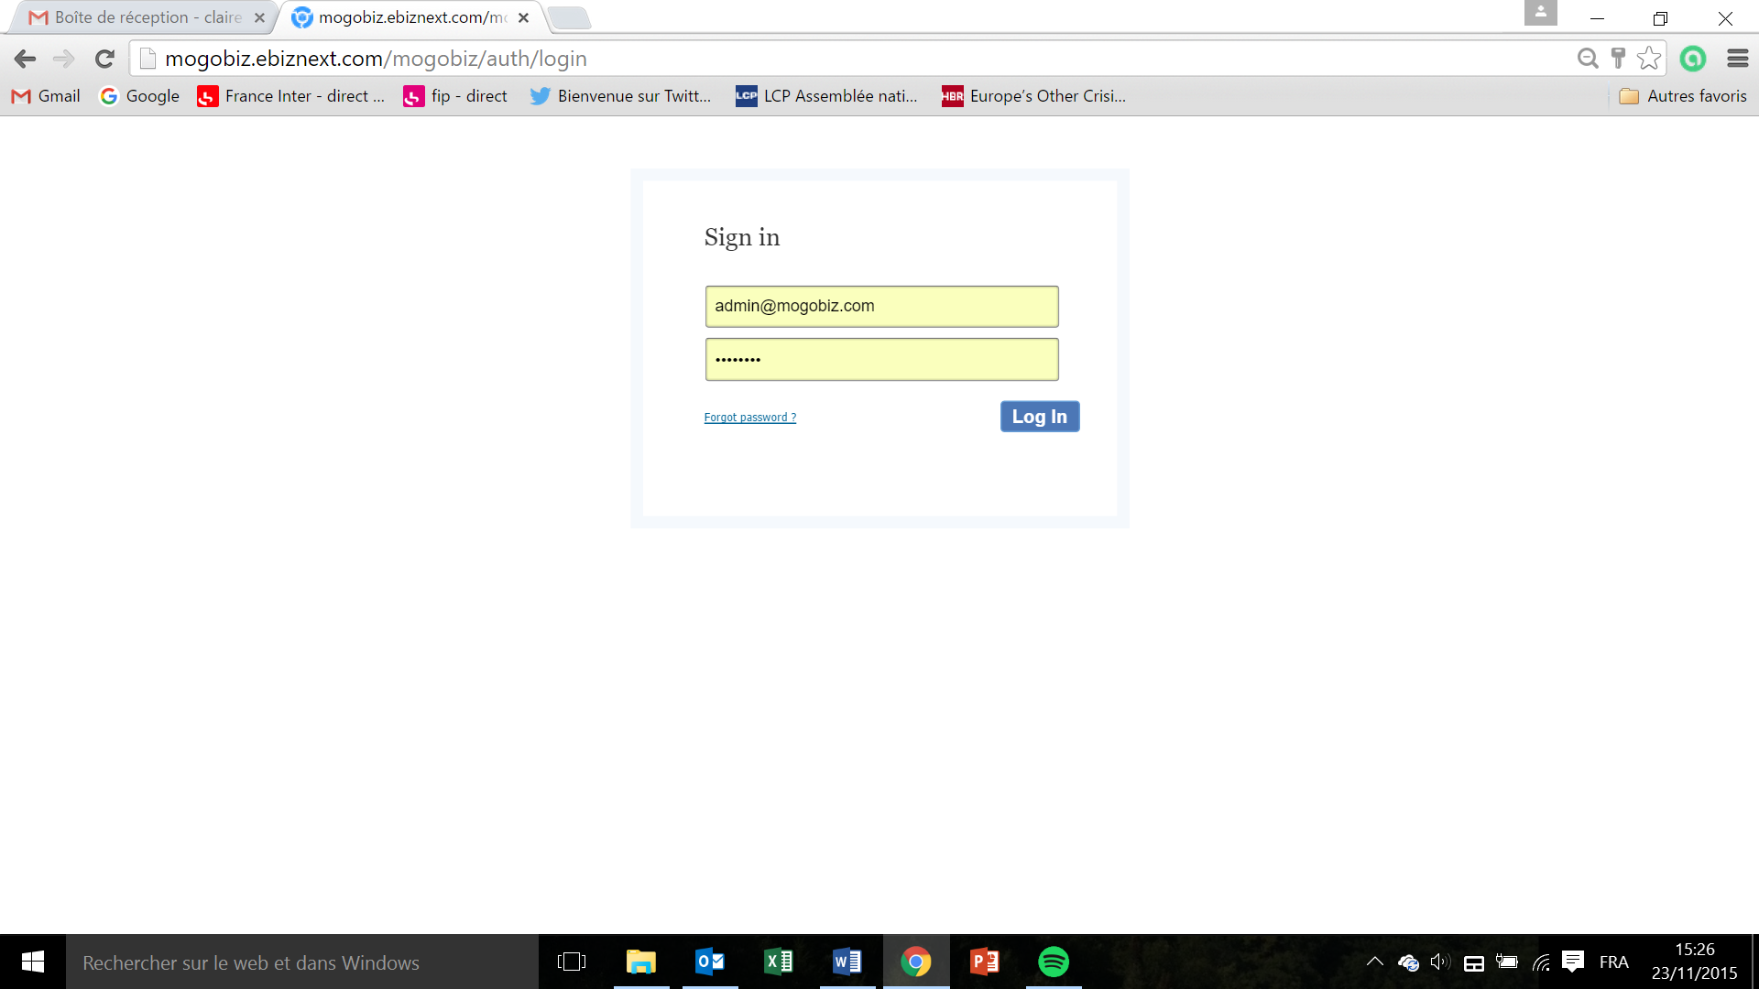

* Enter your email and password attributed by your administrator and sent to you by email, and click **Log In.**
* If you forgot your password click on **Forgot Password**

If you’ve clicked on **Forgot Password** :

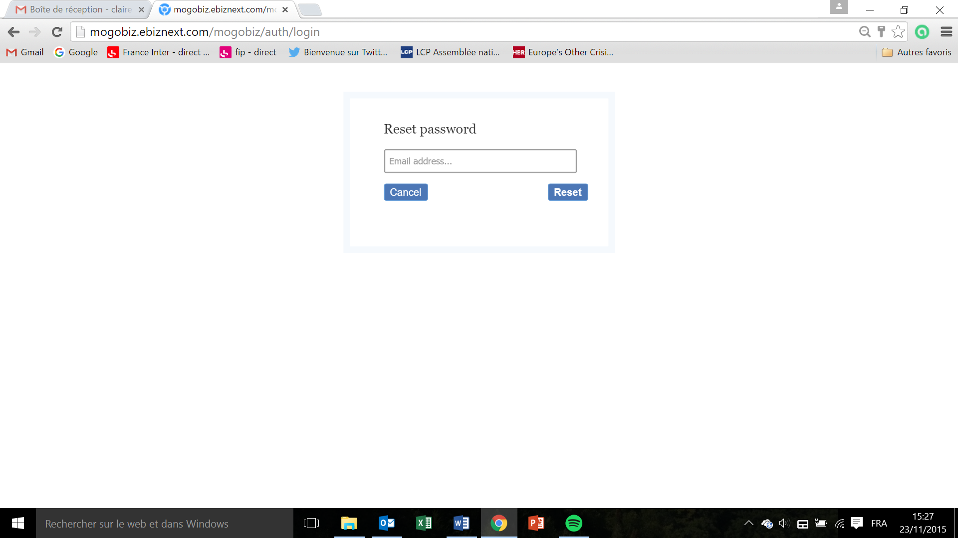

* Enter your email address in the **Email address** field
* A new password will be sent to you by email

## Presentation

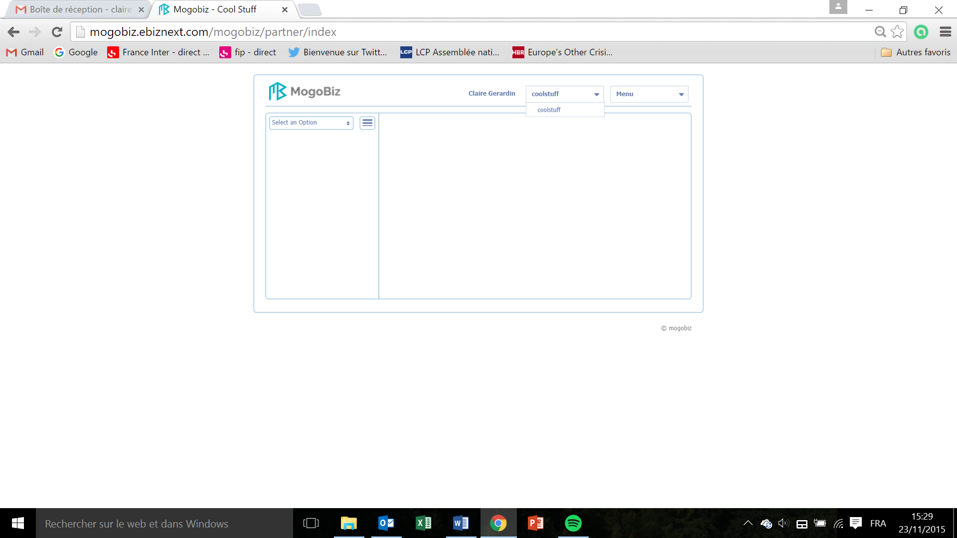

* As set up in the user’s profile, the user can access several stores from the top right drop down menu (here the “coolstuff” store is the unique accessible store by Claire Gerardin user) changer le nom du user?.

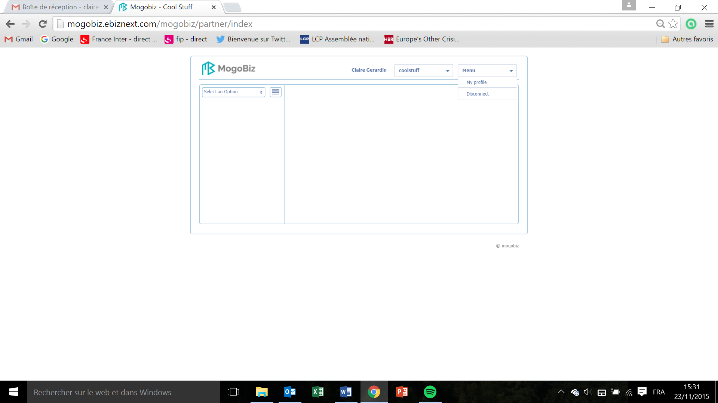

* The user can see its profile’s details

or

* The user can choose to disconnect from the far top right drop down menu by clicking on **Disconnect**, at any time.

Example of a user’s profile details (see the Users section to know how to create a user profile) :

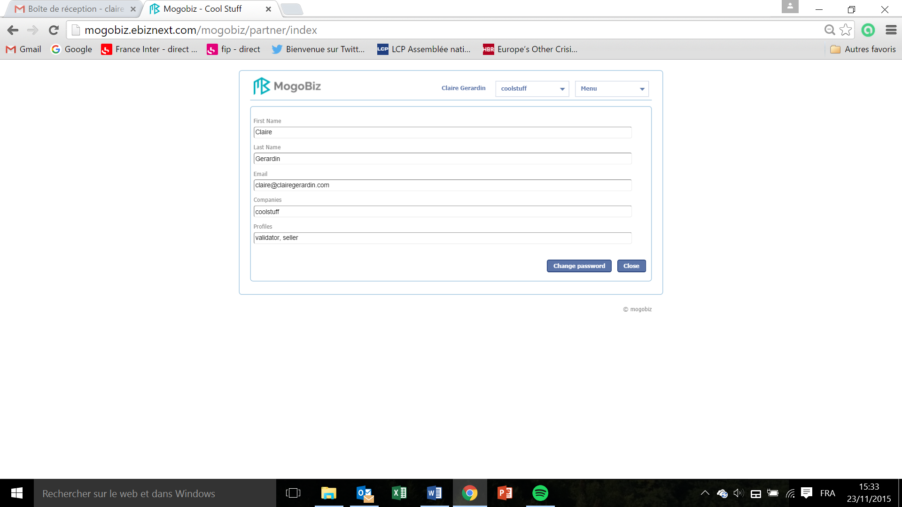

* Idem, peut on mettre un autre user que moi?
* Click on **Close** to close the user’s profile screen and go back to the Store management screen

Or

* Click on **Change Password** to reset your password

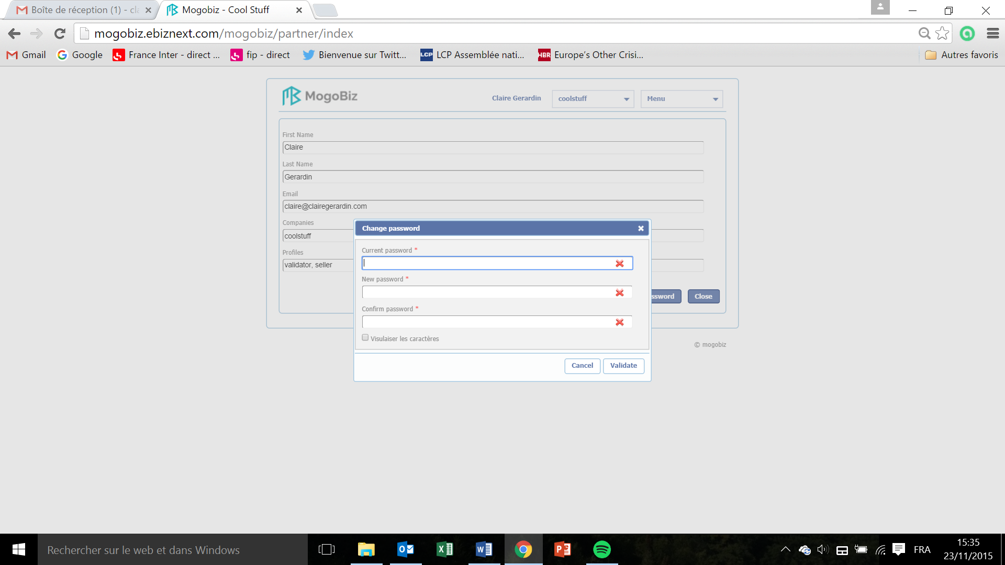

* In the window that pops up, enter your **current password**, **new password**, and **confirm** your new **password.**
* Tick on the **visualizer les caractères** box to visualize the password you are typing.

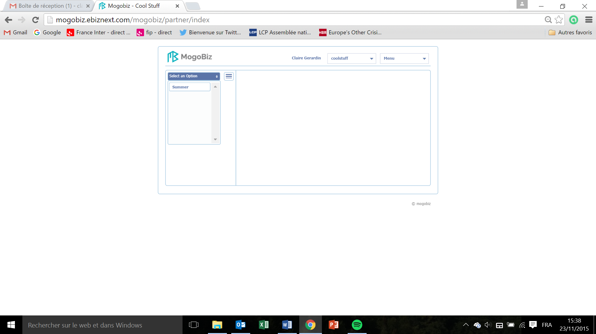

**Store name**: Logo on the top left. “MogoBiz” in this case.

**Catalog**: The drop down menu on the left lists all the catalogs created (see section Create a Catalog for Catalog creation), and enables to select the catalog to work on by clicking on it. Here there is one catalog: “Summer”.

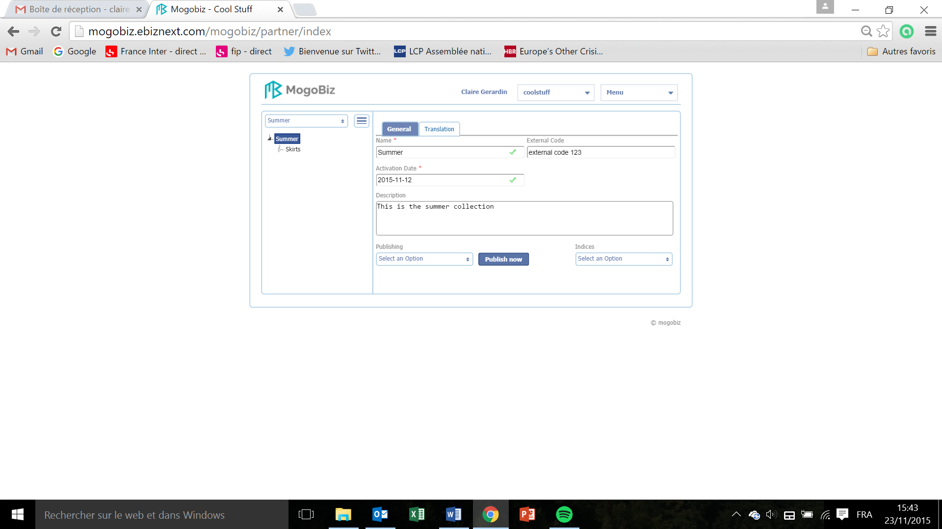

* Select the “Summer” catalogue in the left drop down menu.

**Categories**: The organizational tree on the left displays the list of categories (here “Skirts”). Features defined in a category are shared by all products of that category. (See section Create a product for products creation).

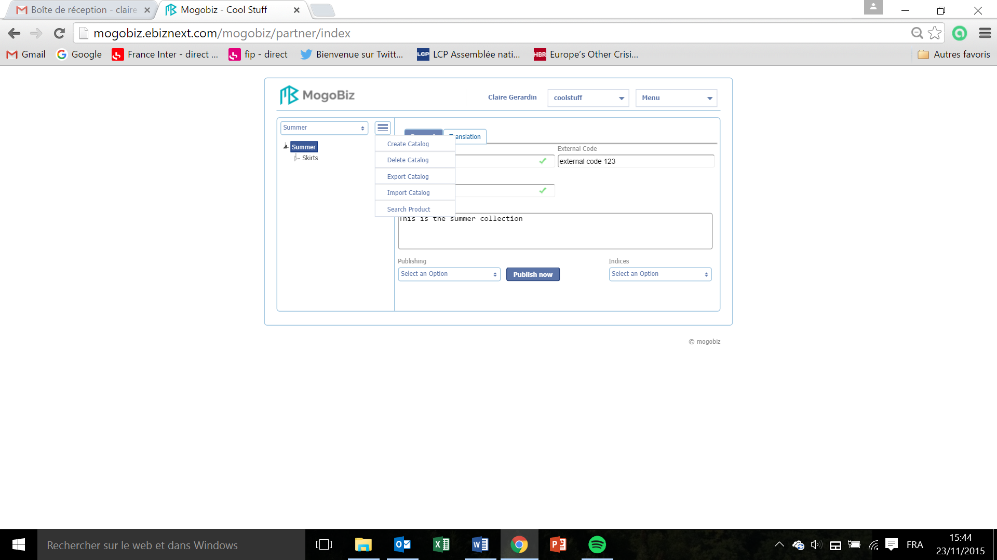

In the drop down menu next to “Summer”, on the top left corner:

* **Export Catalog** enables you to download your catalogue (with all its categories) in an Excel file, in order to ?
* **Import Catalog** enables you to upload a catalogue from your hard drive(?) in order to?. The import needs to be from an Excel /. csv file (?) where all the information is displayed according to the Mogobiz set up. This set up is available on ?

Create a catalogue  
  
This section describes how to create and delete a catalog for your online store.

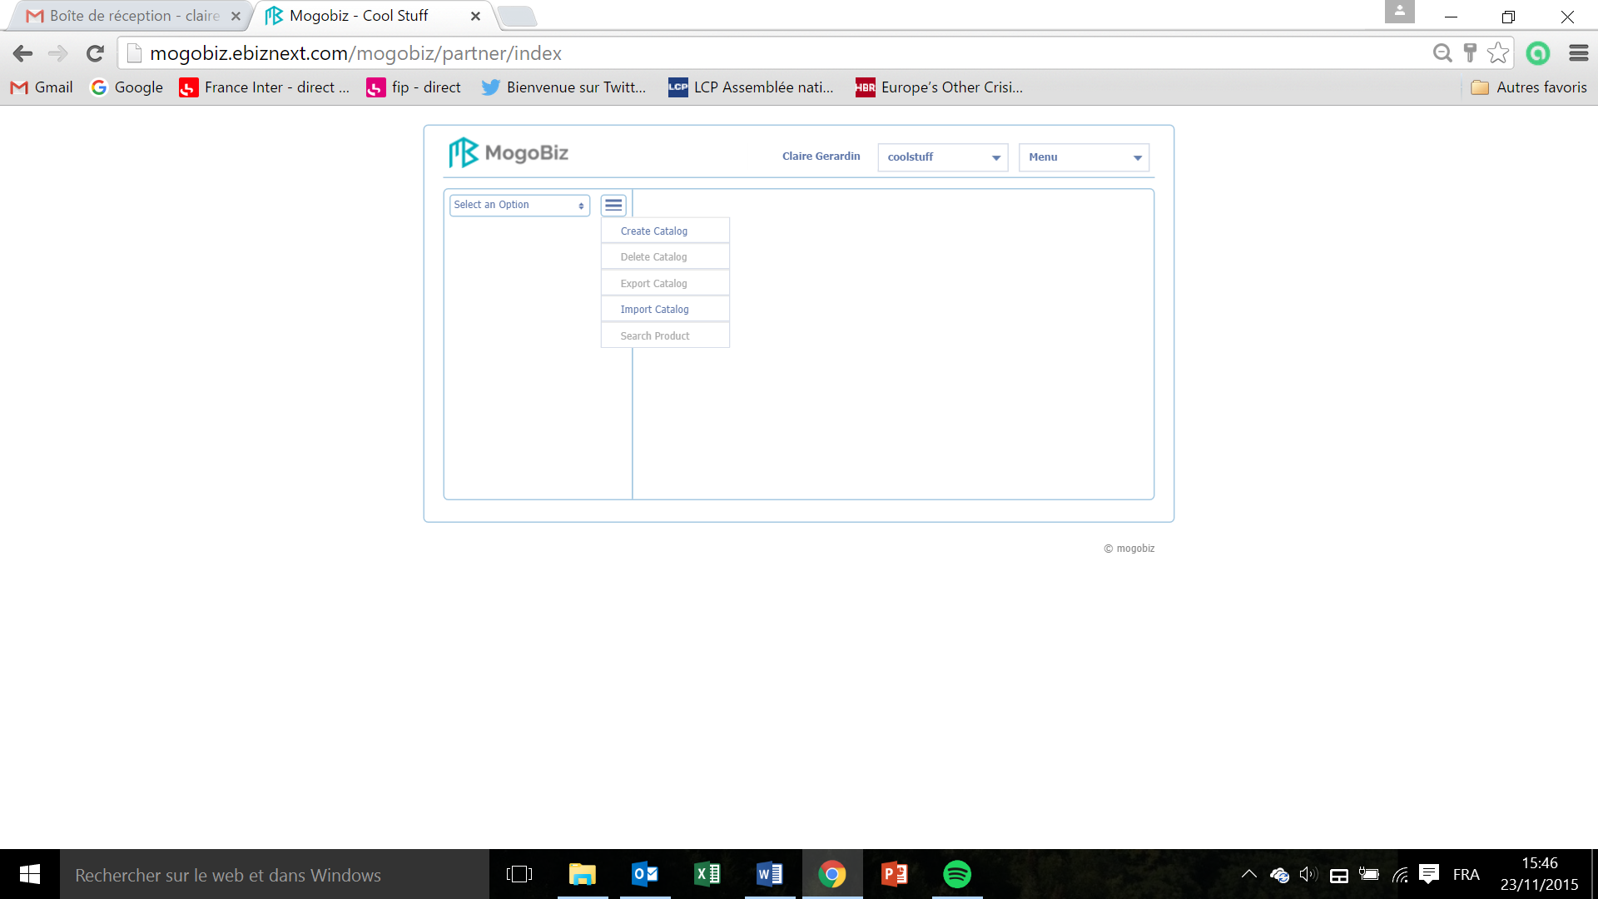

* On the My Store home page, click onthe **drop down menu** next to Select an option.
* In the drop down menu select **Create Catalog.**

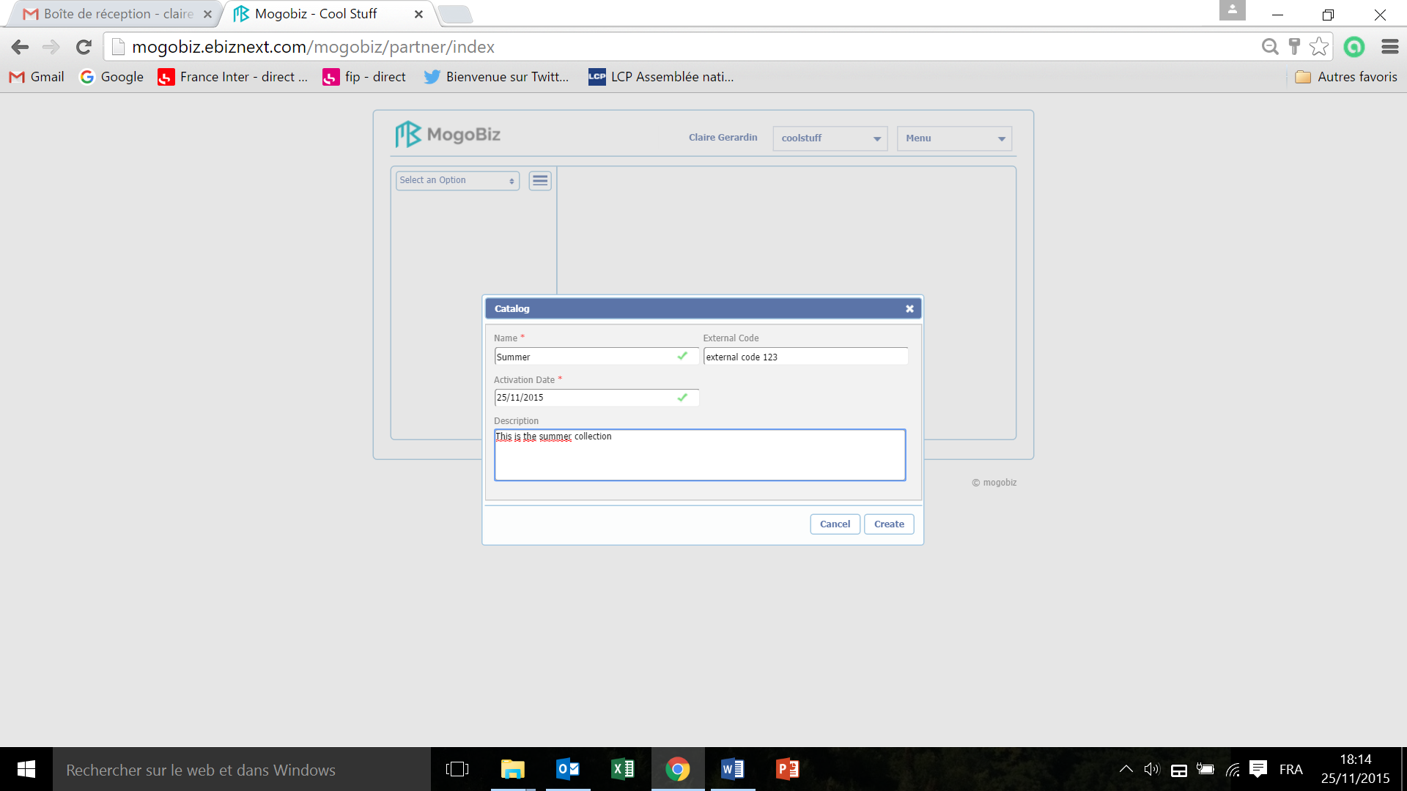

* Enter the **Name** of your catalog. This field is mandatory.
* Choose when this catalog needs to be online: enter the **Activation Date** of your catalog. This field is mandatory.
* Describe the content of your catalog by filling the **Description** field.
* The **External Code** is a unique code that you attributed when entering an item in the database. It can also corresponds to the UUID (Universal Unique Identifier) attributed by Mogobiz. ?
* Click on **Create** to create your catalog or on **Cancel** if you do not want to pursue the catalog creation.

This is how your Catalog screen will look like:

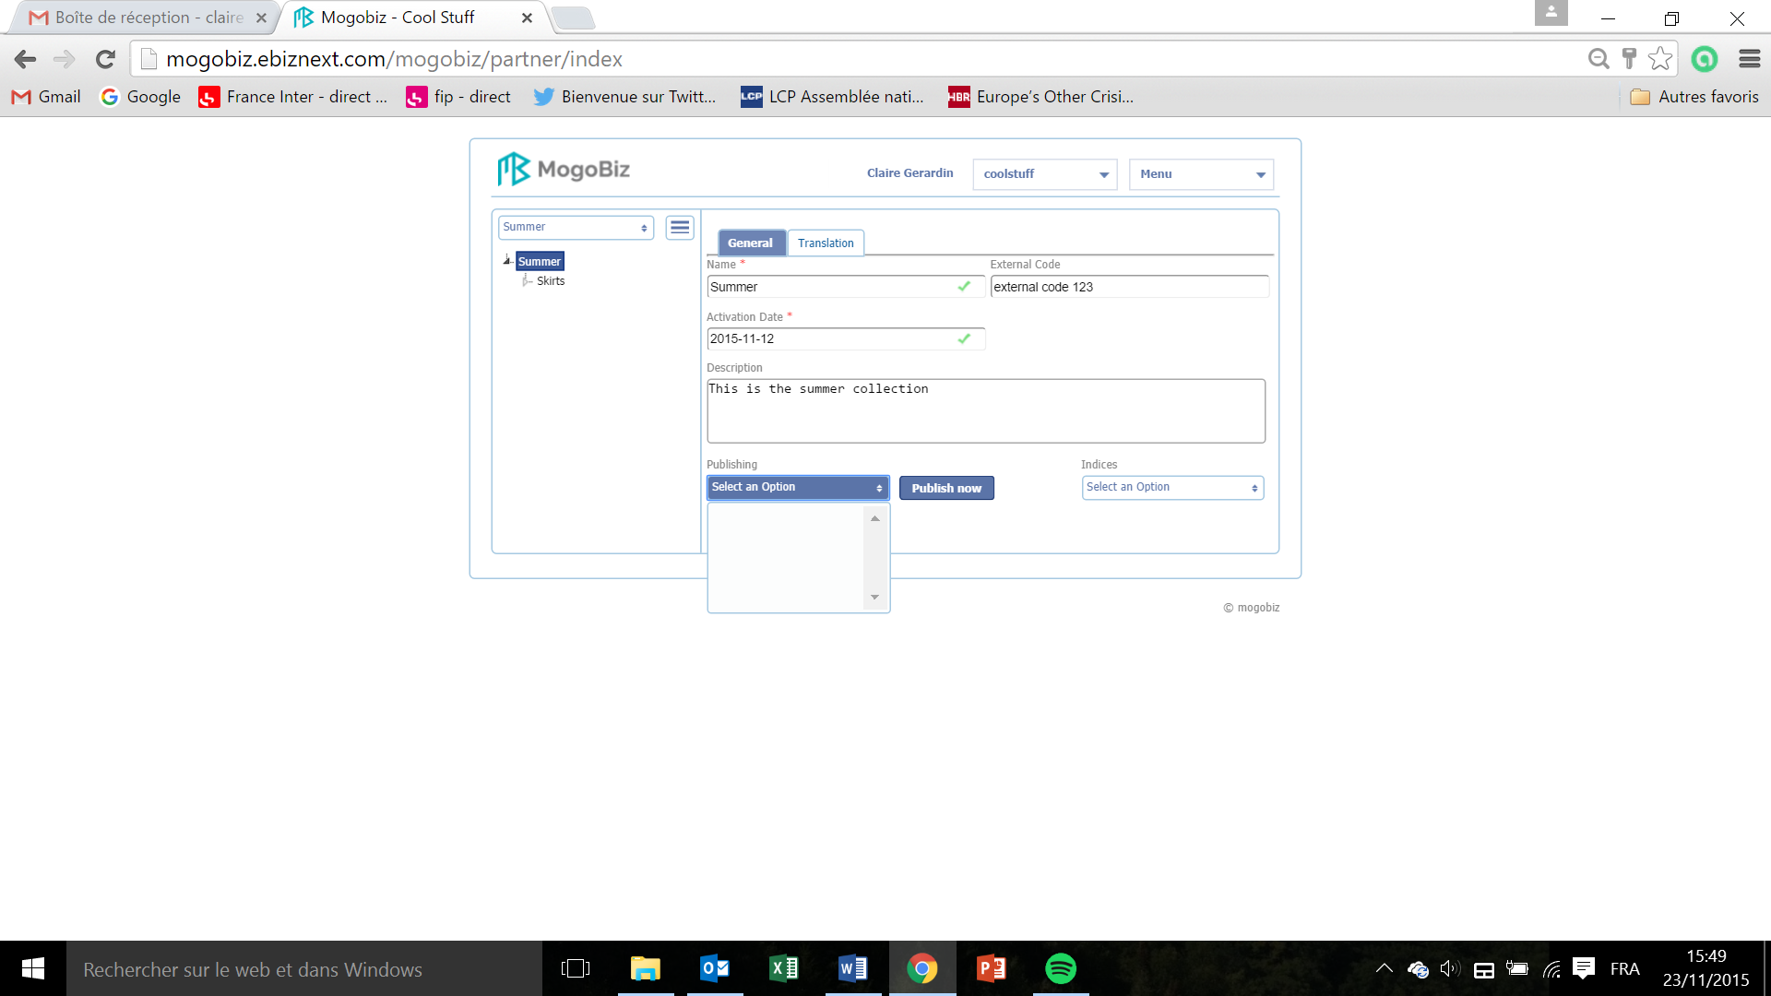

* In the **Publishing** drop down menu, publish your catalog by choosing its status. Click on vide ? and hit **Publish now**.The catalog will then be published on one of the urls created during the store creation phase (see Set up a store an manage users section).

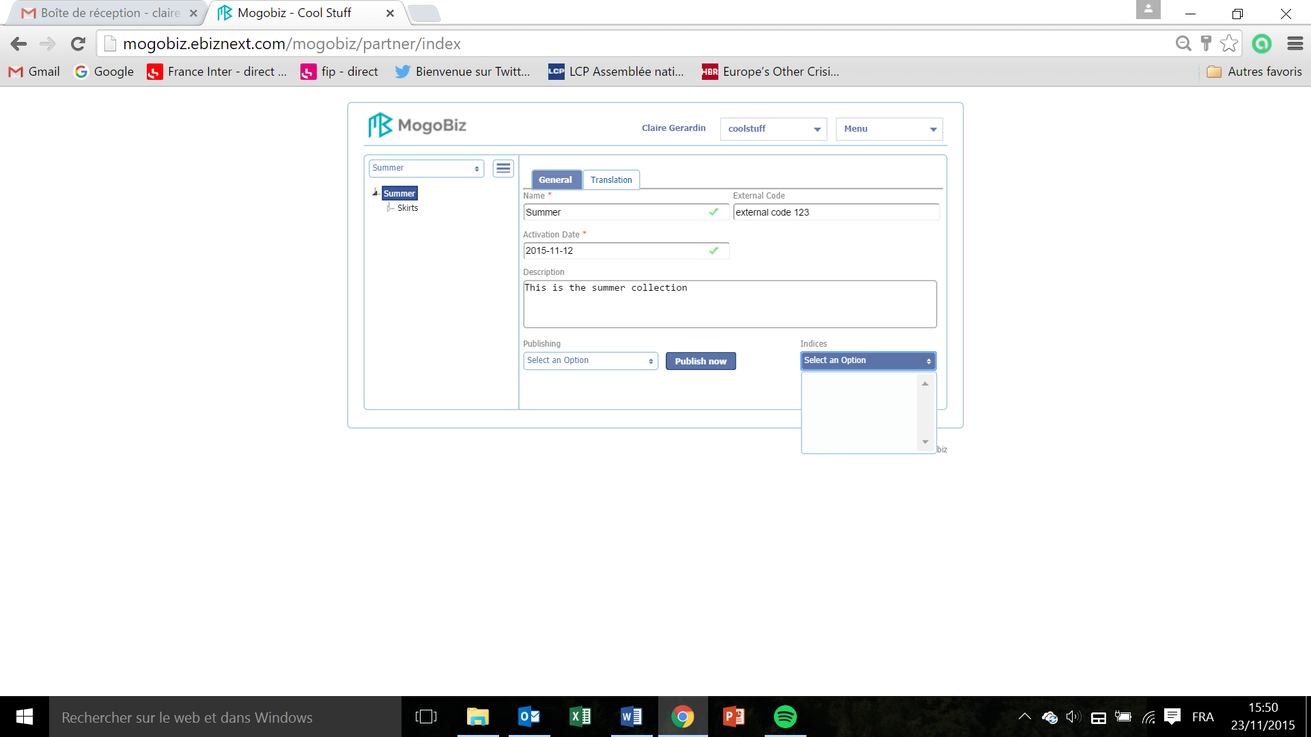

* In the **Indices** drop down menu, select an option ? in order to ?

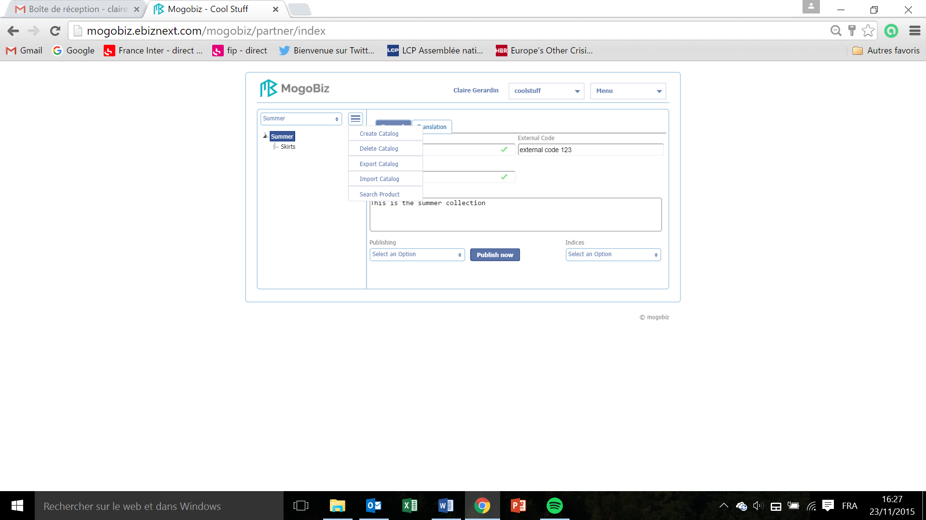

* To delete a catalog, on the drop down menu on the top left corner, select and click on **Delete.** Allthe products and SKUs created under this catalog will be deleted too.

For the Translation tab, see the Translation section.

# Create categories

This section describes how to create a category in your catalog for your Mogobiz online store.

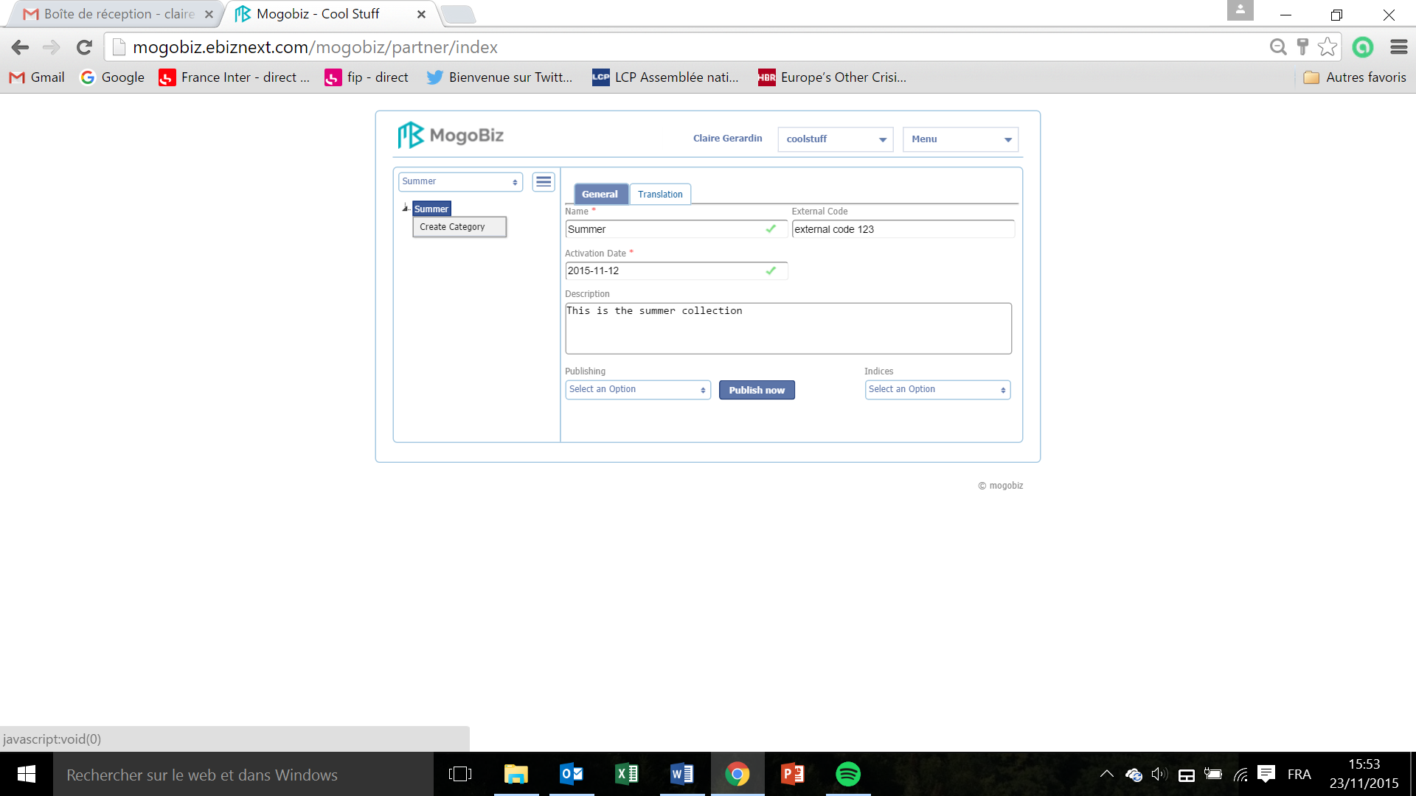

* To create a category, right click on your catalogue’s name in the menu on the left and select **Create Category.**

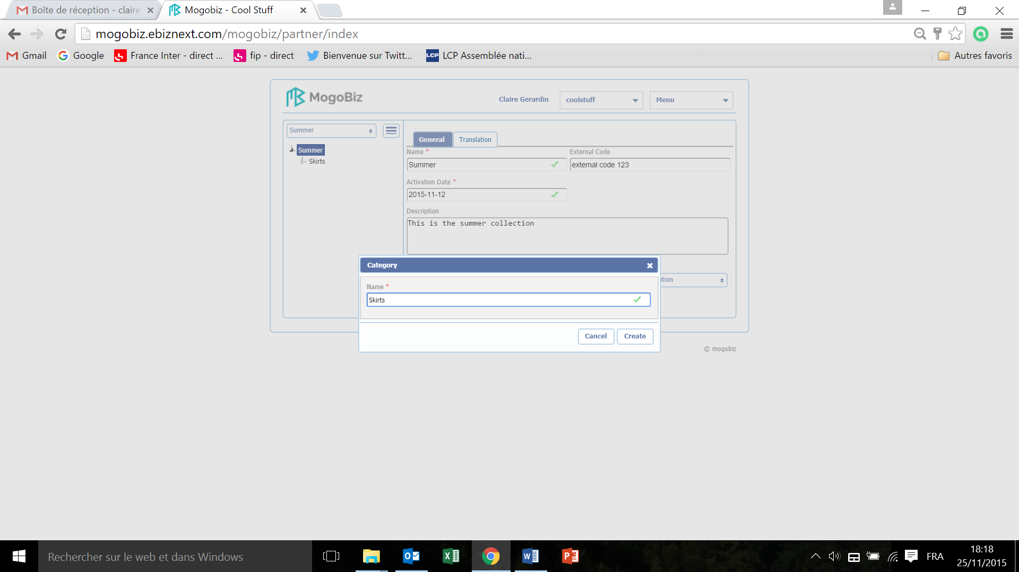

* In the window that pops up, enter the **Name** of you category. This field is mandatory.
* Click on **Create** or on **Cancel** if you do not want to pursue the category creation.

This is how your General screen will look like:

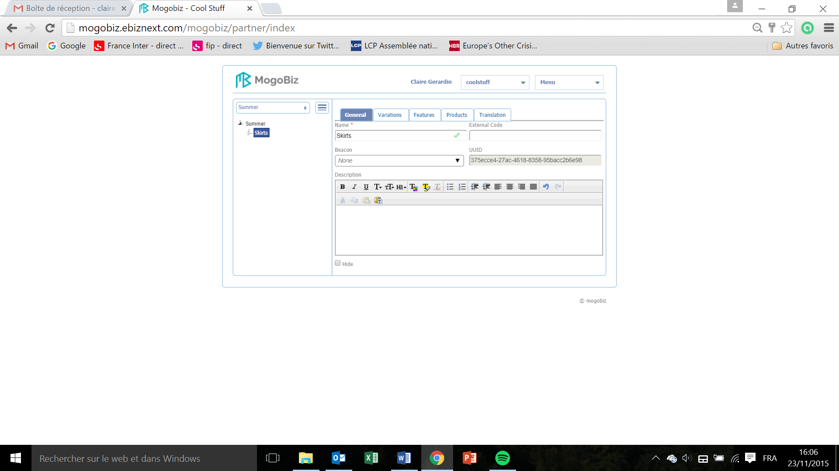

General  
  
This section defines the general settings of your category.

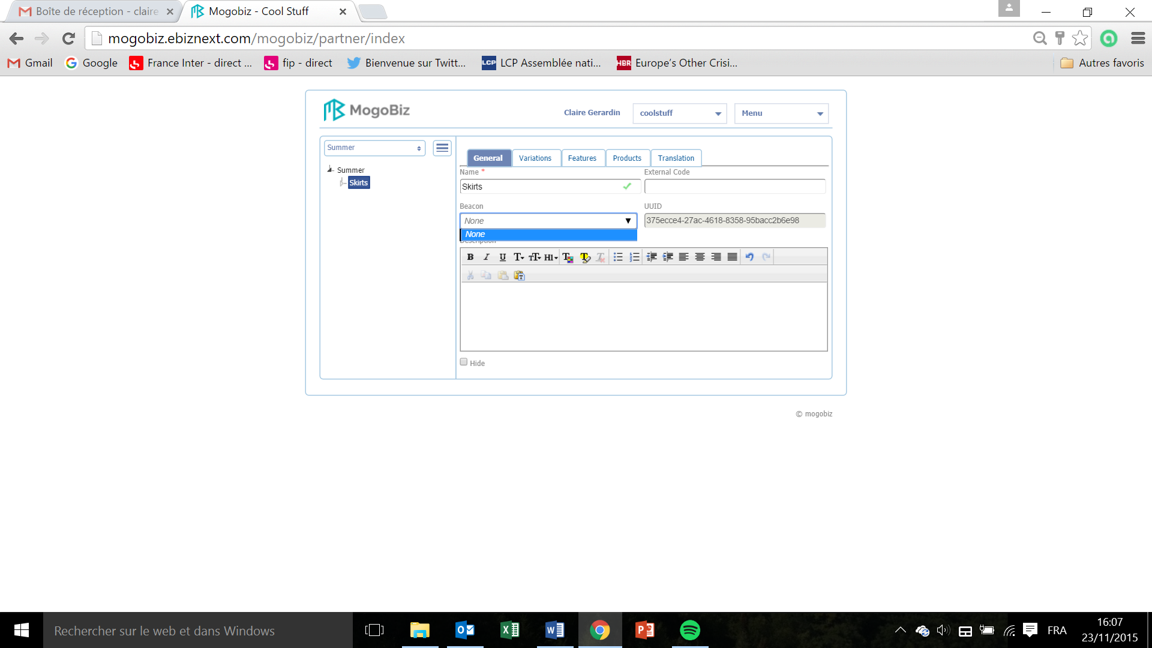

* Enter the **External Code** that you attributed to the item when entering it in the database or Mogobiz can automatically attribute a **UUID** (Universal Unique Identifier).
* Select a **Beacon** in the drop down menu in order to ? section vide
* Describe the content of your category by filling the **Description** field.

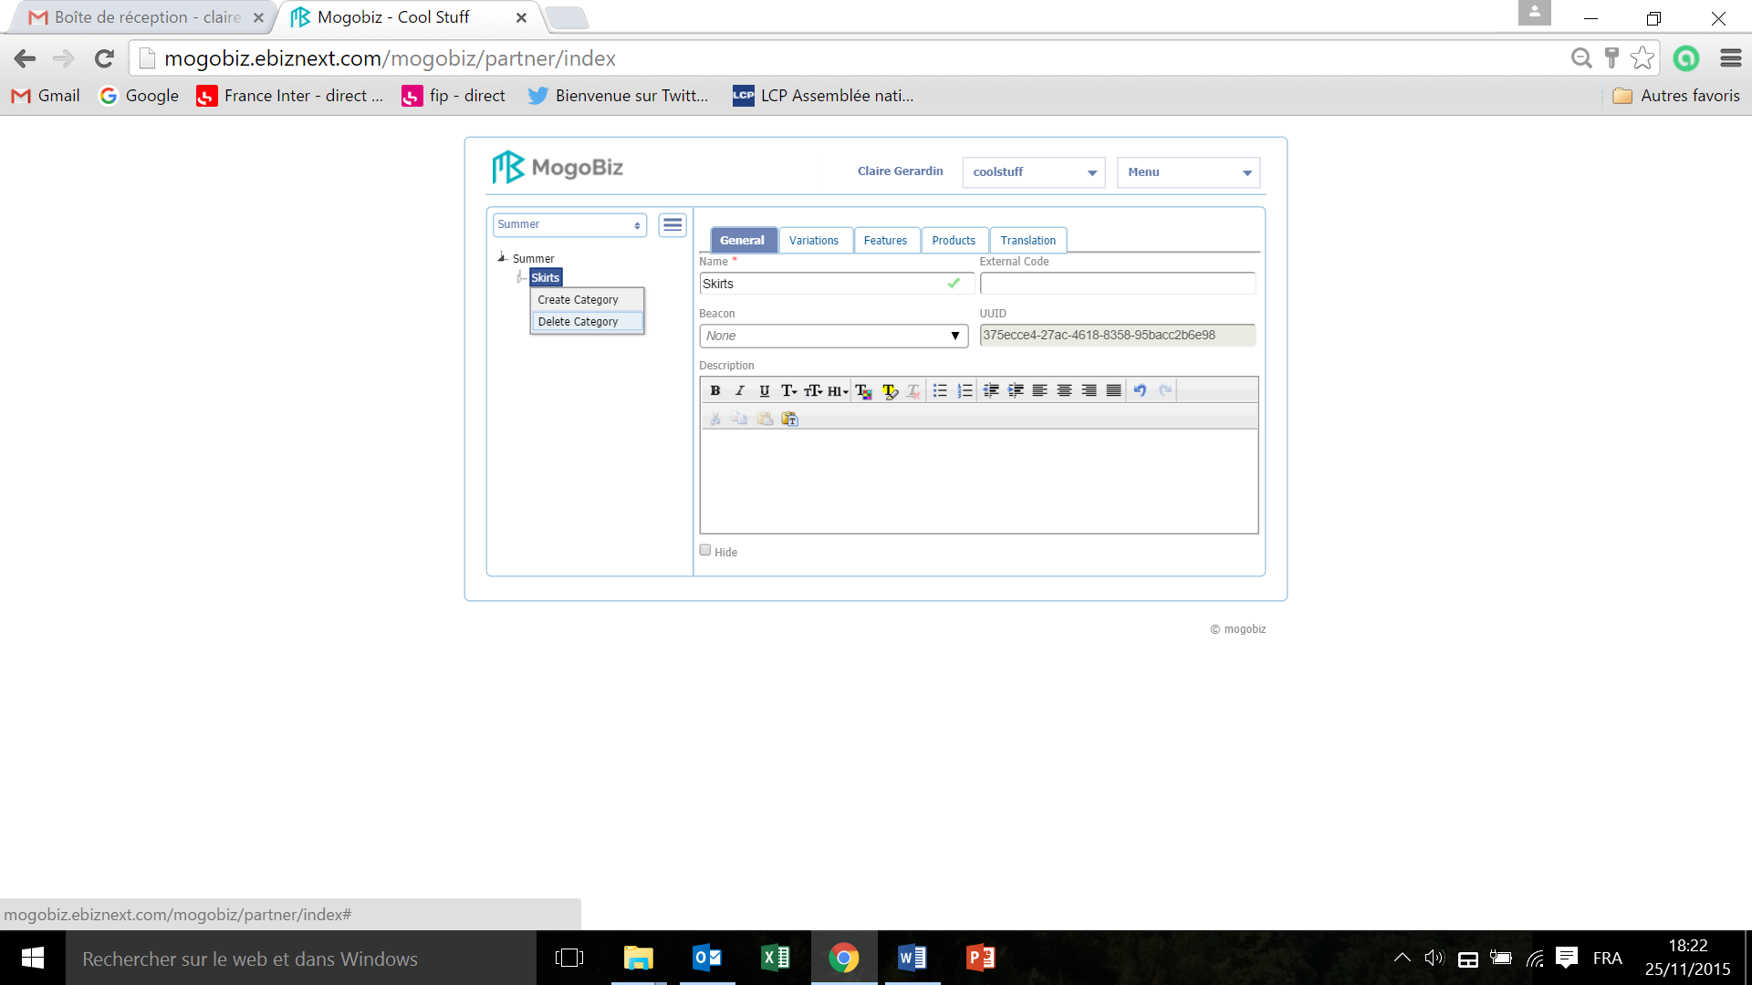

* To delete a category, click on its name in the menu on the left, select and click on **Delete Category.** Allthe products and SKUs created under this category will be deleted too.   
  Il y a dans ce menu déroulant de nouveau “create a category », et quand j’essaie d’en créer une ca ne fonctionne pas

### Variations

This section defines all the variations, which are the product/service properties values - that will vary according to customers’ orders and stock availability - an item can have (colors, sizes etc.).

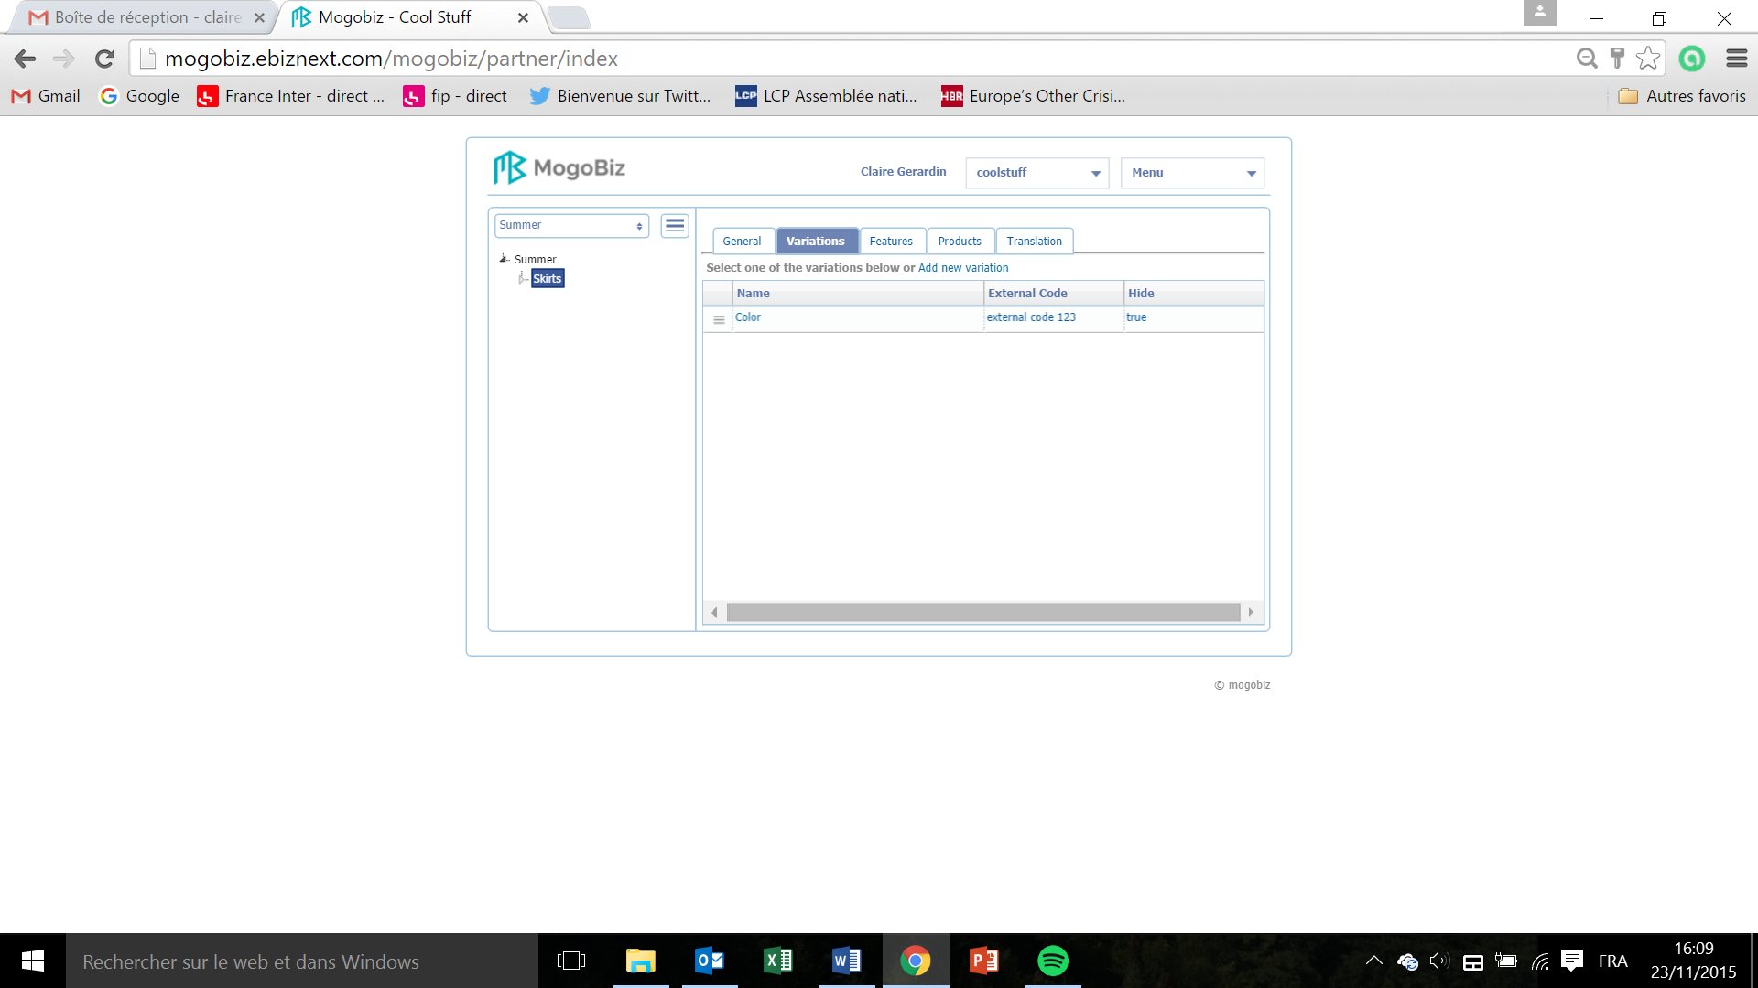

* To create a variation, click on **Add a new** **Variation.**

Je ne peux pas mettre une copie d’écran vide (sans variation) parce que je n’arrive pas à supprimer cette variation (lorsque je supprime les produits créés ils ne sont pas supprimés).

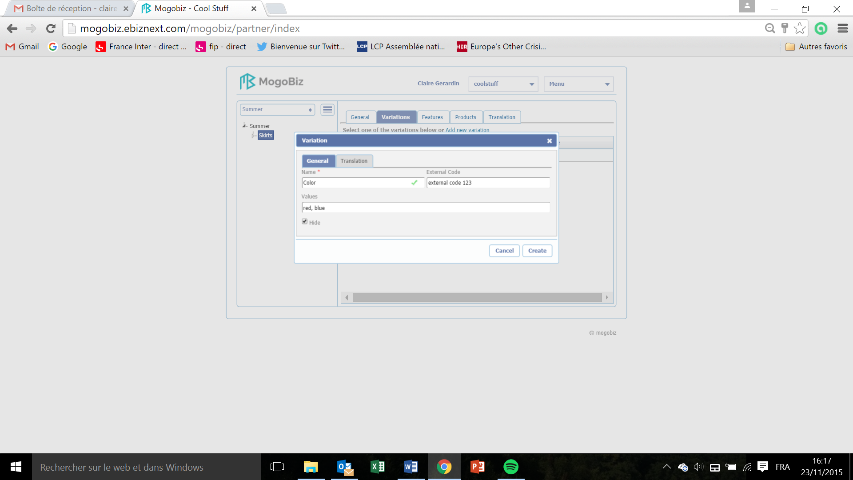

* Enter the **Name** of the item variation in the **General** tab: color, size etc. This field is mandatory.
* Enter the **Values** of these variations: red, blue etc.
* Enter the external code that you attributed to this item when entering it in the database.
* You can choose to hide those variations on your ecommerce site by ticking off the box **Hide.**
* Click **Modify** to save your variations settings,or on **Cancel** if you do not want to pursue the variation creation.

This is how you Variation screen will look like:

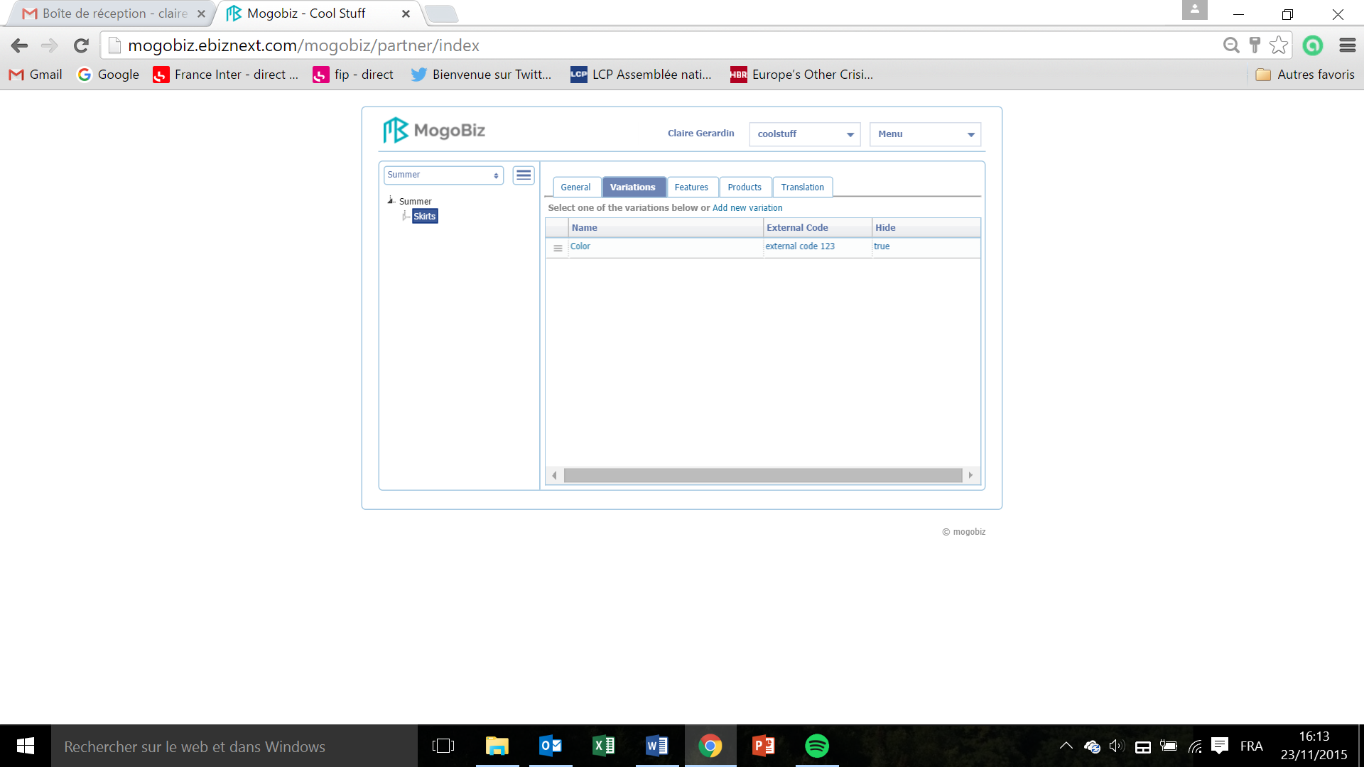

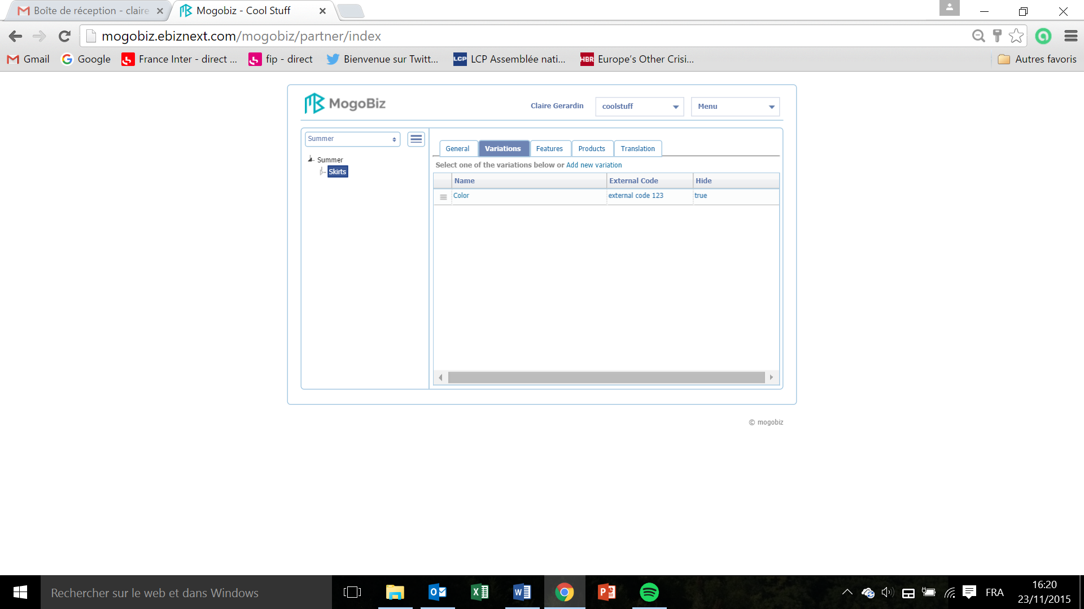

* To delete a variation, click on the variation to be deleted in the Variation screen

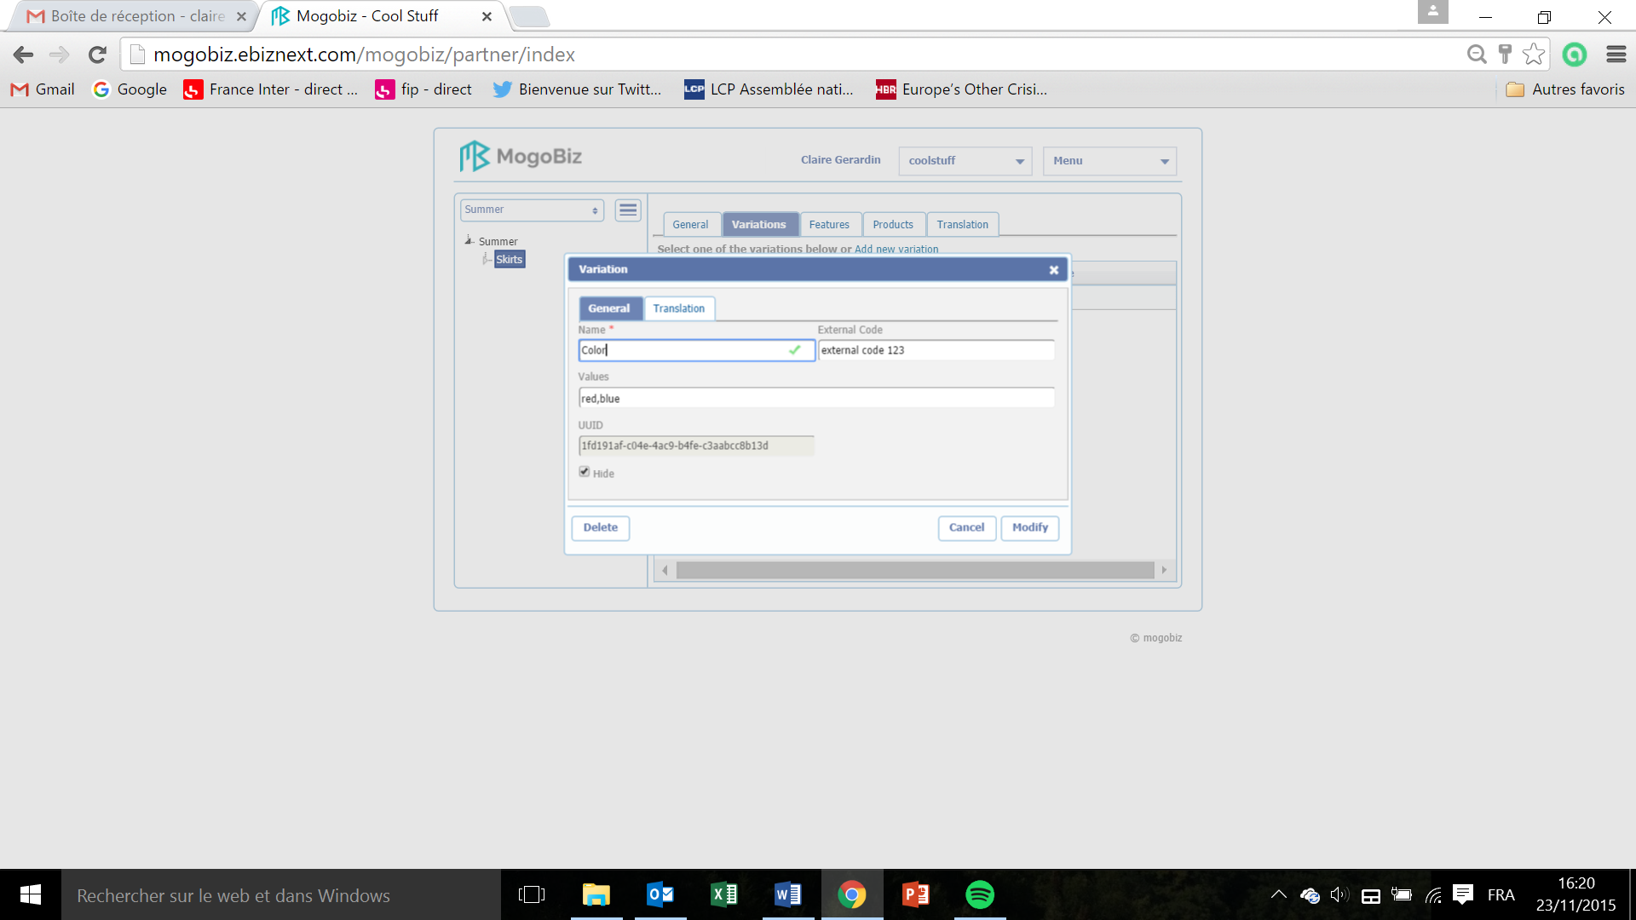

* Click on **Delete**.

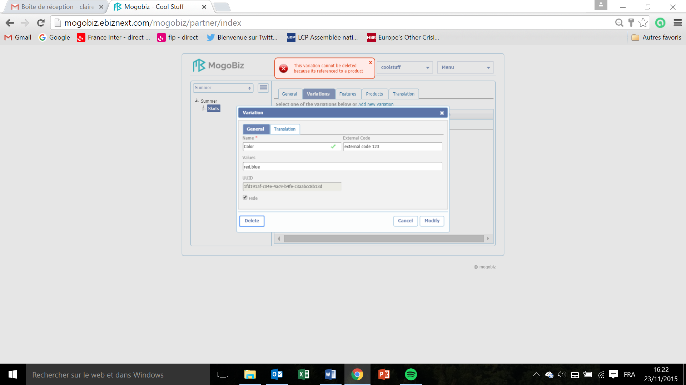

* You cannot delete a variation that is already attributed to a product in the Product section. You need to first delete the product(s) referenced in the product section.

### Features

This section defines all the features, which are product/services properties an item can have and that will never vary.

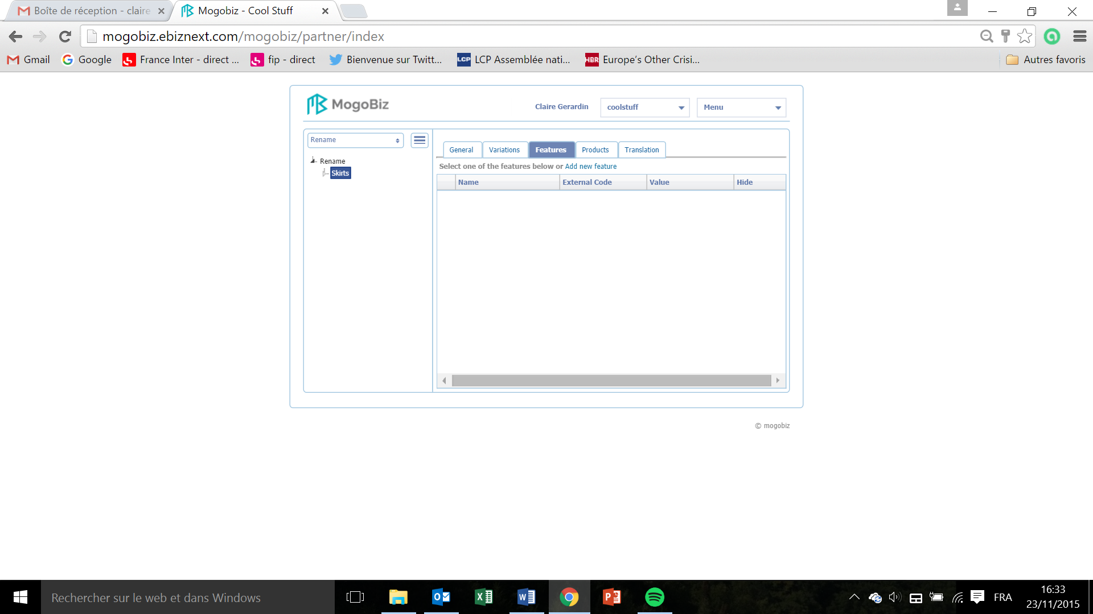

* To create a Feature, click on **Add new feature**.

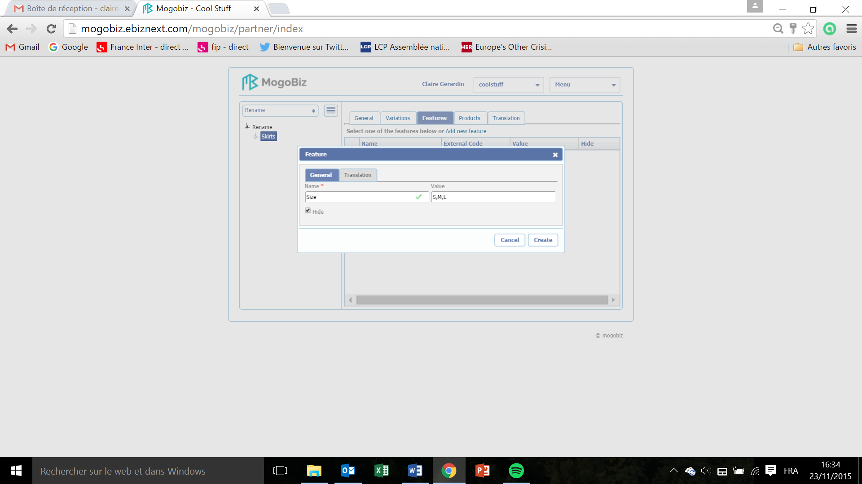

* Enter the **Name** of the feature (color, size etc.) in the **General** tab. This field is mandatory.
* Enter the **Value** of the feature (S,M,L etc.).
* You can choose to hide those features on your ecommerce site by ticking off the box **Hide.**
* Click on **Create** to save the feature settingsor on **Cancel** if you do not want to pursue the feature creation.

This is how your Features screen will look like:

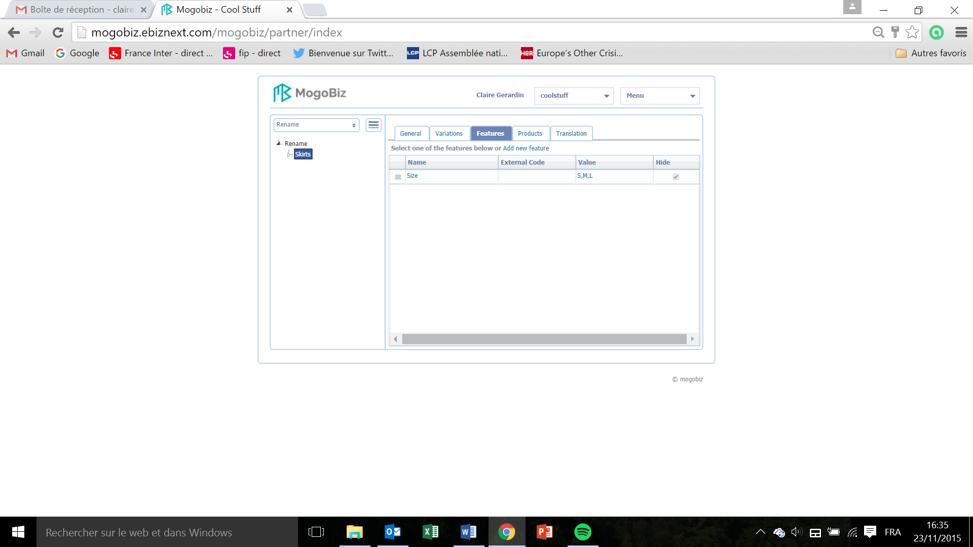

# Create products

This section describes how to create the products/services that will be displayed on your Mogobiz online store, belonging to the category created in the catalog.

## Product Creation

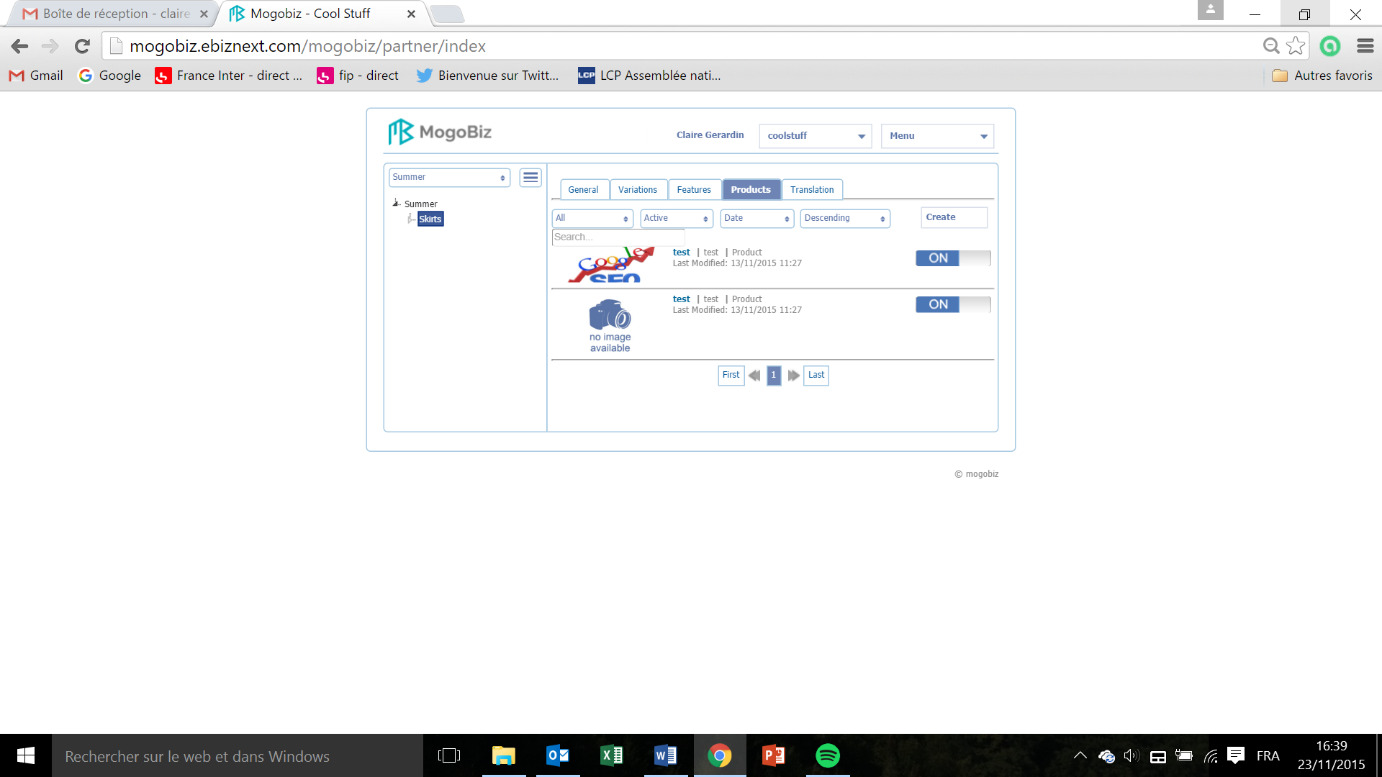

* To create a product click on **Create.** Même problème que mentionné plus haut: impossibilité de supprimer les produits

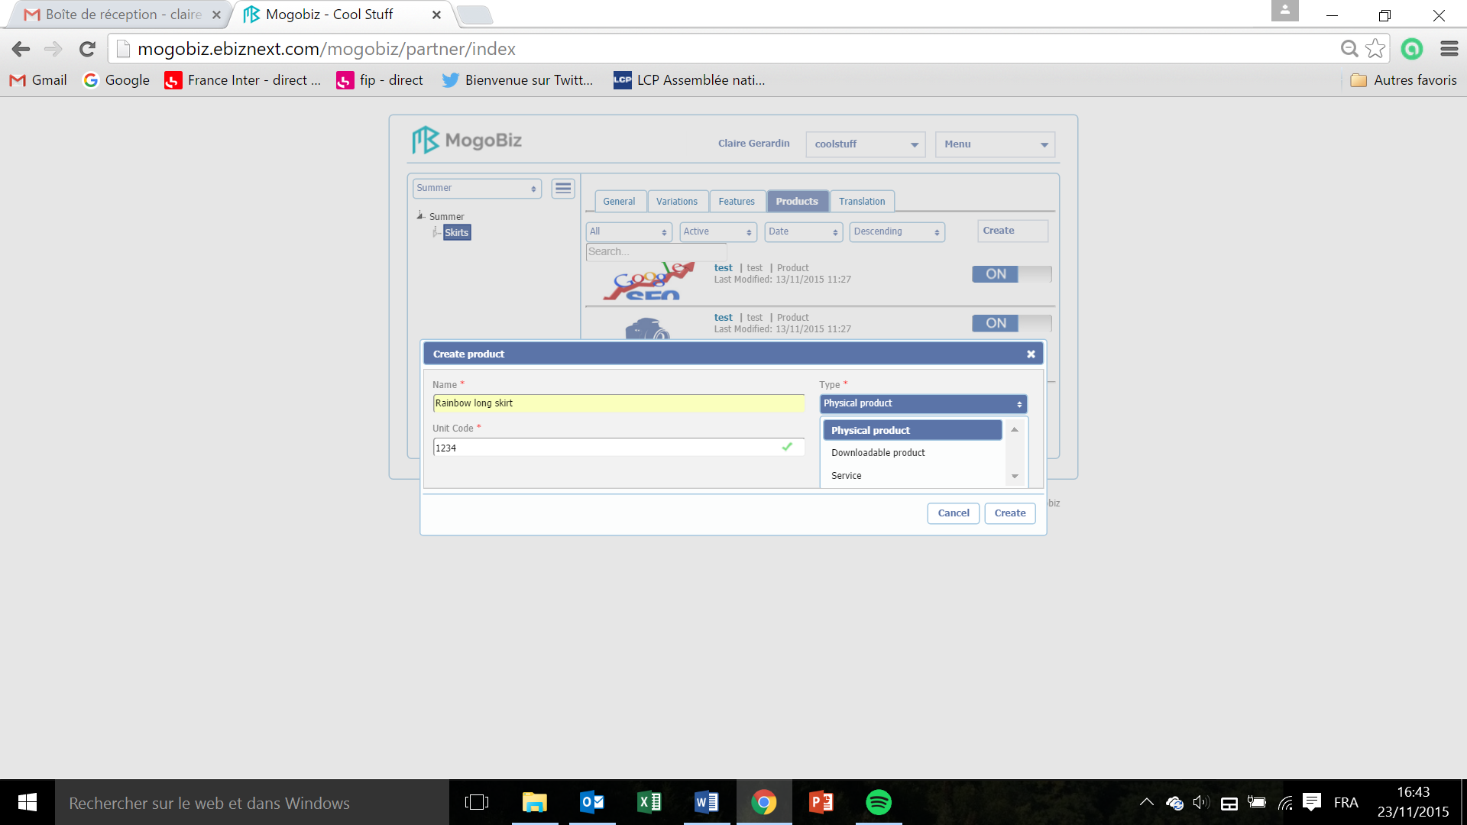

* Enter the product name in the **Name** field. This field is mandatory.
* Enter the unit code attributed during the store creation?. This field is mandatory.
* Select the type of product from the drop down menu **Type: Physical product**, **Downloadable product**, or **Service**. This field is mandatory.
* Click on **Create** to save your product creation or on **Cancel** if you don’t want to pursue.

## Product Description

This section describes the product/service created in the Product Creation section.

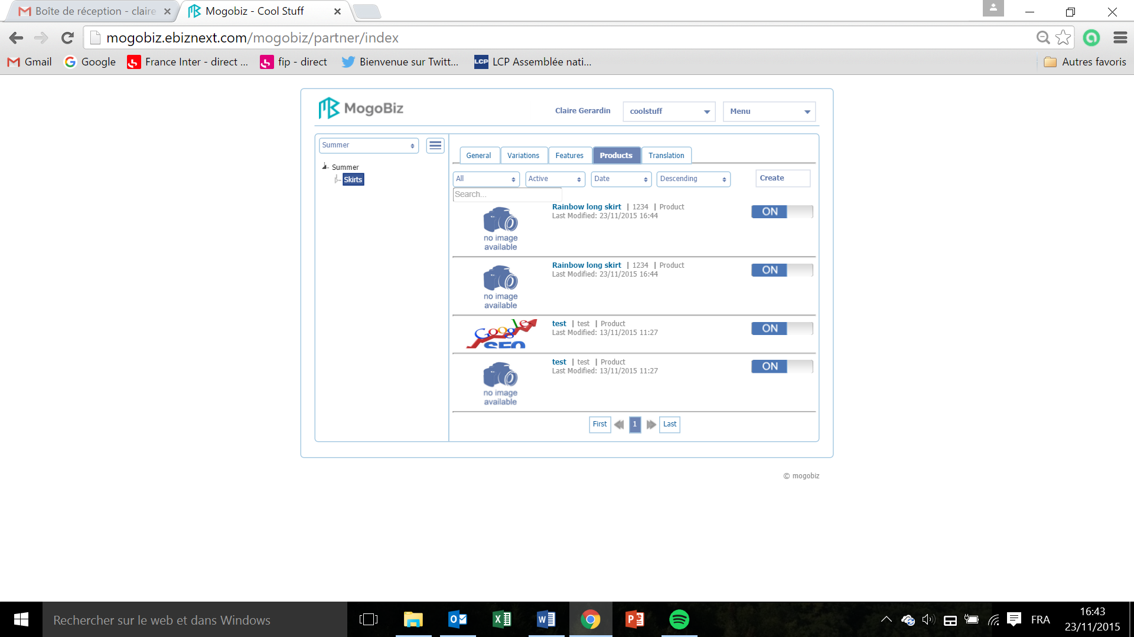

* Click on the product you created to create its settings.

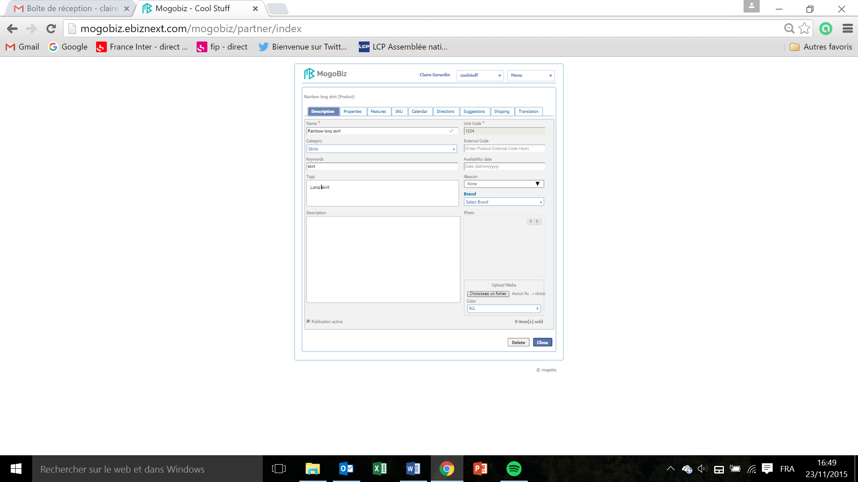

* The **Name** field is automatically populated with the product name you created during the product creation process.
* The **Category** field is automatically populated with the category name you created during the category creation process.
* Enter the tags for this product in the **Tags** field. A tag will create a cross a category that includes products created in other categories.
* The **Unit Code** attributed during the product creation will be populated automatically.
* Enter ? the **External Code** of the product, which is the unique code that you attributed when entering the item in the database.
* In the **Availability date** field, enter the availability date of the product.
* In the field **iBeacon** select the one you created during the category creation. Pas de choix de Beacon possible, et nommée Beacon dans catégorie et non iBeacon
* In the field **Brand** select in the drop down menu the brand of the product. The brands were created during the ? process (see section xx).

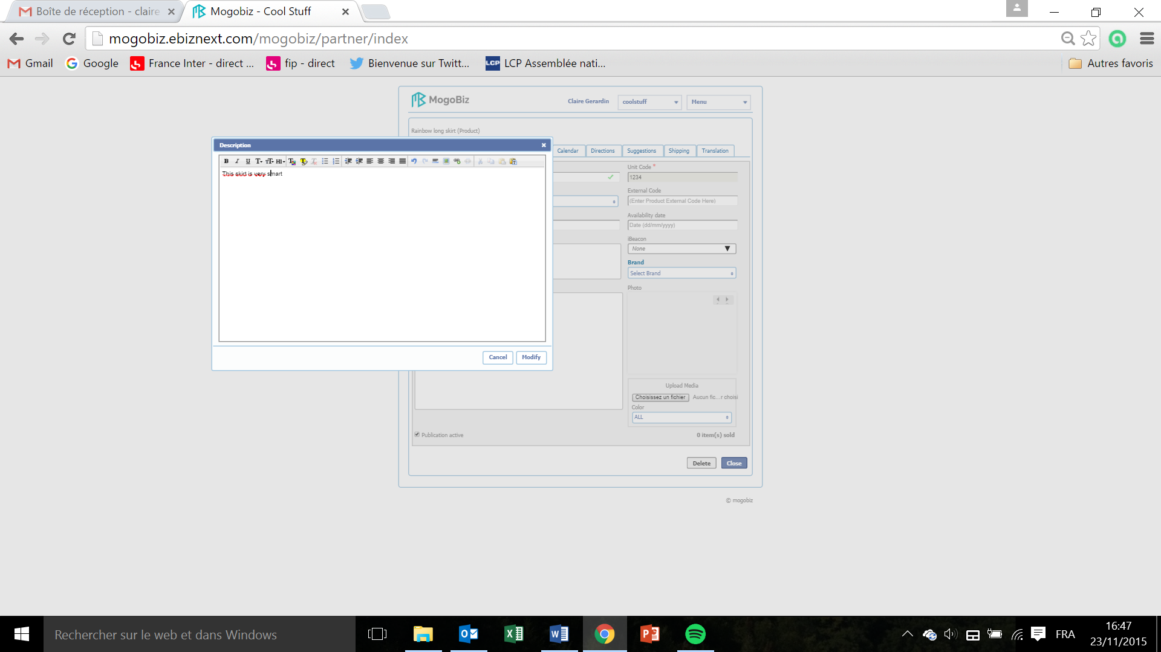

* To enter a product description click in the **Description** space.
* Enter the description of the product, type in up to XXX characters.
* Click on **Modify** to save your description or **Cancel** if you don’t want to pursue.

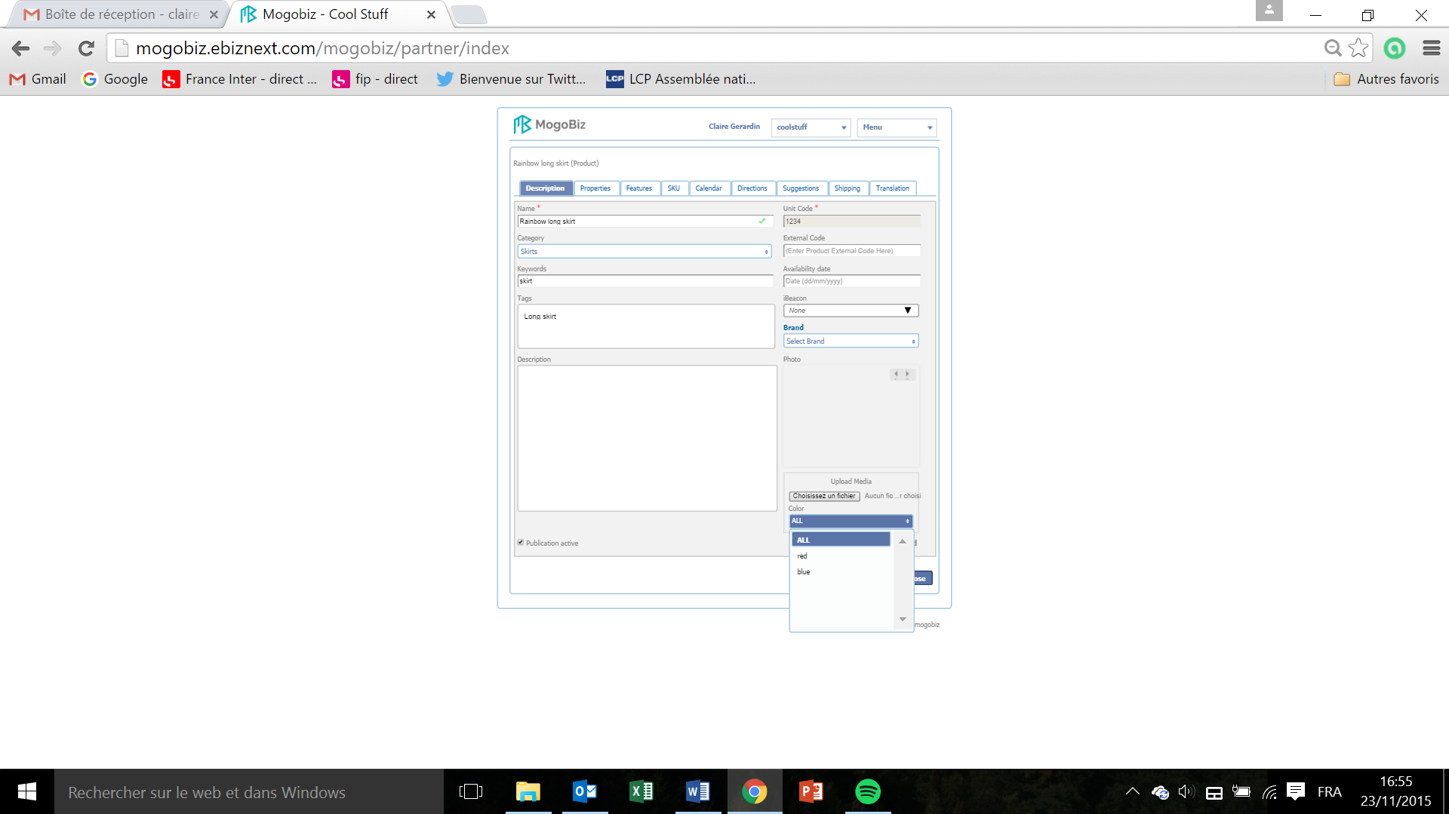

* Click on **Choisissez un fichier** in the **Photo** field to upload a picture to illustrate the product/service or download.
* Browse through your files and select a picture.
* In the **Color** drop down menu, select the variations - created in the product creation process - to which the image is associated. For example your image is a red skirt, and will only be displayed to illustrate the skirt product in red.

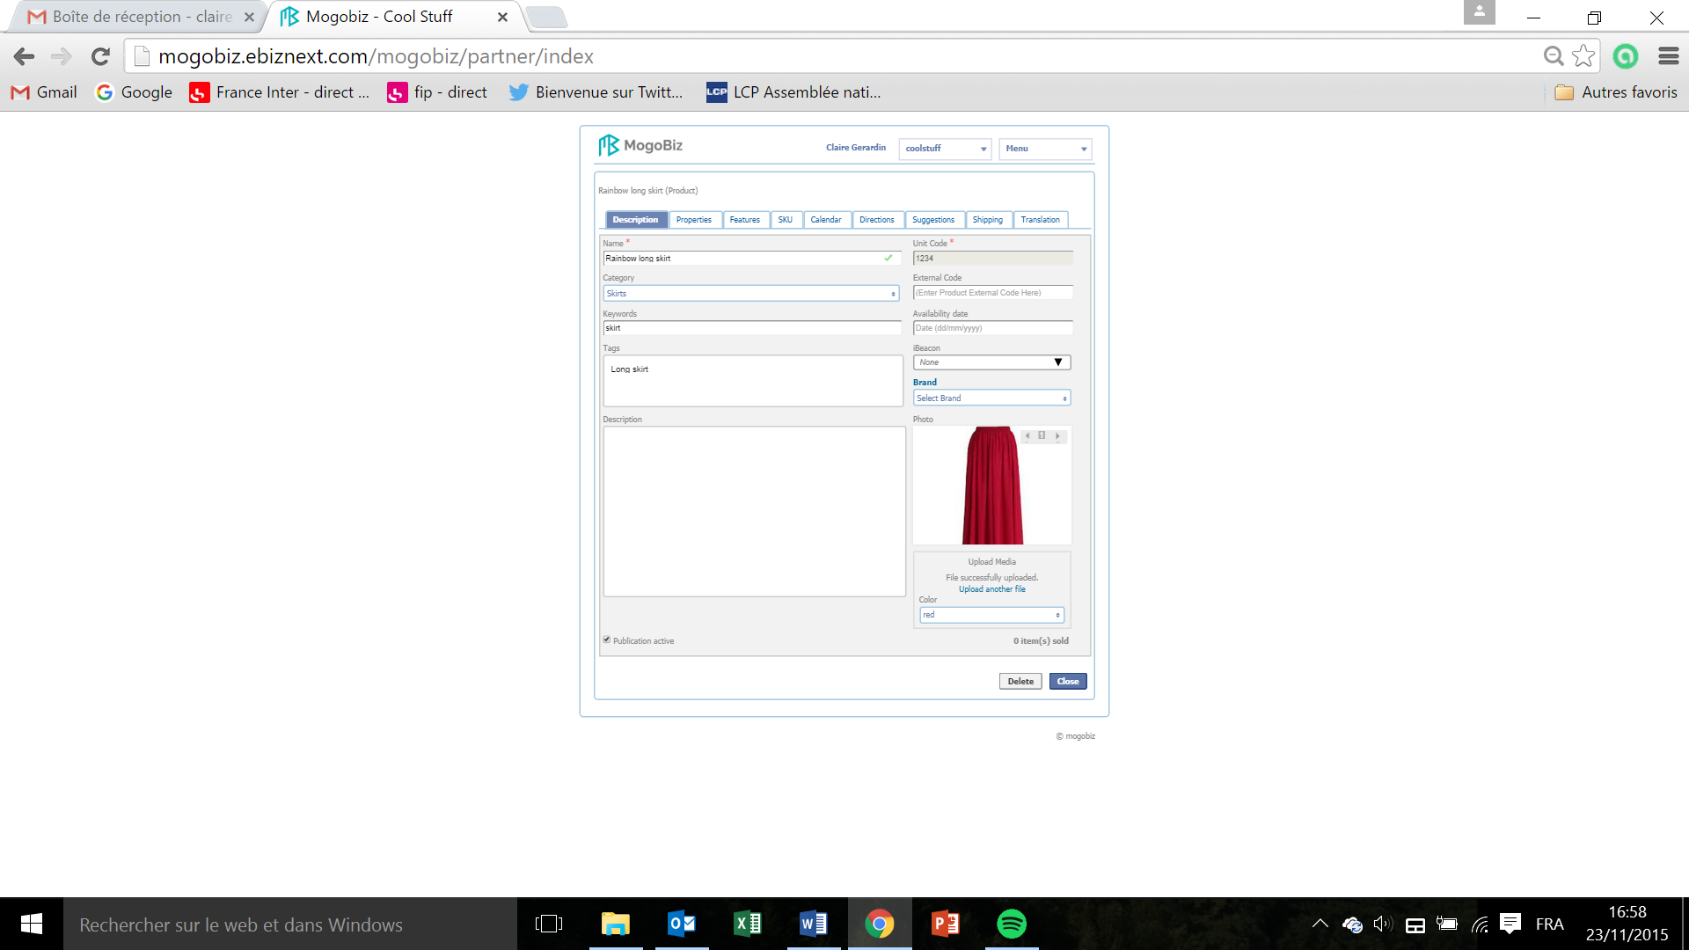

* The message “File successfully updated” will appear. You can visualize your picture in the **Photo** field.
* Check the **Publication active** box if you want for this product description to be displayed on your online store.
* Click on **Close** to save your Description settings, or on **Cancel** if you don’t want to pursue the product creation. Les settings de couleur/ variation associée ne sont pas sauvegardés lorsque l’on retourne sur le produit ultérieurement.

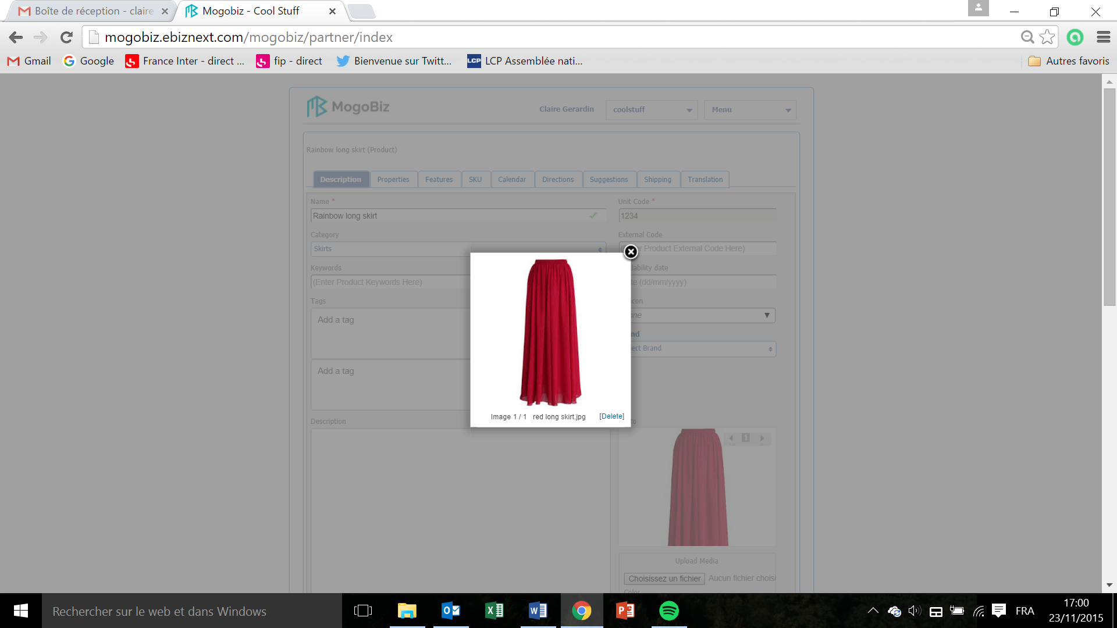

* When you click on the picture, you can visualize the color variations to which the image is associated. Fonction ne fonctionne pas?

## Product Properties

This section defines the properties of the product/service created in the Product Creation section.

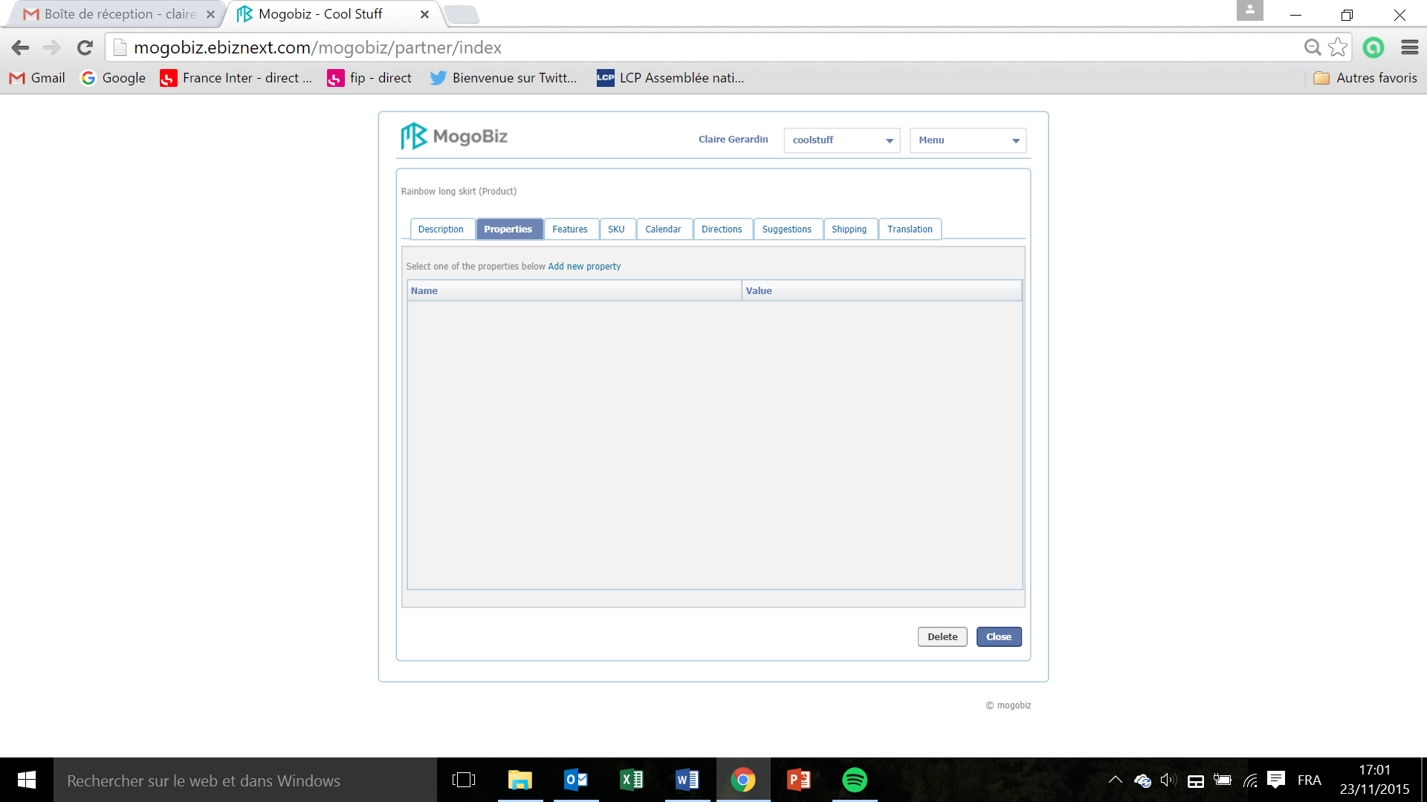

* In the **Properties** section, click on **Add new property.**

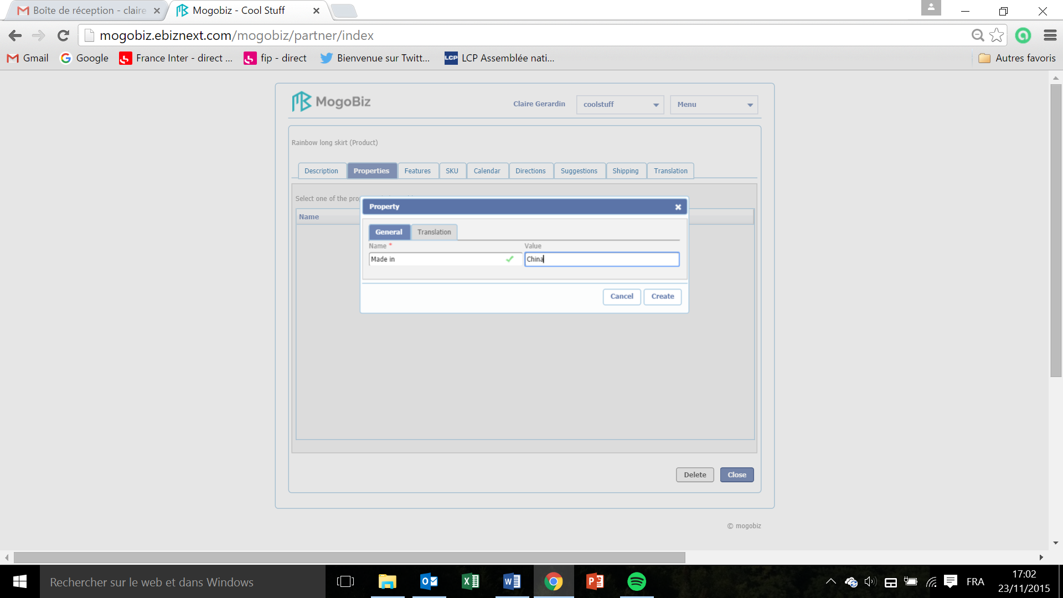

* In the **General** tab, enter the **Name** of your product property (origin, specific regulatory compliance, etc.). This field is mandatory.
* Enter the **Value** of this product property (China, No compliance etc.).
* Click on **Close** if you want to save the properties settings or **Delete** if you don’t want to pursue.

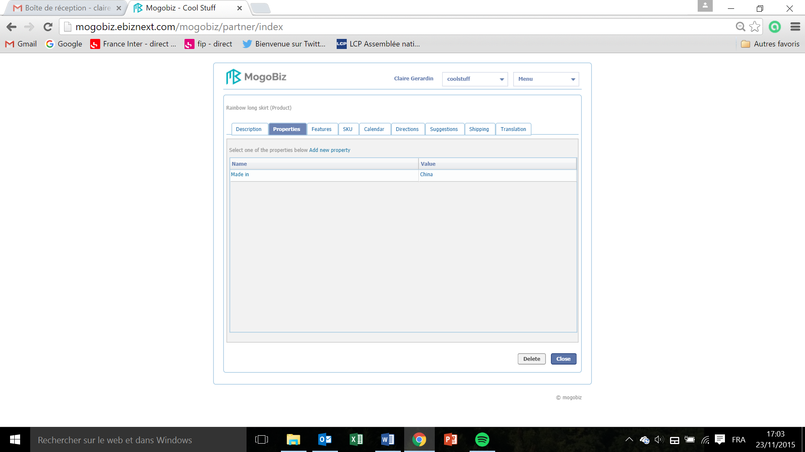

* Click on **Close** to go back to the list of products page, or **Delete** if you want to delete the product created.

Product Features

This section defines the features of the product/service created in the Product Creation section.

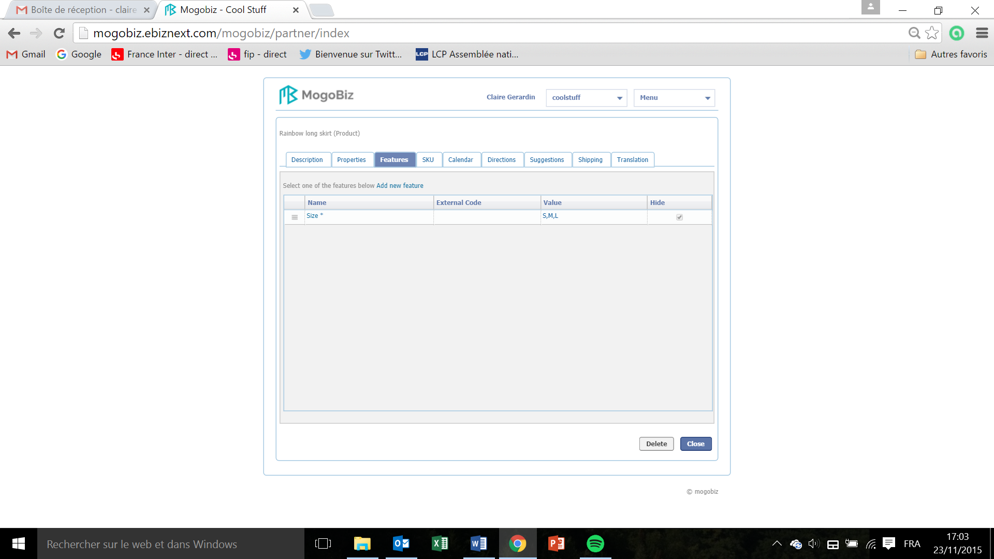

* The **Features** are automatically populated with the features you created during the category creation process.
* Click on **Add new feature** to add new features, and follow the process described in section Category/ Features.
* Click on **Close** to go back to the list of products page, or **Delete** if you want to delete the product created.

## Product SKU

This section defines the stock keeping unit (SKU) of the product/service. An SKU embodies all variations associated with the product/service and it distinguishes it from all other items.

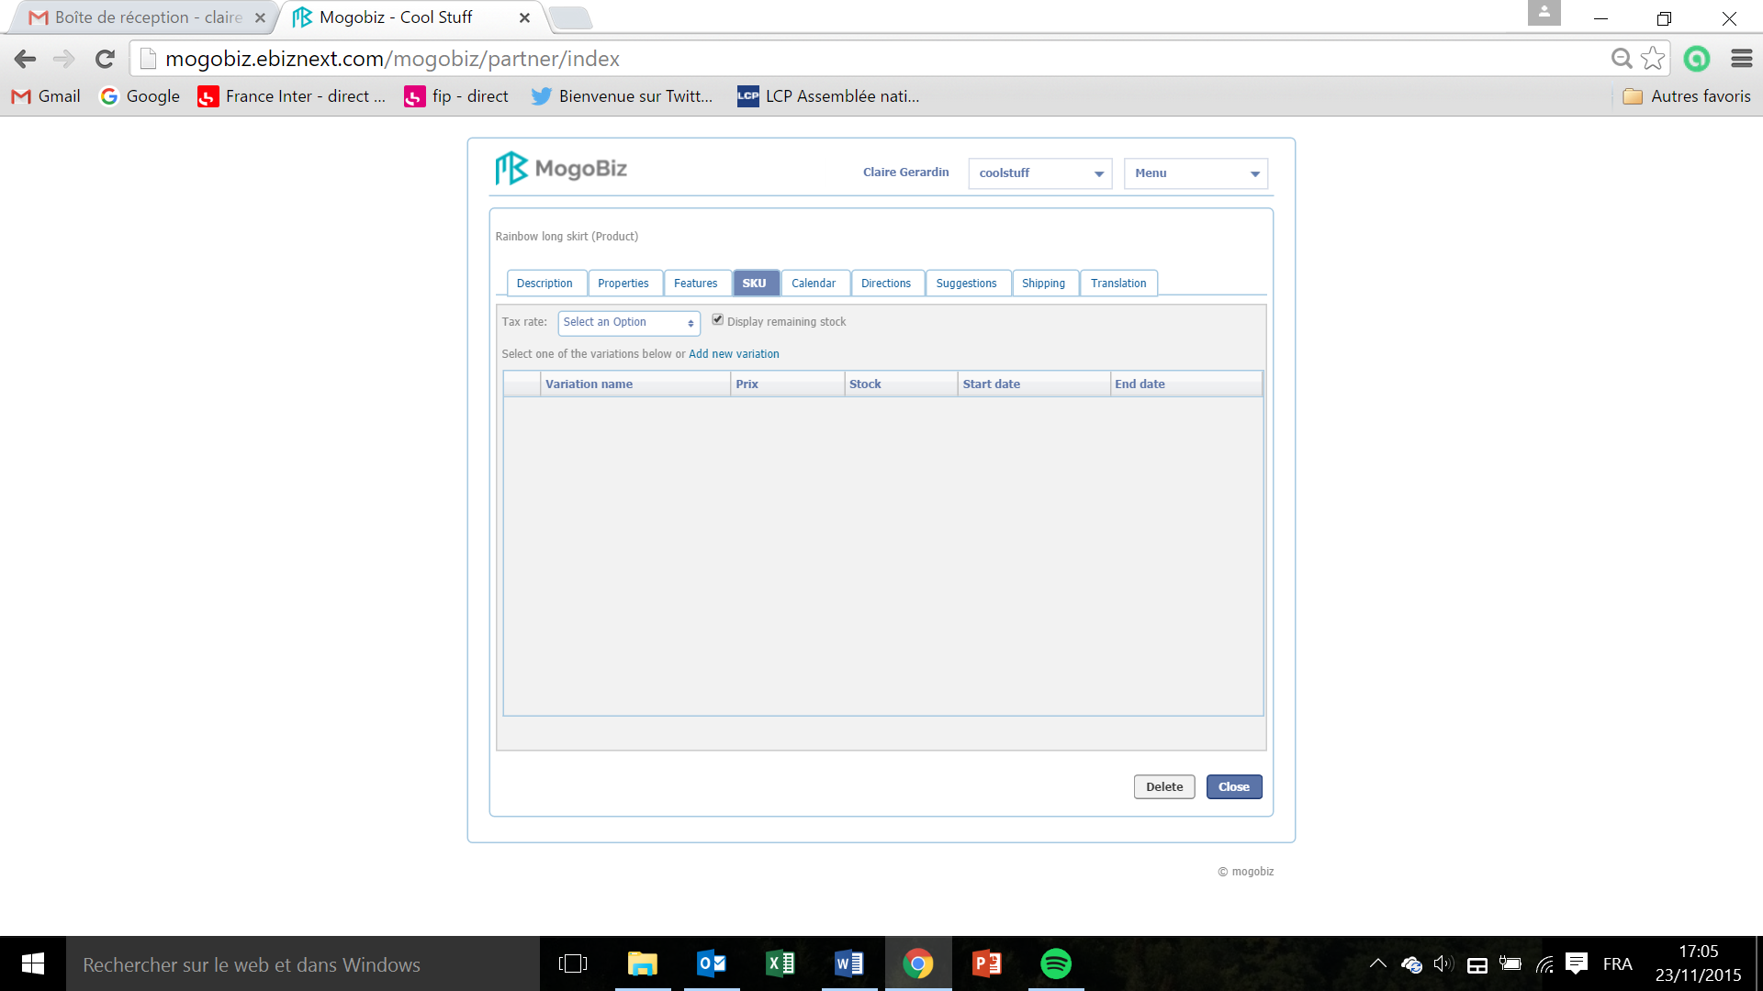

* Click on **Add new variation.**

Prix en francais

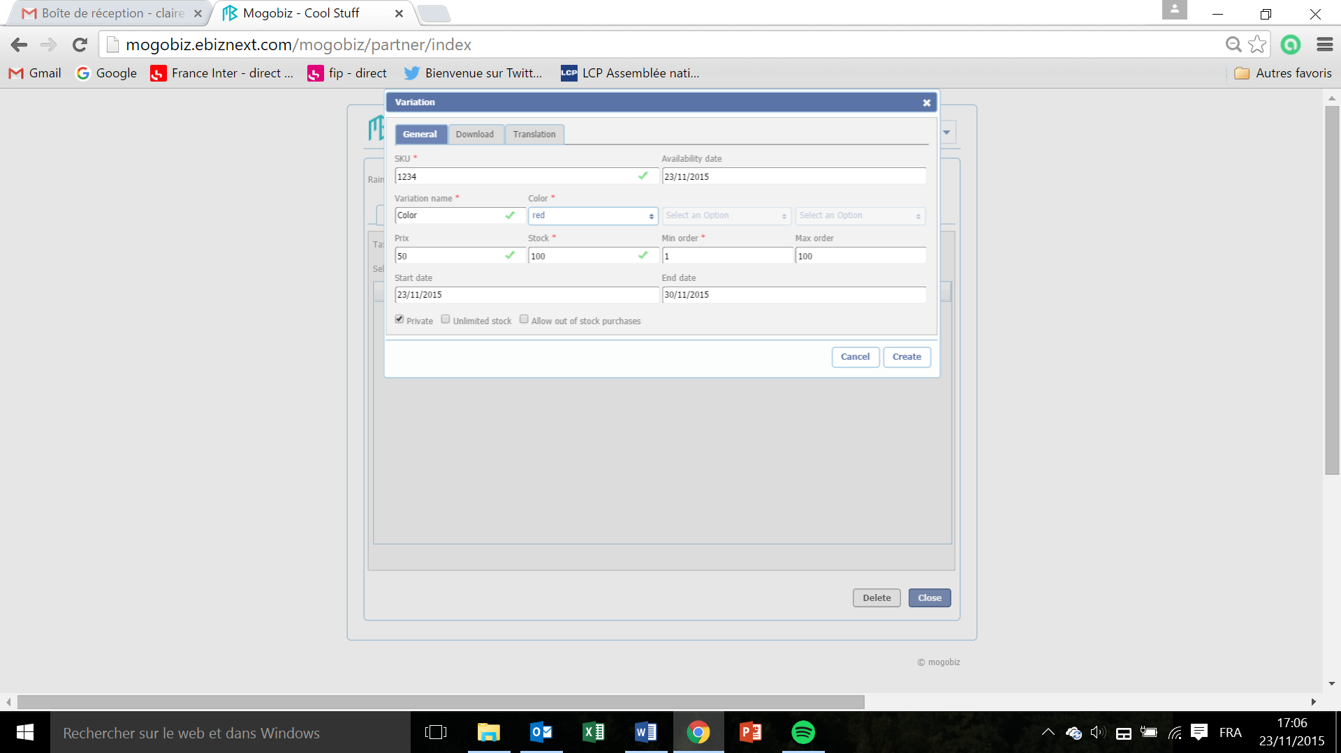

* In the **General** tab, enter The SKU code attributed during the product creation in the **SKU** field. This field is mandatory.
* In the **Availability date** field, enter the date at which the product is or will be available.
* Enter the variation of the SKU in the **Variation Name** field. This field is mandatory.
* In the **Color** drop down menu, select the color of the SKU variation. This field is mandatory.
* Les 2 menus déroulants Select an option ne sont pas disponibles ?
* Enter the SKU price in the **Prix** field. This field is not mandatory.
* Enter the available stock of the SKU in the **Stock** field. This field is mandatory.
* Enter the minimum amount of SKU that can be ordered in the **Min order** field, in relation to the stock available. This field is mandatory.
* Enter the maximum amount of SKU that can be ordered in the **Max order** field, in relation to the stock available. This field is not mandatory.
* Enter the start date when the SKU is to be displayed on your online store in the **Start date** field.
* Enter the end date until when the SKU is to be displayed on your online store in the **End date** field.
* Check the **Private** box if you don’t want for this SKU to be displayed on your online store.
* Check the **Unlimited stock** box if your SKU stock is unlimited.
* Check the **Allow out of stock purchases** box if you want to allow the sale of an SKU that is not available in your stock.
* Click **Create** to save and create your SKU variation or **Cancel** if you don’t want to pursue.

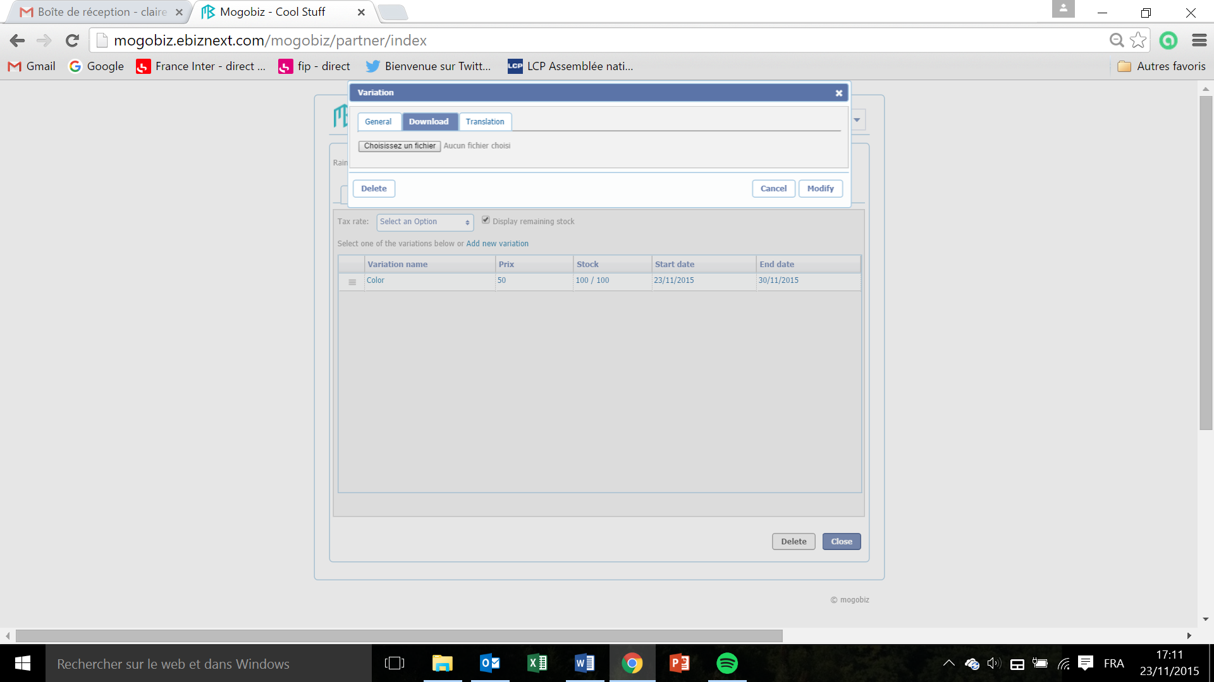

* In the **Download** tab, click on Choisissez un fichier to upload a file that contains your SKUs list?, in a ? format only…
* Click on **Modify** to save the file, on **Cancel** if you don’t want to pursue the upload, or **Delete** if you want to delete the Variation.

For the **Translation** tab, see the Translation section.

Product Calendar   
  
This section defines the calendar periods during which your products/services are displayed on your Mogobiz online store, valid for sale, and the periods during which they’re not. This is mainly for services sale, like show tickets.

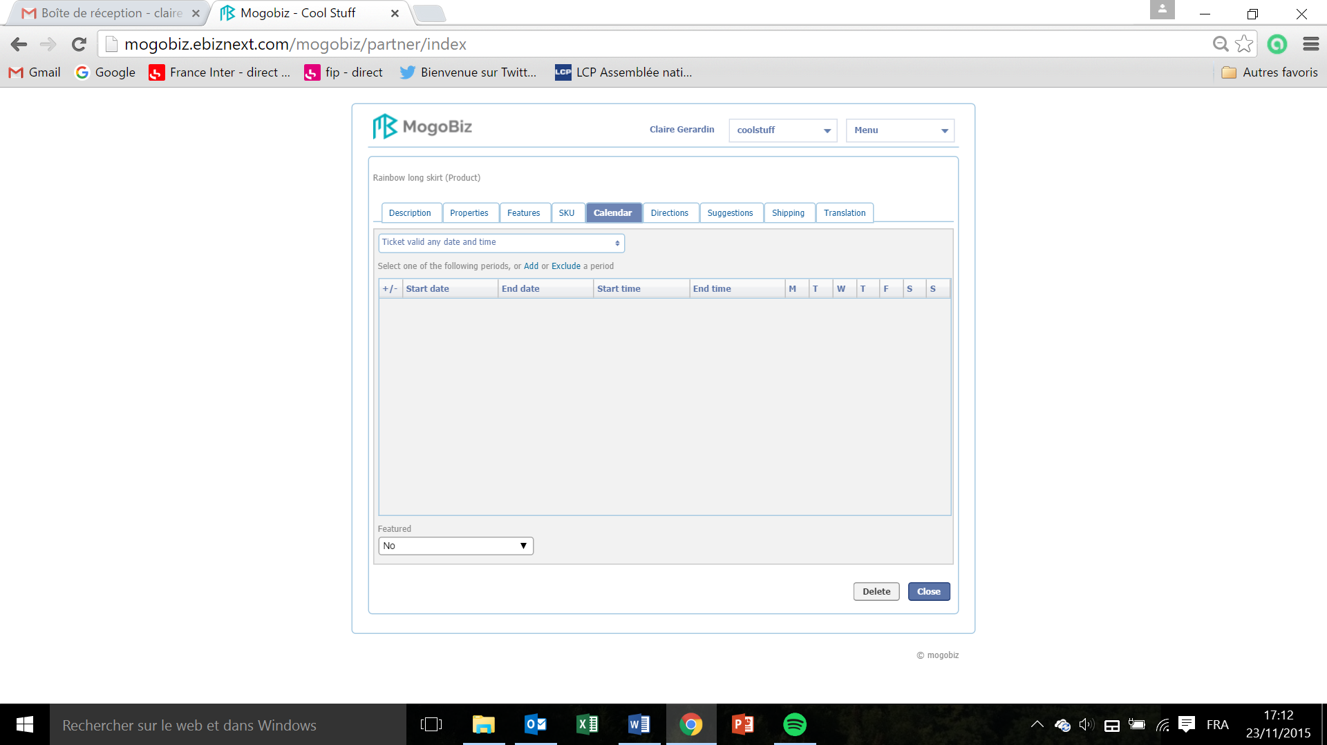

### Ticket display

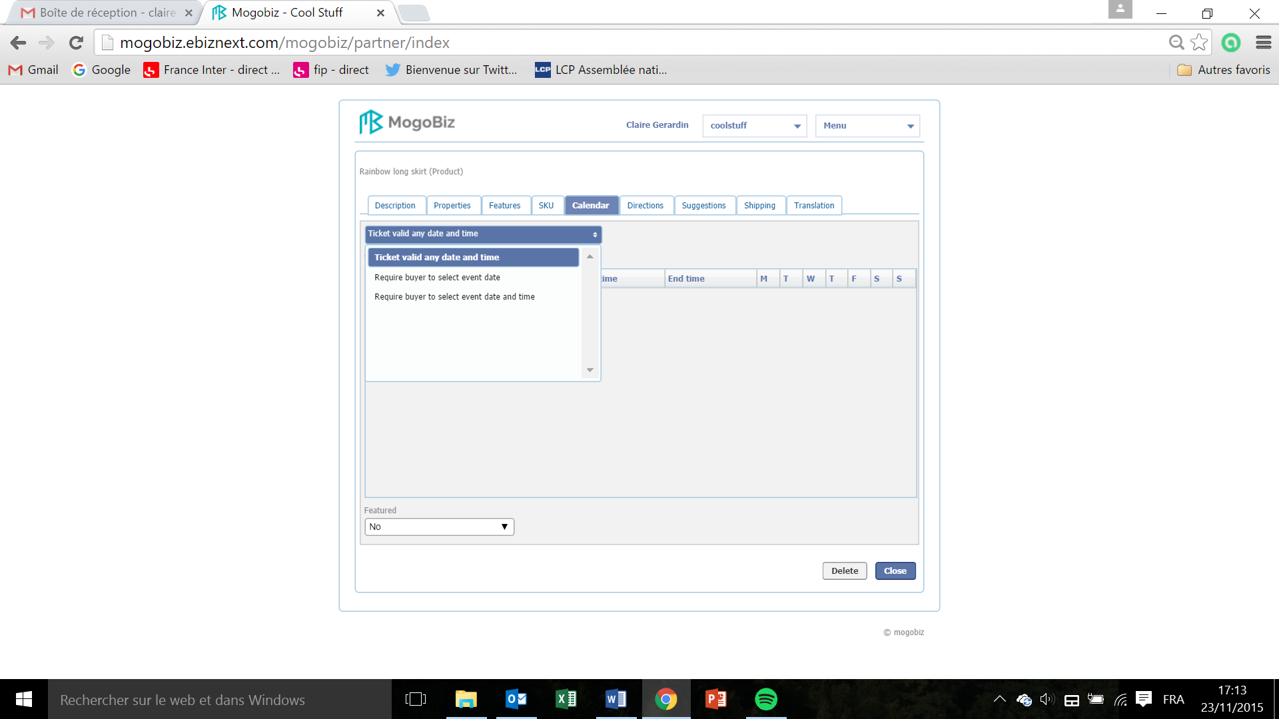

* To create a calendar period during which your ticket will be displayed on your ecommerce site, click on the drop down menu and select whether:
  + You want your ticket to be displayed without calendar restrictions: select **Ticket valid any date and time.**
  + You want the ticket display restricted to a period of time: select **Require buyer to select event date.**
  + You want your product display restricted to a date and time: select **Require buyer to select event date and time.**

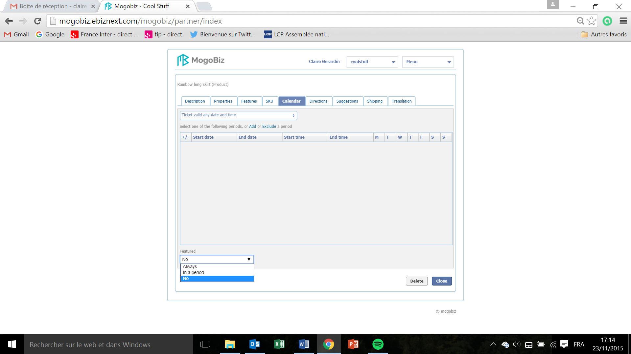

* Select the period during which the validity of the ticket is active and should be displayed on the Home page as a featured product: click on the **Featured** drop down and select:
  + **Always** to display the ticket permanently.
  + **In a period** to display the ticket during a period of time.
  + **No** to hold the display for the moment.

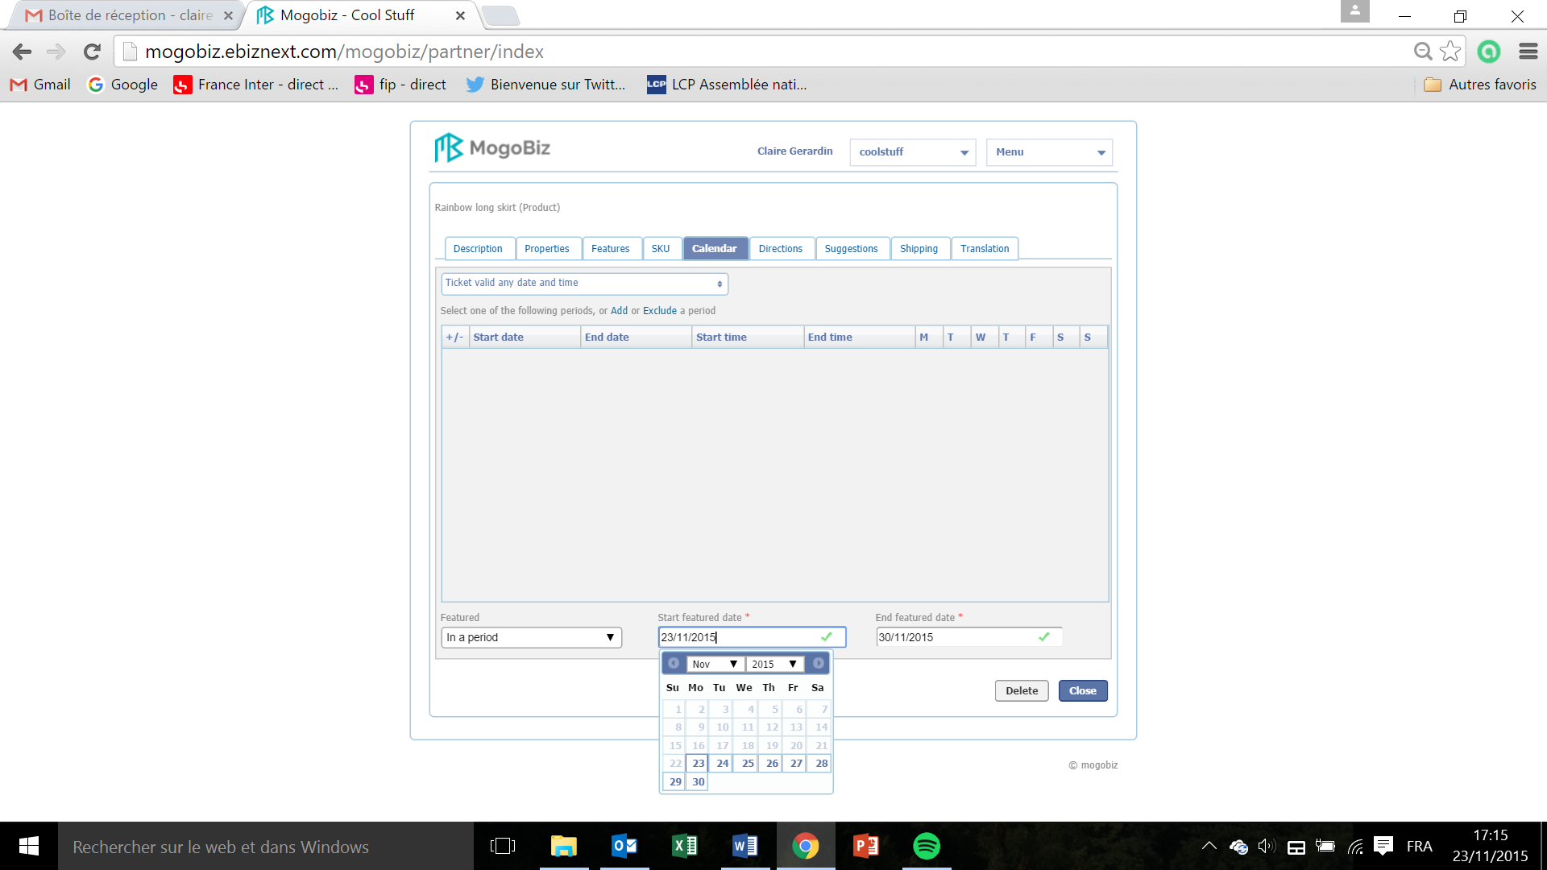

If you choose to display the ticket during a certain period of time:

* Click on the field **Start features date**. In the calendar that pops up, select the start date of the period during which the validity of the ticket is active and should be displayed on the Home page as a featured product. This field is mandatory.
* Click on the field **End featured date**. In the calendar that pops up, select the end date of the period during which the validity of the ticket is active and should be displayed on the Home page as a featured product. This field is mandatory.

### Ticket Validity

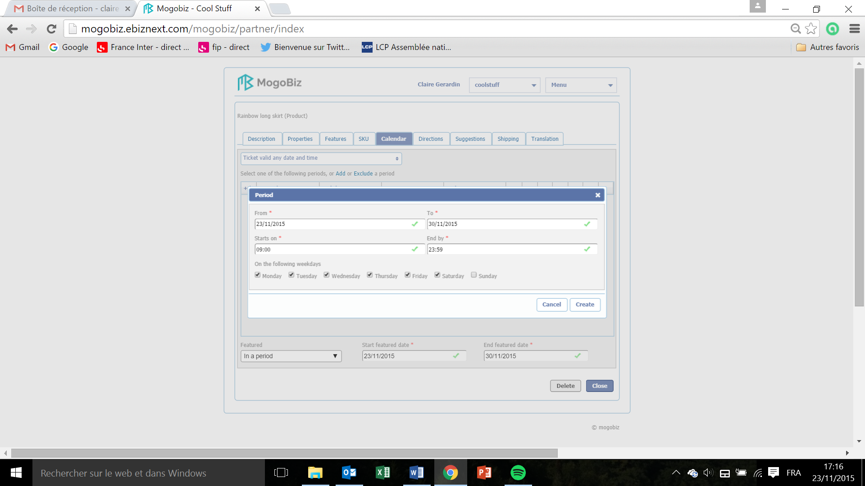

The validity of the ticket is the period during which it is usable and not outdated (for example for a concert).

* Click on **Add** a period to add a period during which the validity of the ticket is active or on **Exclude** a period to add a period during which the validity of the ticket is not active:
* Click on the field **From**. In the calendar that pops up, select the start date. This field is mandatory.
* Click on the field **To**. In the calendar that pops up, select the end date. This field is mandatory.
* Enter the start time in the **Starts on** field. This field is mandatory.
* Enter the end time in the **End by** field. This field is mandatory.
* Select the days during which the validity of the ticket is active and should be displayed on the Home page as a featured product by ticking off the boxes under **On the following weekdays : Monday, Tuesday, Wednesday, Thursday, Friday, Saturday, Sunday.** You can tick off one, several or all boxes.
* Click on **Create** to save the period settings or on **Cancel** if you don’t want to pursue.

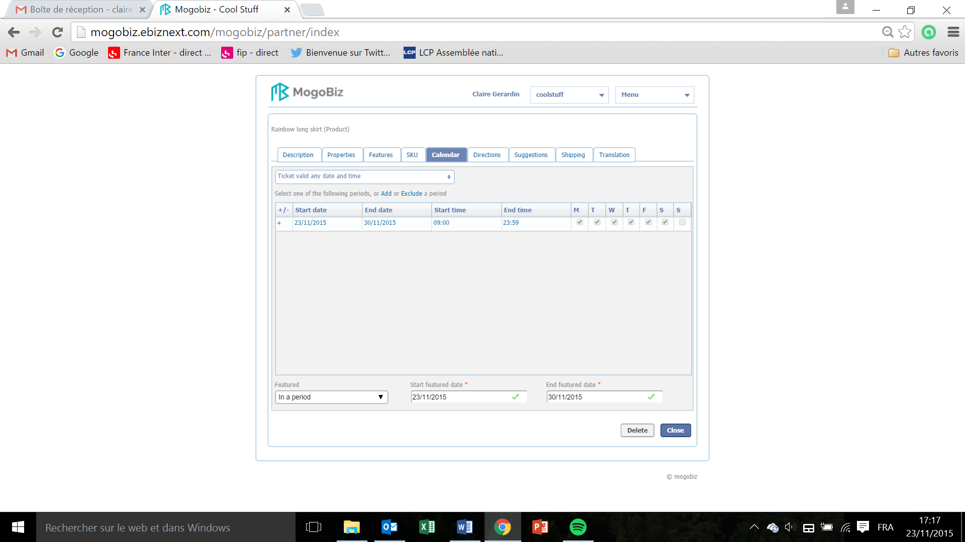

* In the Calendar screen that displays the period times, you can select or unselect the days already set up.
* Click on **Close** to go back to the list of products page, or **Delete** if you want to delete the ticket validation period.

Product Directions   
  
This section defines how to display on a map the location where the product/service can be found. You can create as many shops or product directions as you need.

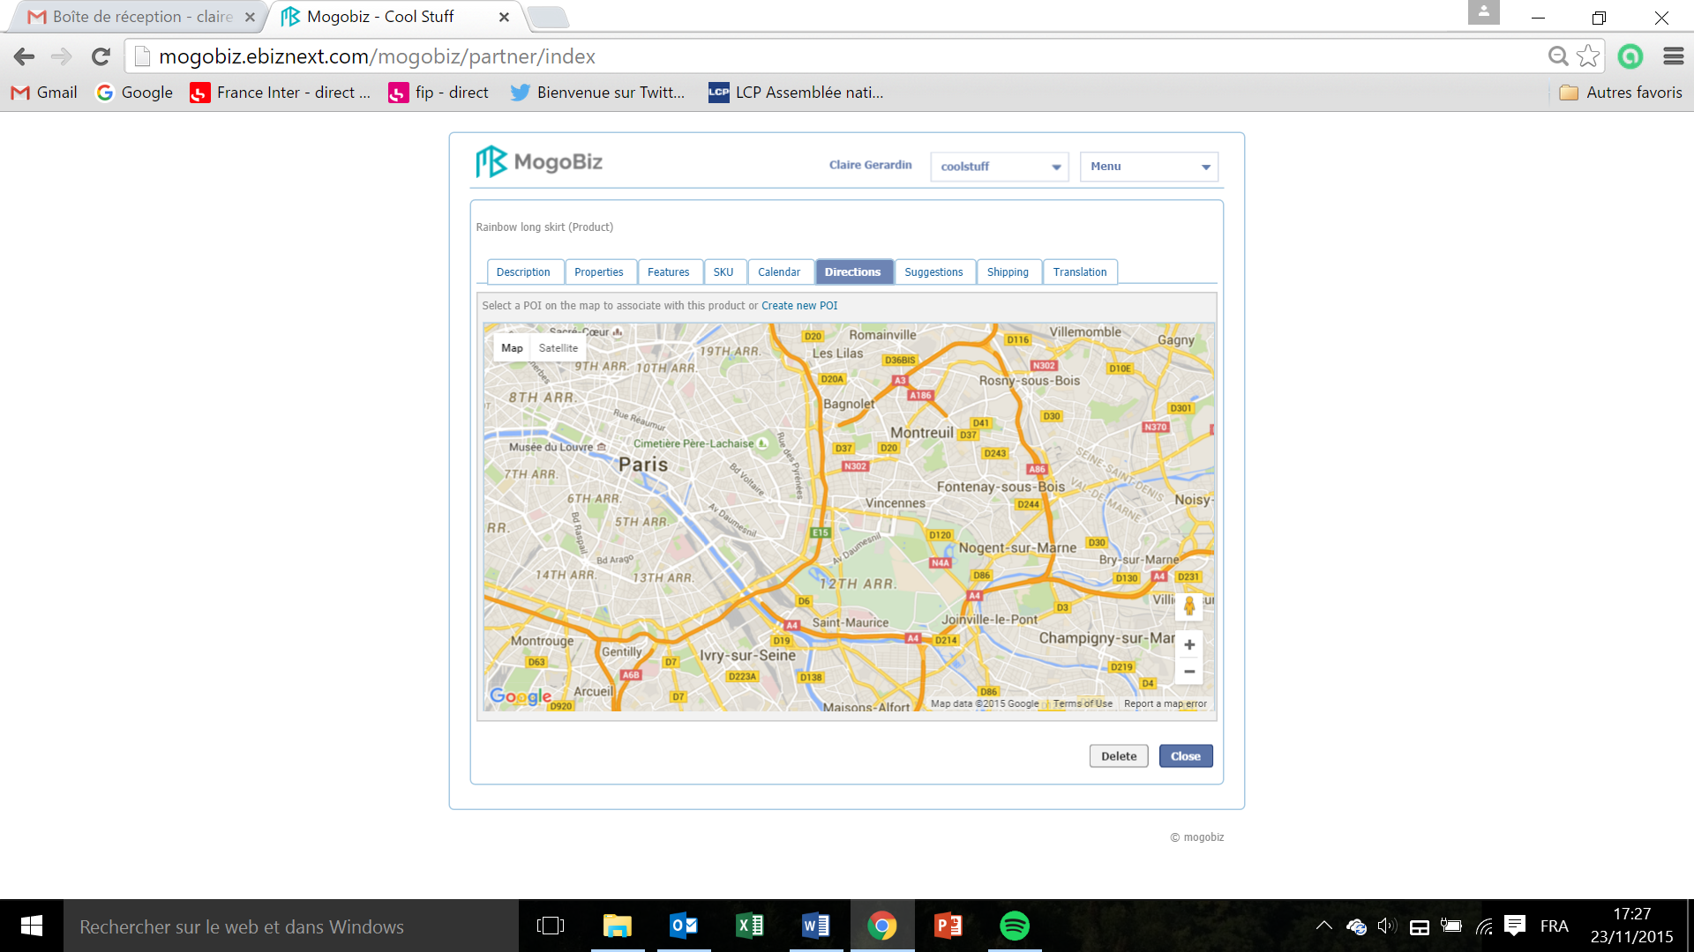

* To create a Point Of Interest (POI) to associate with the product click on **Create new POI.**

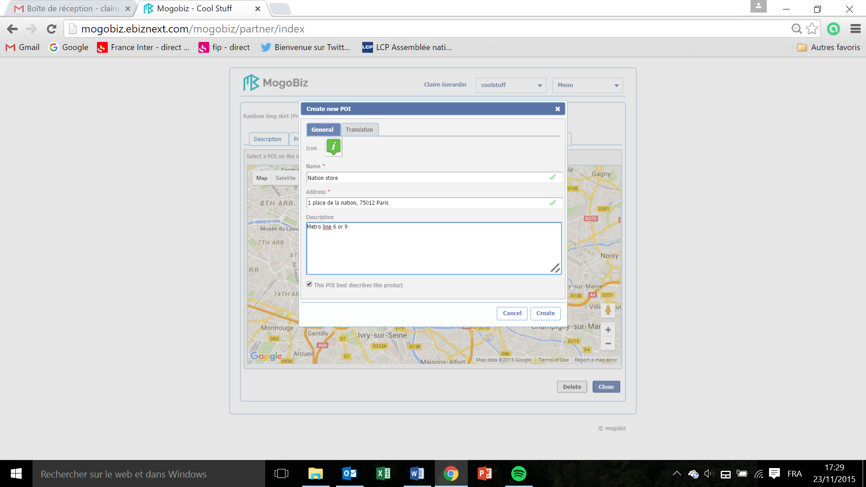

* In the Create new POI window that pops up, in the **General** tab, enter the name of the shop or location where the product is located in the field **Name.** This field is mandatory.
* Enter the address of the shop or product location in the field **Address**. This field is mandatory.
* Describe the shop or location in the field **Description**.
* If this POI best describes this product tick of the box **This POI best describes the product**.
* Click on **Create** if you want to save and create this POI, or on **Cancel** if you don’t want to pursue.

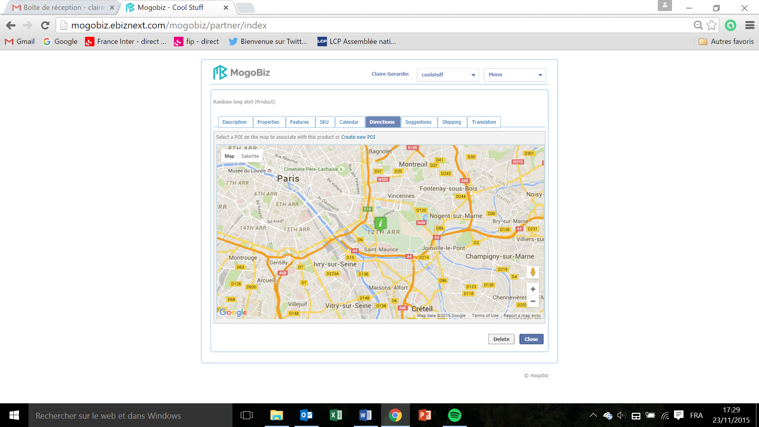

* The green “i” shows your product location.

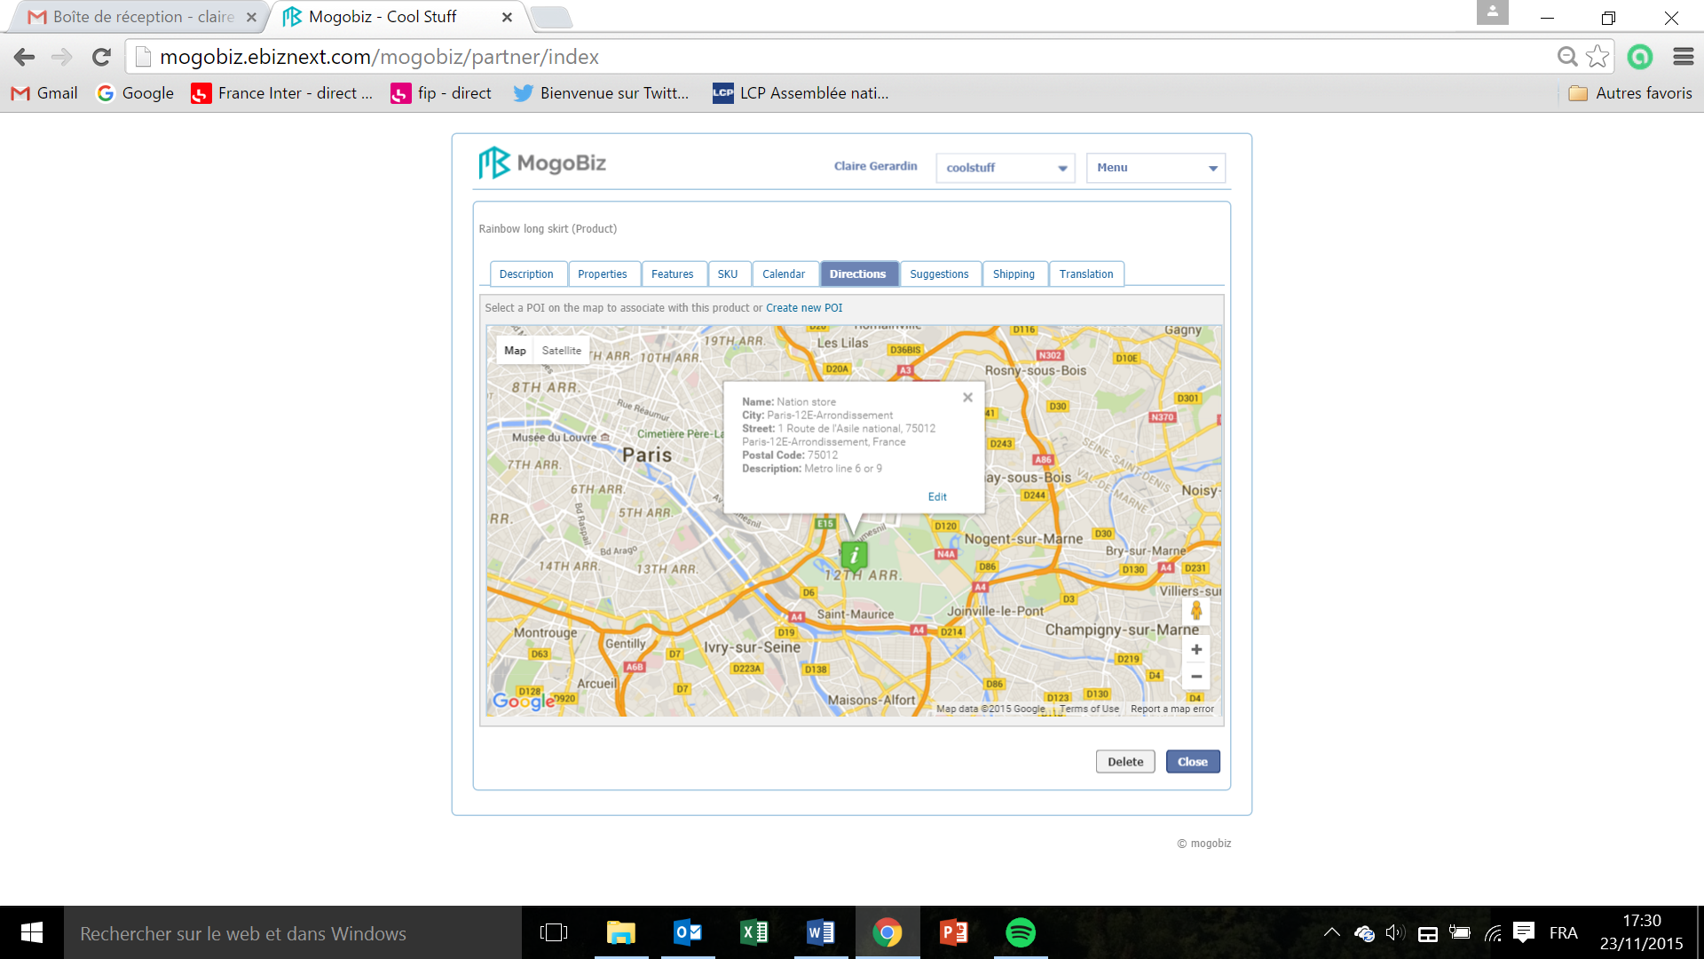

* Click on the green “i” to see your product location details.
* Click on **Edit** if you want to edit your product location details.

If you’ve clicked on **Edit**:

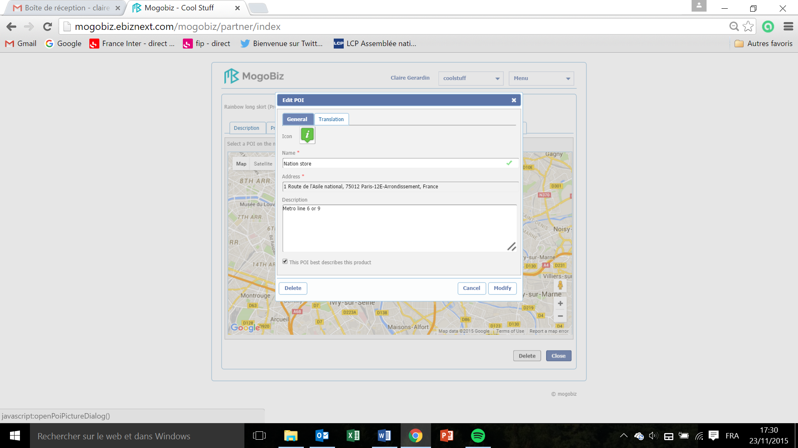

* You can modifiy the **Name** or **Description** information, then click on **Modify** to save your modifications.
* Click on **Cancel** to go back to Directions page, or **Delete** if you want to delete this shop or product location.



* Click Close to go back to the product page or Delete if you want to delete your shops or product direction creation.

Product Suggestions  
  
This section defines the packages you want to suggest to your customers. It links the product/service purchased with a complementary one (example: a hoover is purchased, hoover bags are suggested), and set a discount for this suggested product.

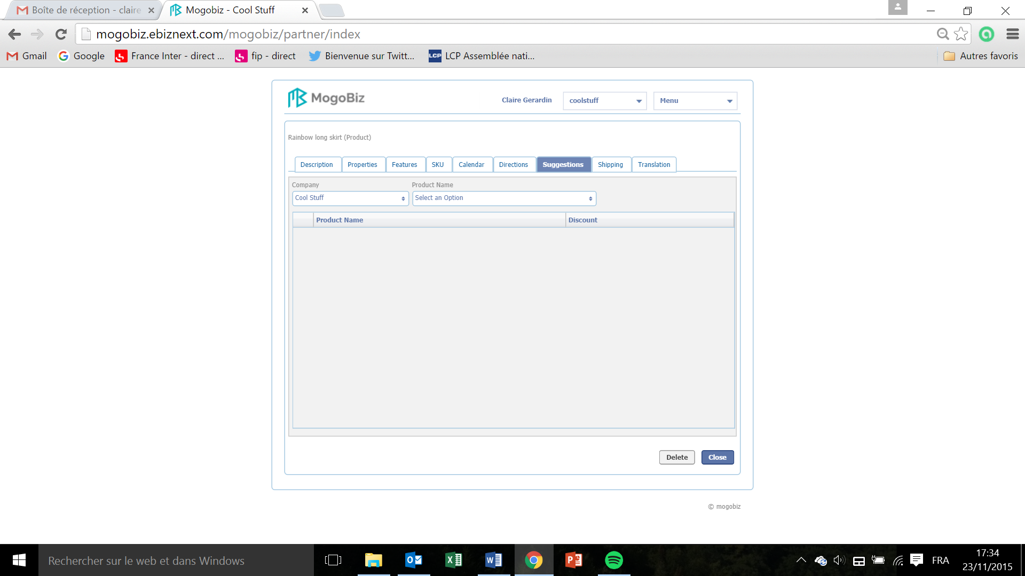

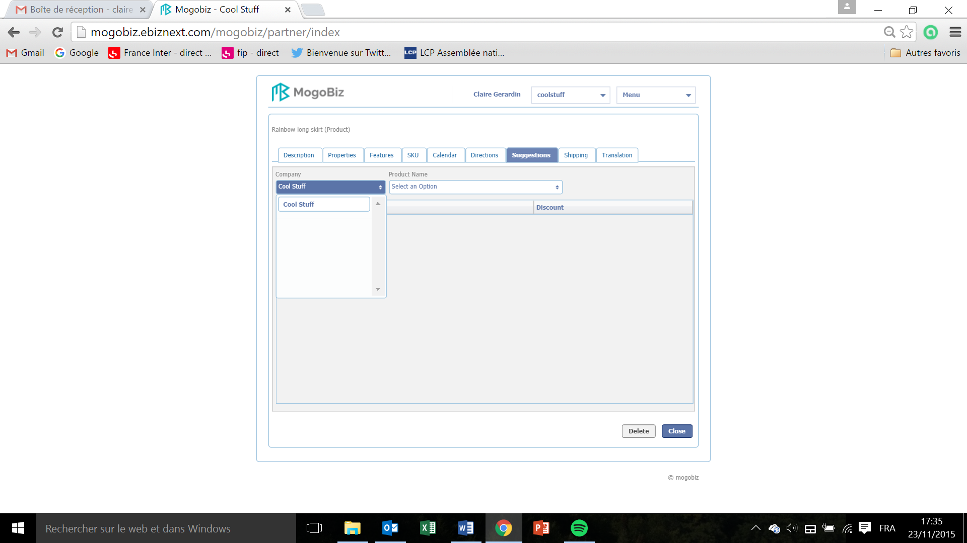

* Select the store for which you want to create a product association by clicking on the **Company** field.
* In the **Company** drop down menu, select the store and click on it.

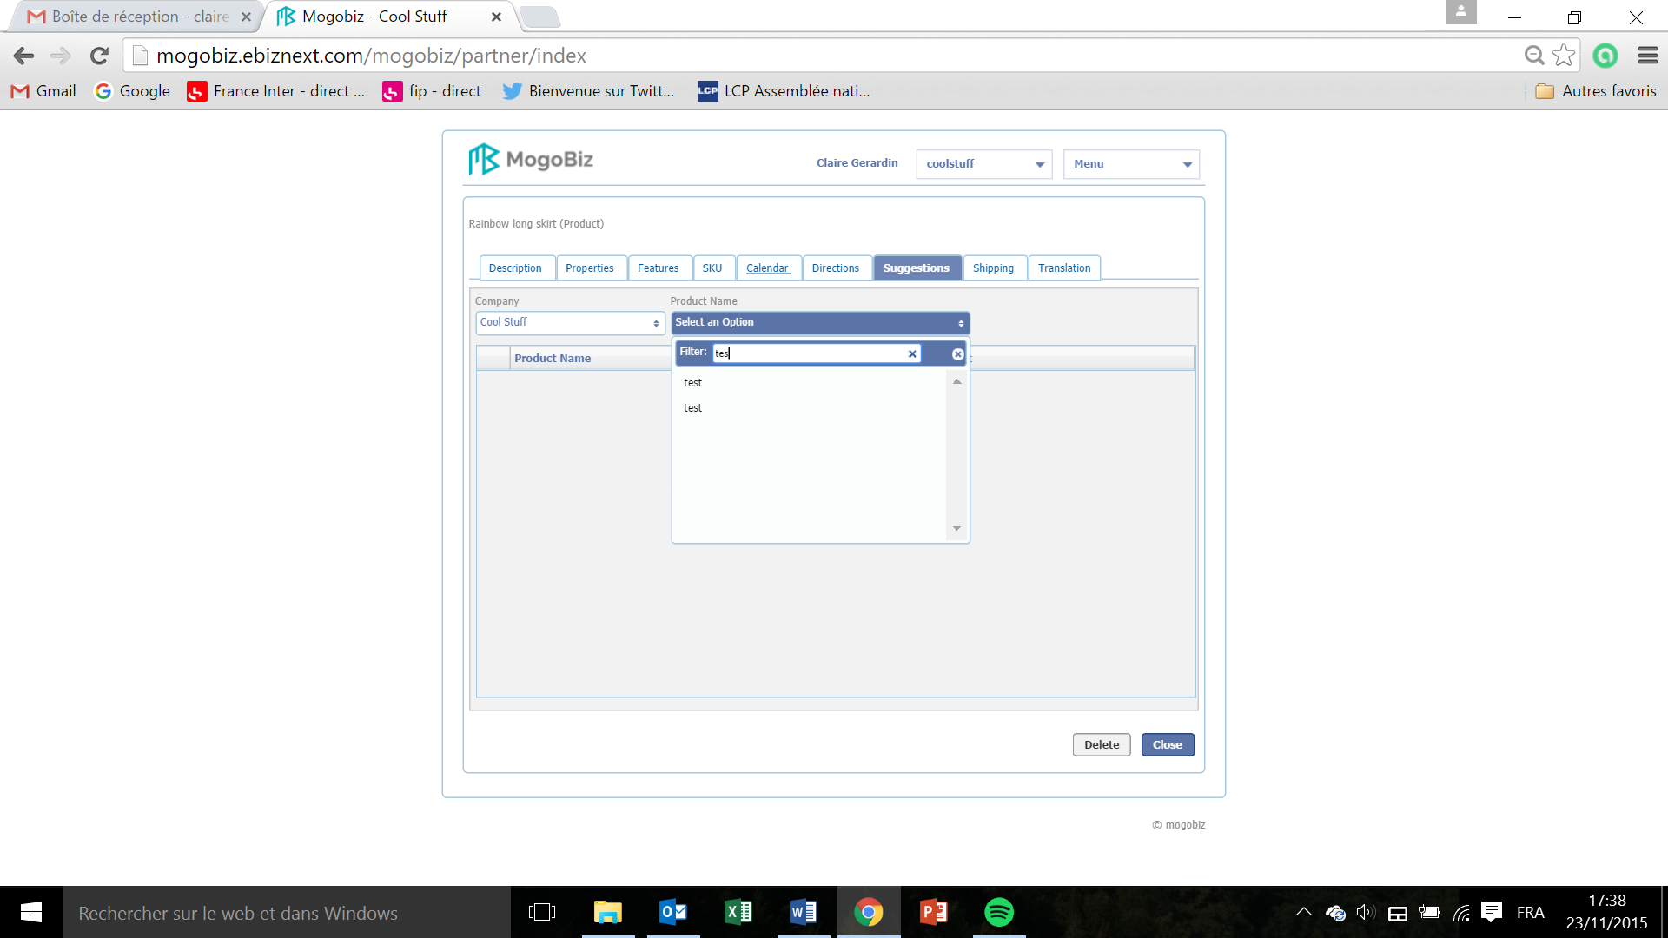

* Select the Product to be associated by clicking on the **Product Name** field. In the drop down menu, enter the three first letters of the product in the catalog with which you want to associate your product.
* Click on the product to be associated.

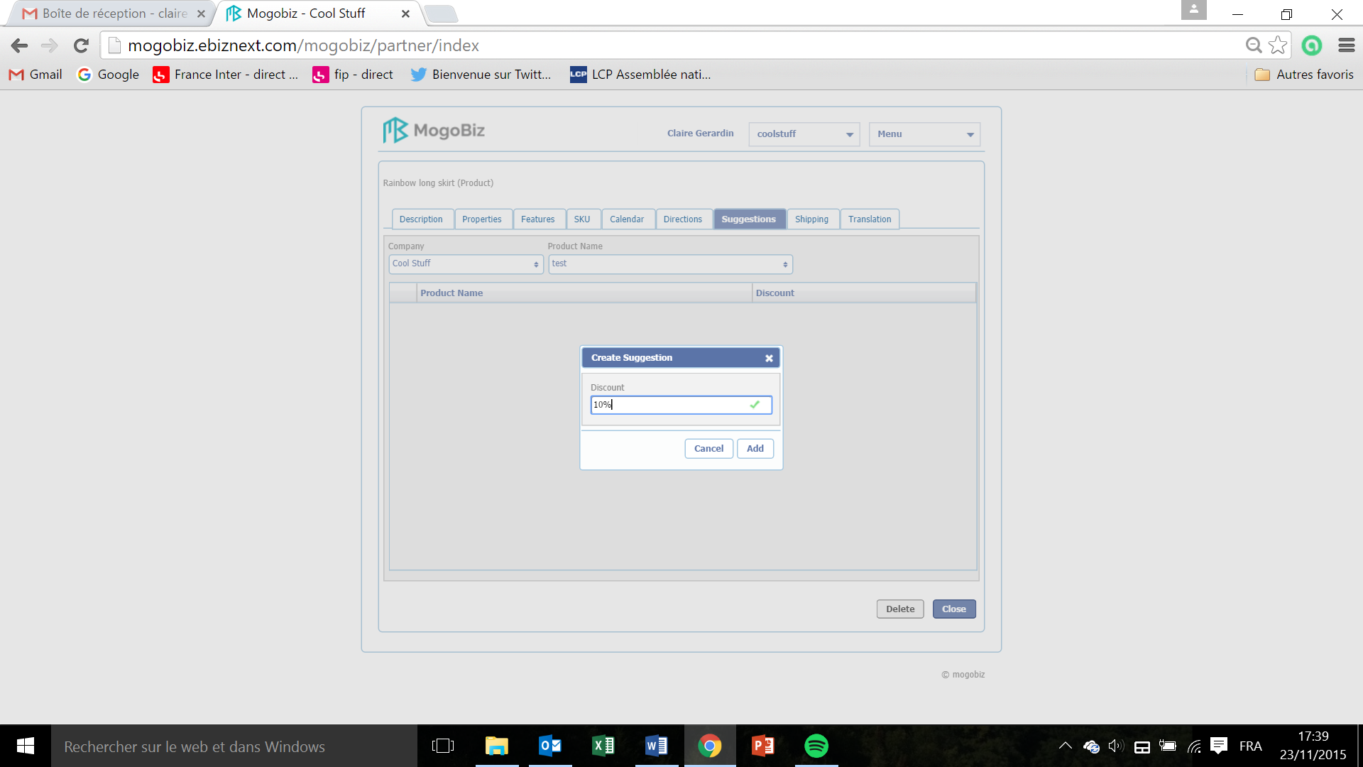

* To create a discount for the associated product, in the **Create Suggestion** window that pops up enter the amount in the **Discount** field, in percentage.
* Click on **Add** tosave and create this discount, or on **Cancel** if you don’t want to pursue.

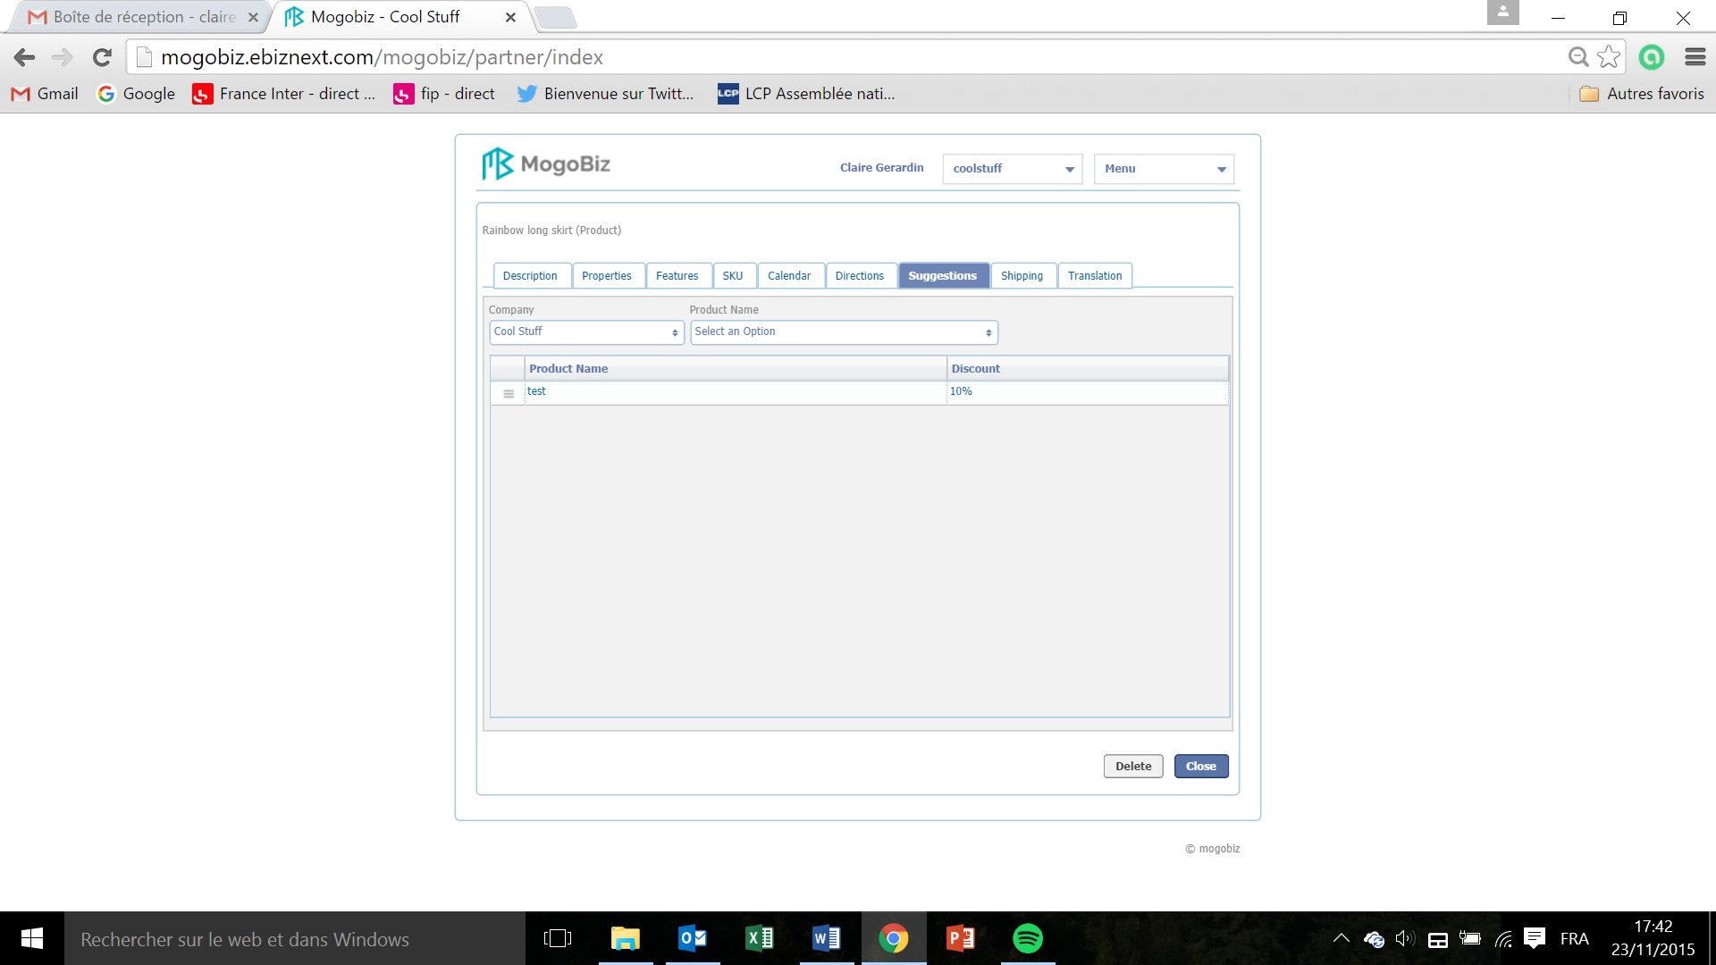

* Click on **Close** to go back to the products list page, or **Delete** of you want to Delete this suggestion.

Product Shipping  
  
This section defines the size and volume of the product/service for shipment purposes.

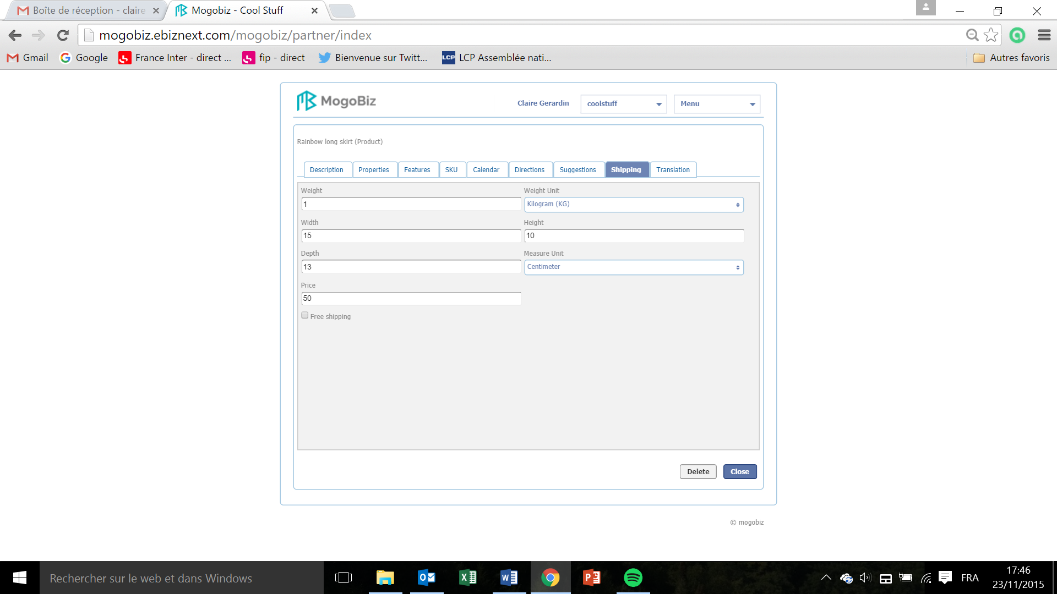

* Enter the weight of the product in the field **Weight.**
* Enter the width of the product in the field **Width.**
* Enter the length of the product of the field **Height.**
* Enter the depth of the product of the field **Depth.**
* Enter the cost of the shipment in the field **Price.**
* To set this product shipment free of charge tick off the box **Free shipping.**

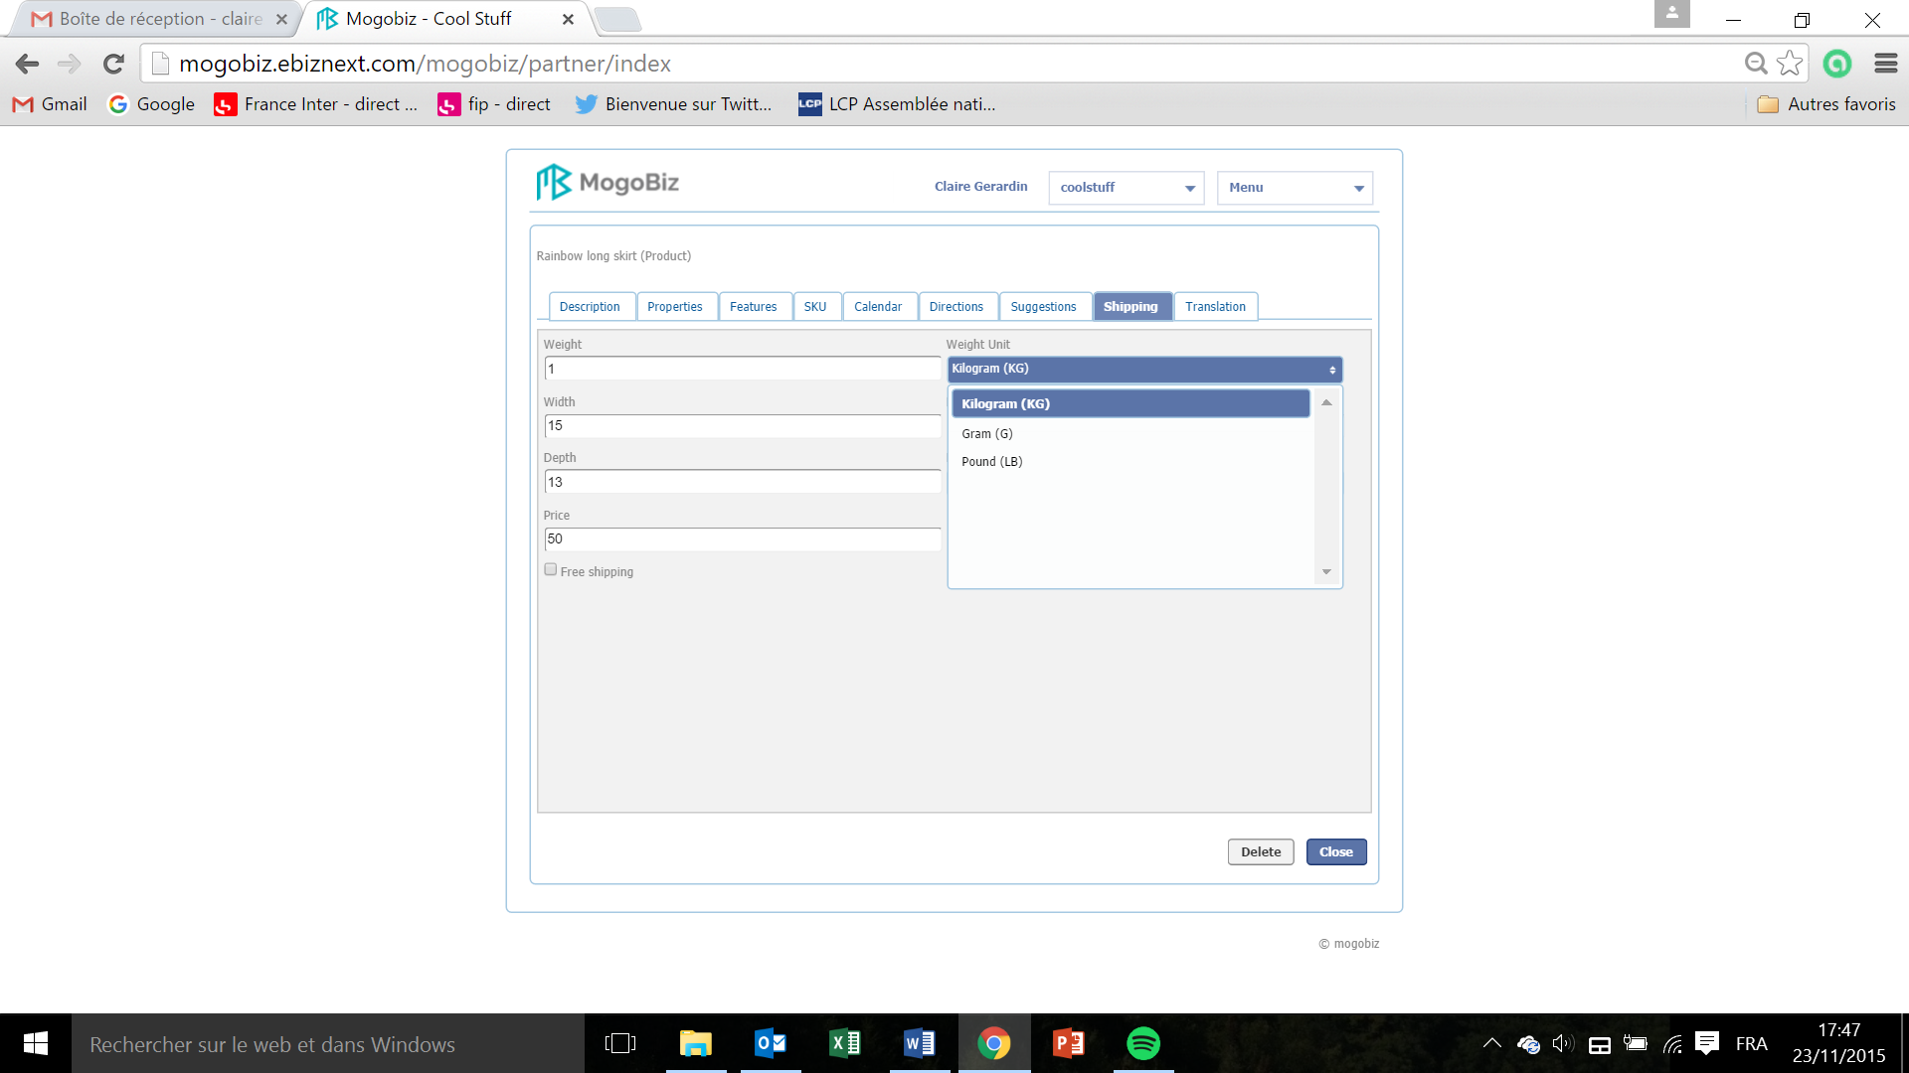

* To set up the weight unit to use for the shipment click on the **Weight Unit** drop down menu and select the unit.

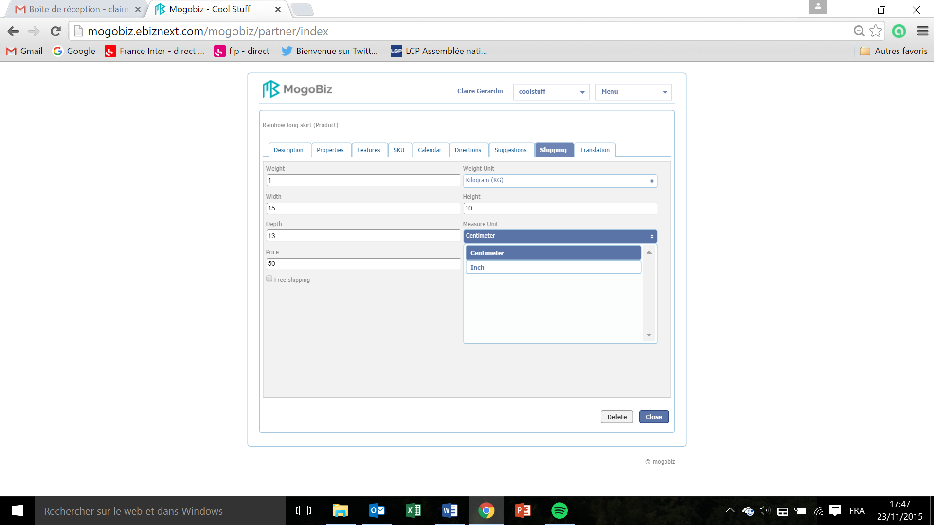

* To set up the measurement unit to use for the shipment click on the **Measure Unit** drop down menu and select the unit.
* Click on **Close** to save and go back to the list of products page, or **Delete** if you want to delete this shipping information.

How to Edit or Delete  
  
In the store, catalog, category and product set up phases you can edit or delete the information created. The edition or deletion process is identical for each set up phase, below is an example of how to proceed:

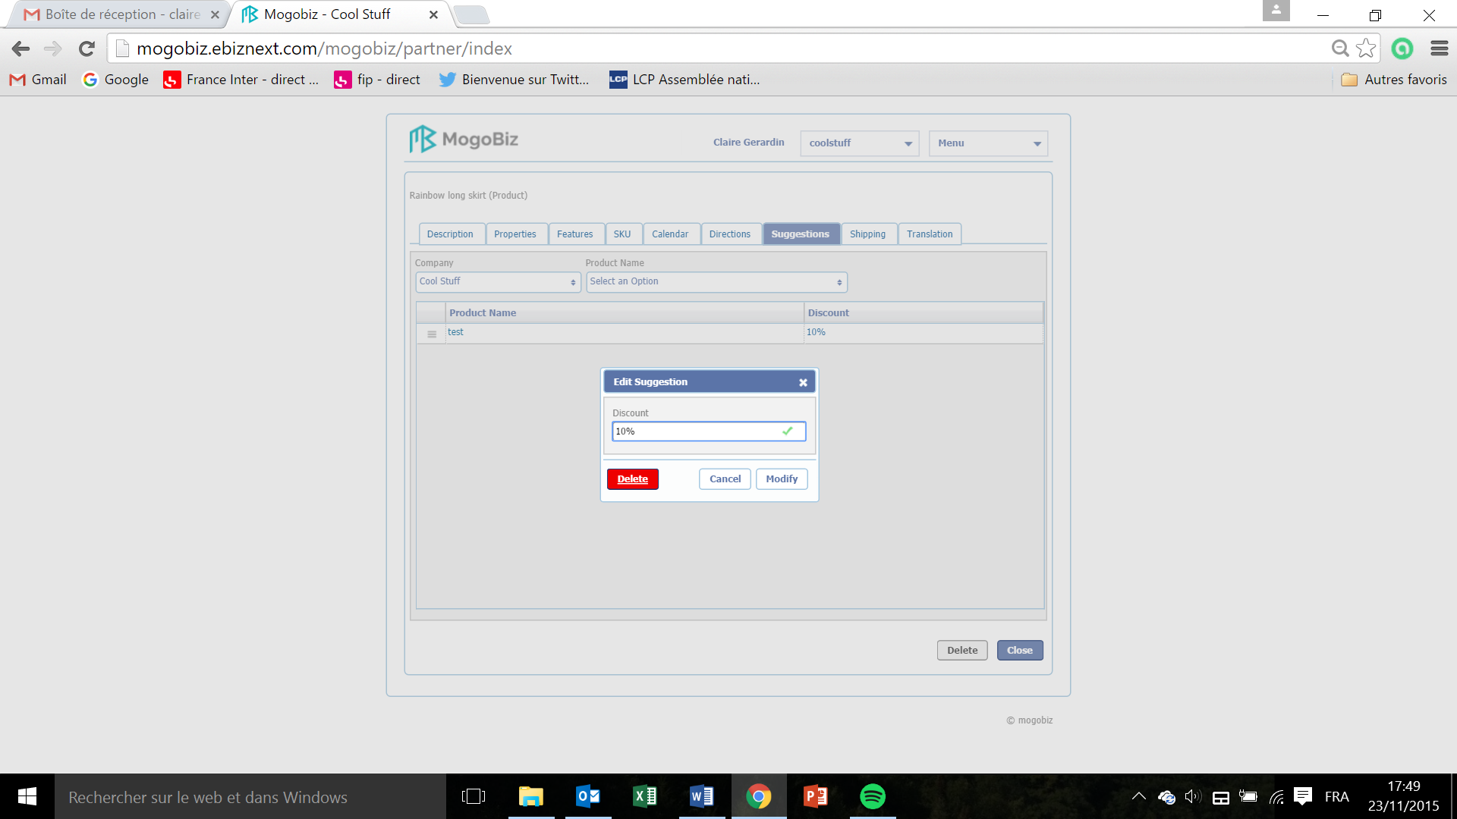

* To edit or delete a suggestion, click on its name under the **Product Name** column.
* Click on **Delete** to delete it.

Translation  
  
In the store, catalog, category and product set up phases you can translate the information created into the language of your choice. The fields that can be translated are all the modifiable ones, which can be potentially displayed on your online store. The name and value of the information can be translated. The translation process is identical for each set up phase, below is an example of how to proceed:

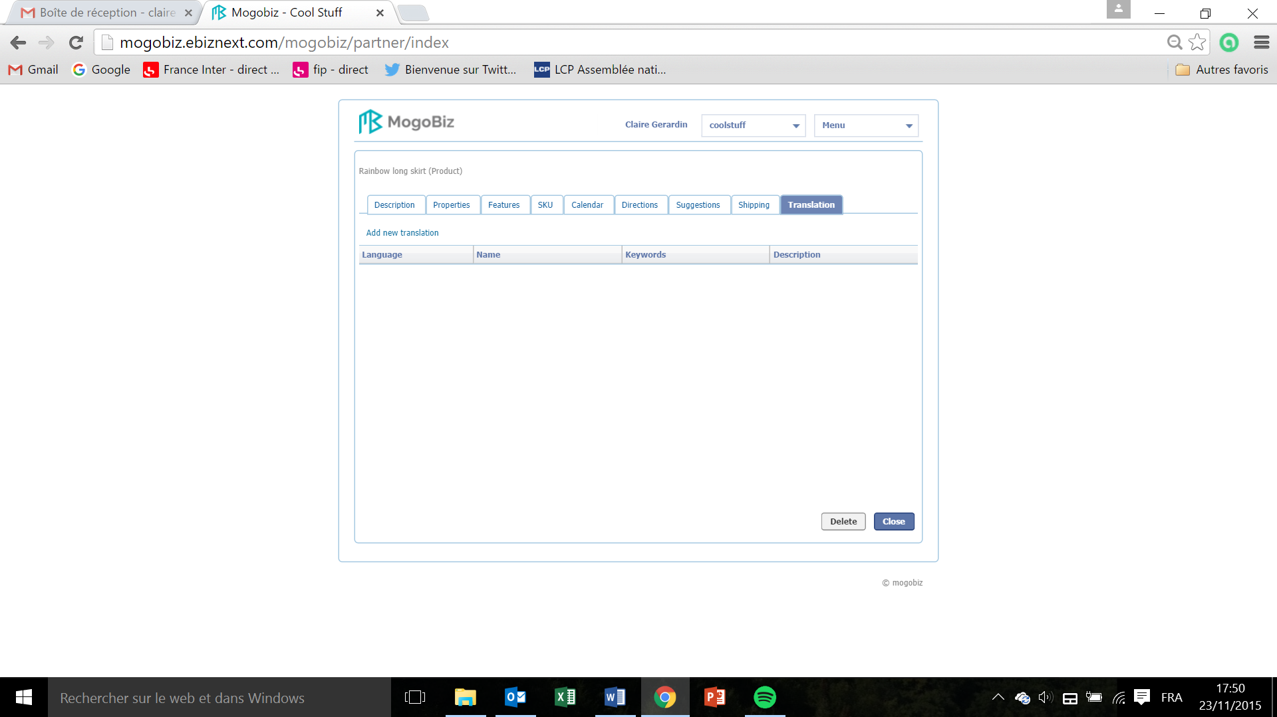

* To add a new translation click on **Add new translation.**

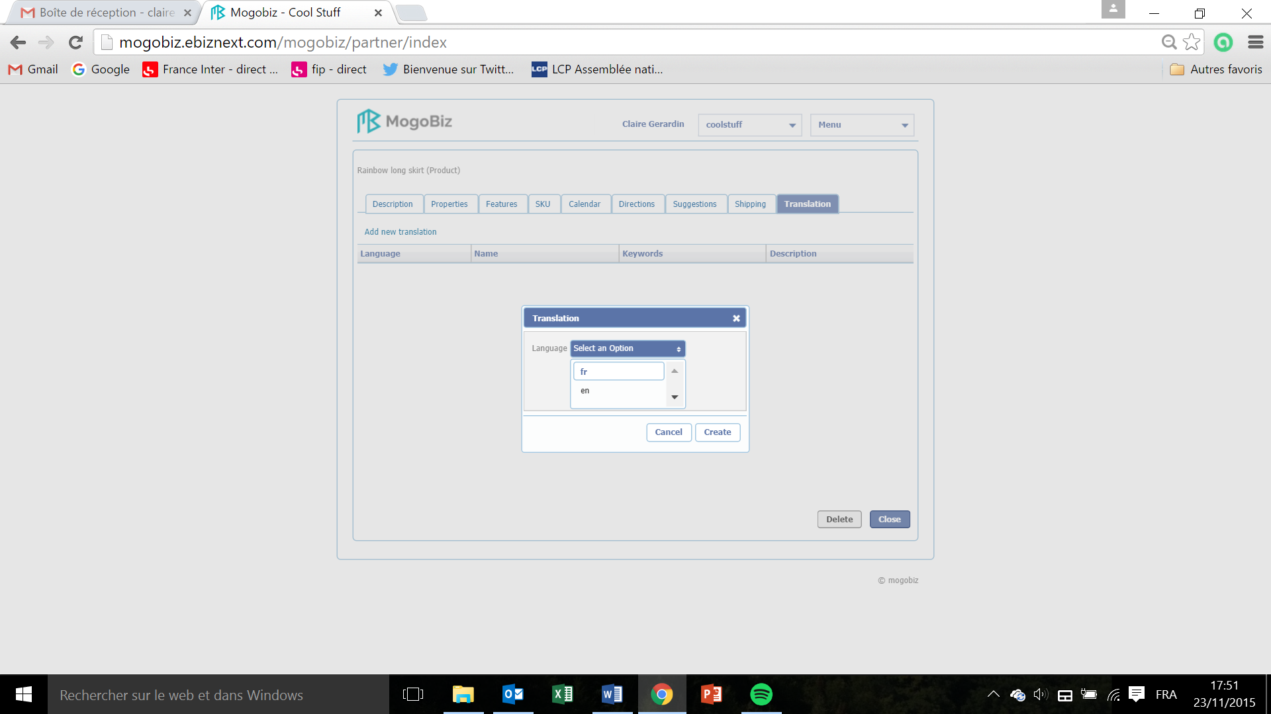

* In the **Translation** window that pops up, select the language of translation by clicking on **Select an Option** drop down menu.
* Click on the language you want to set.
* Click on **Create** if you want to save and create the language or on **Cancel** if you don’t want to pursue.

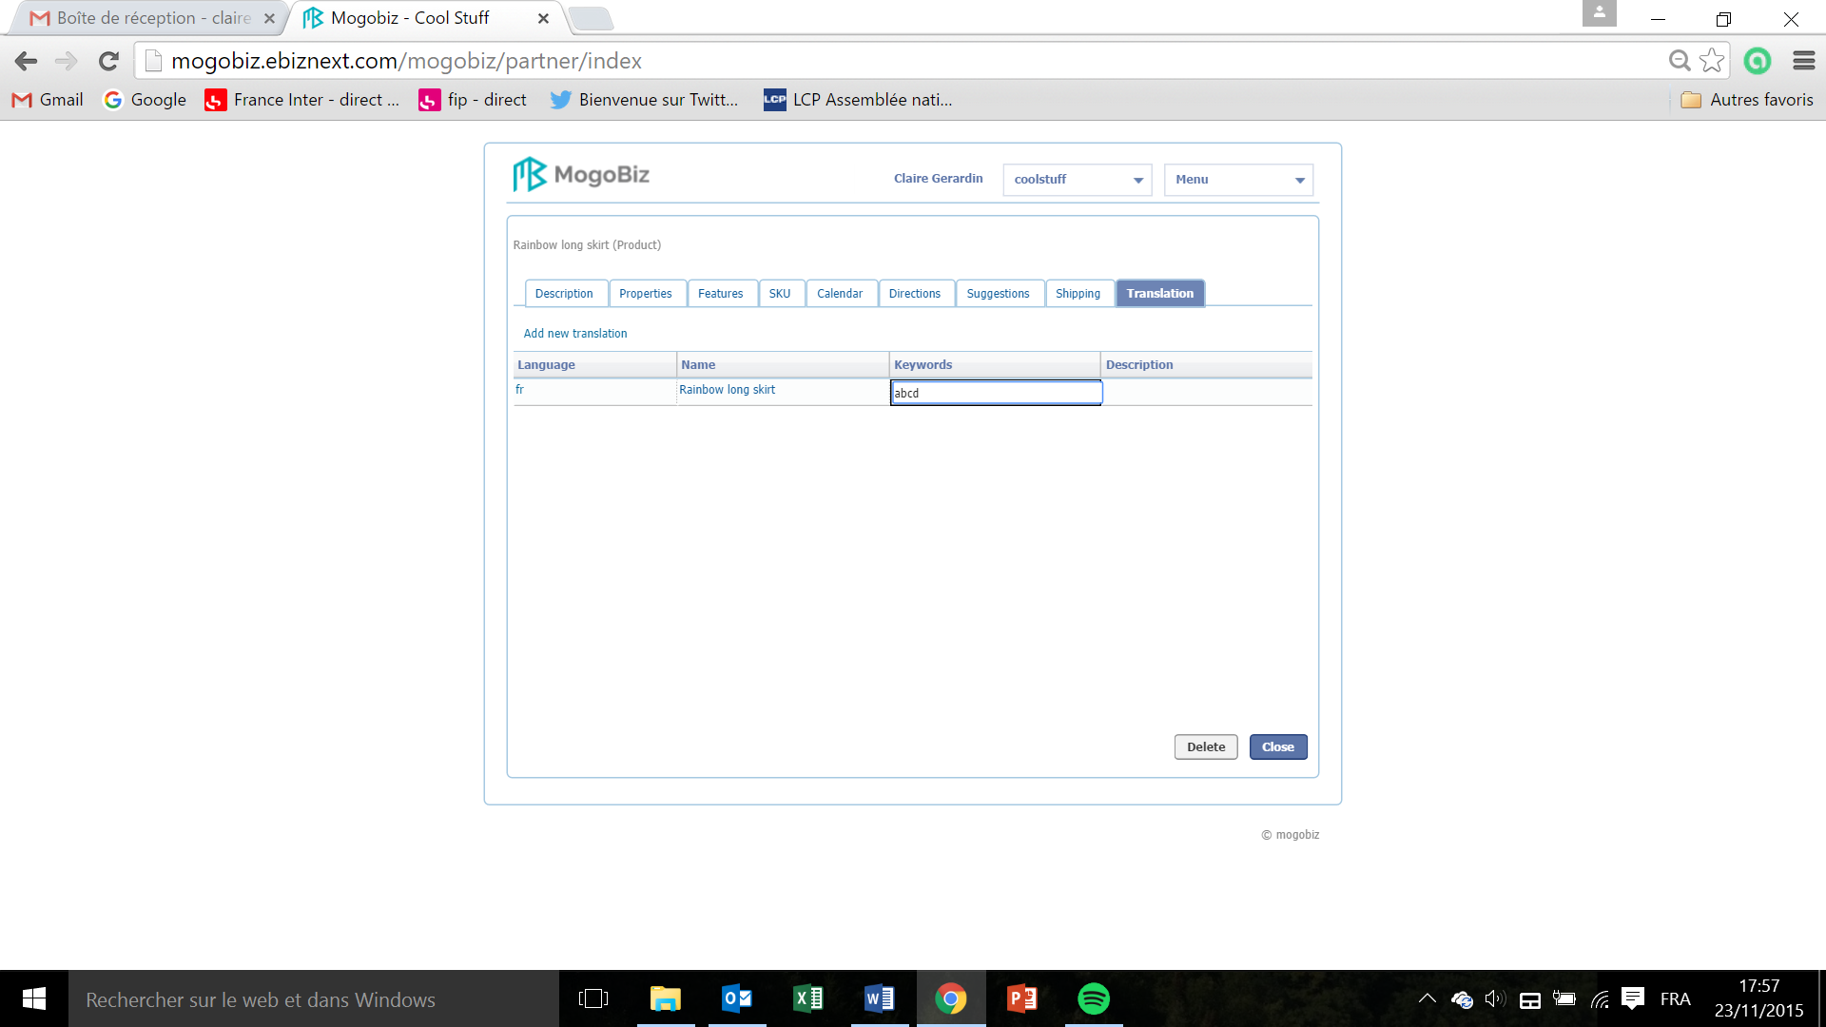

* Double click in the blank field under the Keywords tab and enter the translation of the product keywords?. Il n’y a pas de Keywords pour toutes les autres options de translation

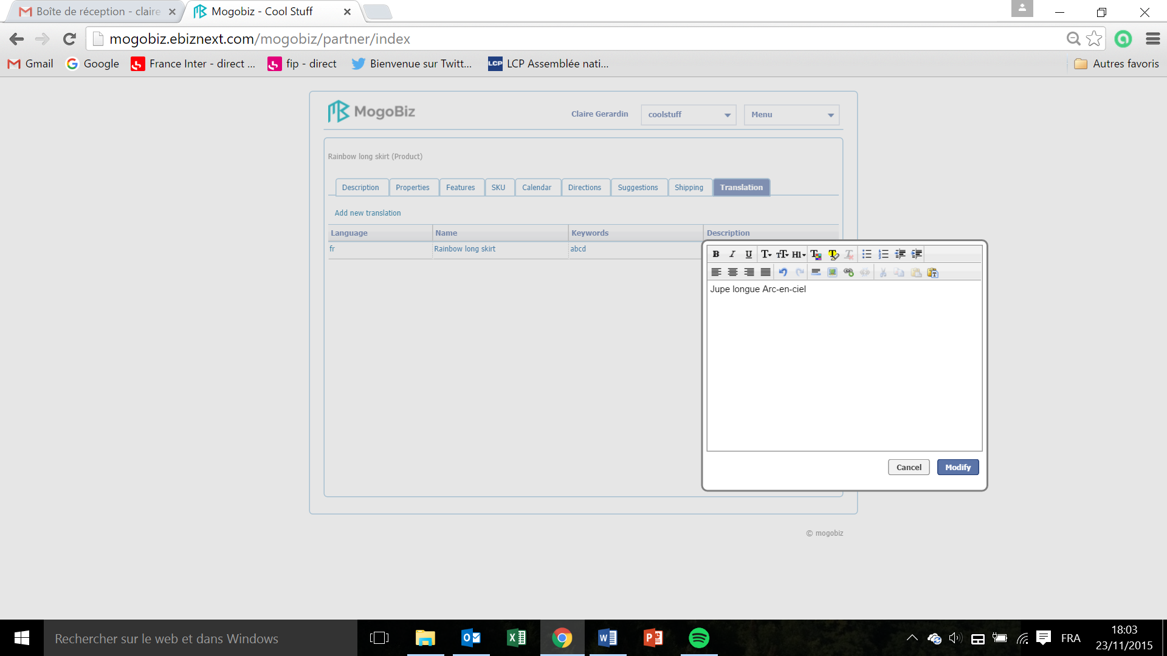

* Double click in the blank field under the Description tab and in the editor window that pops up enter the translation of the product name.
* Click on **Modify** if you want to save the translation or **Cancel** if you don’t want to pursue.